JUNK FOOD PREVENTION EDUCATION PACKAGE INTERVENTION AND ITS EFFECT ON BEHAVIOURAL INTENTION AMONG STUDENTS OF KAGESWORI MANOHARA MUNICIPALITY, KATHMANDU DISTRICT, NEPAL
Basanta Chalise
Institute of Medicine, Maharajgunj Medical Campus
Key words: Junk food, Educational Package, Interventional Study, Theory of Planned Behavior, P process
- Abstract Body

The study was carried out in Kageshwori Manohara Municipality of Kathmandu district. Descriptive cross sectional study for baseline and interventional study consists of pretest-posttest with control group. Study was conducted in 3 phases, descriptive cross sectional study design, education package development and intervention study (Quasi experimental-pretest-posttest with control group) was designed including implementation of junk food prevention education package and assessment of its effectiveness after 15 days. The site was selected purposively, after that list of public high schools was created. Four schools were selected randomly for baseline data collection. For interventional study two schools were randomly selected as intervention group and two schools were selected as control group. All students of grade eight and nine was taken as study group. For baseline study Sample size was determined by n = 4pq/L²
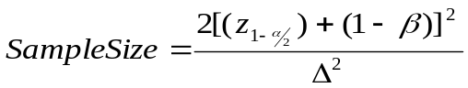For Intervention study sample size was determined

Using above formula, the calculated sample size for each wing of intervention and control school students in 1:1 ratio was 170. All the interested students having written signed consent of grade 8 and 9 were included on the study. Data collection was done by using self-administer questionnaire.
The baseline study showed that the understanding of junk food was satisfactory but 79.7% replace their meal with junk food at least one time per week.
For the evaluation of effectiveness of intervention Mann Whitney U tests was used. The result showed in the pre-test, there were no significant differences between two groups. After intervention there was significant improvement in each construct of TPB.
This study developed behavioral intention among the intervention group. Behavior intention will lead to change in intended behavior.

- Image:
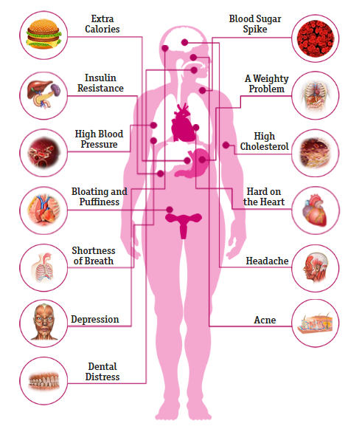
- Reference:
- Delisle H, Chandra-Mouli V, de Benoist B. Should Adolescents Be Specifically Targeted for Nutrition in Developing Countries: To Address Which Problems, and How? World Health Organization/International Nutrition Foundation for Developing Countries Available at http://www who int/childadolescent health/New_Publications/NUTRITION/Adolescent_ nutrition_paper pdf. 2000.
- Bake MA. A Study of on Urban Food Habits of Children and Adolescents Of Kathmandu Valley. 2012.
- Sharma I. Trends in the intake of ready-to-eat food among urban school children in Nepal. SCN News. 1998;16:21-2.

- Biography:
Basanta Chalise has completed his Master in Health Promotion and Education from Tribhuvan University, Kathmandu, Nepal. At present, he is in the post of Health Education in Health Directorate, Hetauda. He has more than 10 years working experience under government health system. He has decade long experience in teaching from PCL to Bachelor level in various institutions.
He has published article in international journal and completed online course on “Introduction to Communication Science by University of Amsterdam”. He has conducted and participated in various trainings and seminars.

- Presenting author details:

Full Name: Basanta Chalise
Contact number: 9841601213
Category: Oral presentation
Passport Number: 10554015

