Cultural Adaptation and Preliminary Psychometric Evaluation of the Nepali Version of Cancer Stigma Scale
Ishwari Rajbhandari¹, Prof. Zhou Lian Qing², Narayan Bhatta³

¹ Central South University, Hunan, China
² Department of Physical Examination, Hunan Cancer Hospital, Hunan, China
³ Ministry of Social Development, Province 3, Hatuada, Nepal

Keywords: Cancer Stigma, Cancer Stigma Scale; Reliability; Validity; Instrument Translation; Validation
- Abstract Body
In Nepal, there was no any valid tool to examine the stigma in cancer patient, so this study aimed to validate the Nepali version of Cancer Stigma Scale. A standard translation-back-translation procedure was used to collect data by face-to-face interview through consecutive sampling technique. A test retest was performed for to establish longitudinal validity and test retest reliability; the 10% of the total sample were tested in pilot study and after two weeks they were re- tested. The main study done to the total of 392 none sampled patients. For the construct validity, principle component analysis of the factor analysis, factor extraction, rotated component matrix, eigenvalue evaluated by using SPSS.
The age of the participant ranged from 18 to 88 years old (mean = 52.44 (±14.208). The content validity of CVR = 0.49, ICVI= 0.33 to 1, SCVI/Ave = 0.92, SCVI/UA = 0.739; The EFA suggested 6 Factor construct model. Item total correlation coefﬁcient ranged from .148 to .511 (p<.05). The intra-class correlation was .94 in each single measure or test where the average measure were.96; excellent test- retest reliability (α = 0.969) found. The results indicated a valid internal consistency (Cronbach’s alpha = 0.736).
A culturally valid and reliable Nepali version of Cancer Stigma Scale was developed which can be used for research and clinical assessment of cancer patients to find out the stigma.
- Image:
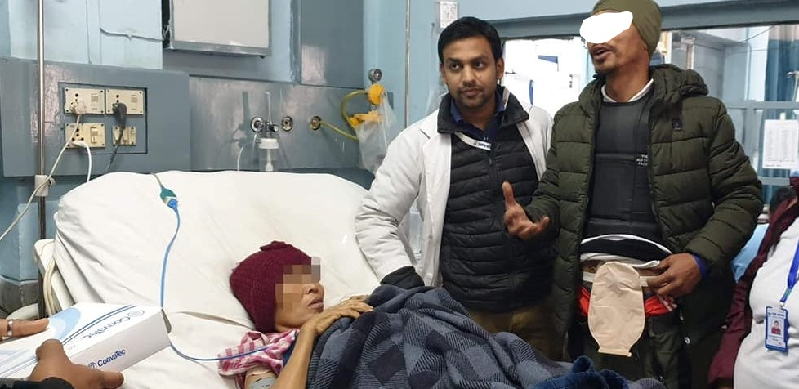

- Reference:
- Sousa VD, Rojjanasrirat W. Translation, adaptation and validation of instruments or scales for use in cross-cultural health care research: a clear and user-friendly guideline: Validation of instruments or scales. Journal of Evaluation in Clinical Practice. 2011; 17(2):268-274. doi:10.1111/j.1365-2753.2010.01434.x
- Beaton DE, Bombardier C, Guillemin F, Ferraz MB. Guidelines for the Process of Cross-Cultural Adaptation of Self-Report Measures: Spine. 2000; 25 (24):3186-3191. doi:10.1097/00007632-200012150-00014
- Cataldo, J. K., Slaughter, R., Jahan, T. M., Pongquan, V. L., & Hwang, W. J. (2011). Measuring Stigma in People with Lung Cancer: Psychometric Testing of the Cataldo Lung Cancer Stigma Scale. Oncology Nursing Forum, 38(1), E46–E54. https://doi.org/10.1188/11.ONF.E46-E54
IV Biography:
Ishwari Rajbhandari has completed her Master degree in Nursing from Central South University, Hunan, China. She is a student of Central South University.

V Presenting author details:



Full Name: Ishwari Rajbhandari
Contact number: +977 9841465396
Twitter account:
Linked In account: Ishwari Rajbhandari
Session name/ number: Master in Nursing
Category: Oral presentation
Passport Number: 0061959

