Title: Crude plant extracts: Potential bio-fertilizers and treatment against tomato plant infection
Etaware PM¹, Etaware EU², Olaoluwa OO³, Oyetunji OJ¹ Aiyelaagbe OO³, Odebode AC¹
¹ Department of Botany, Faculty of Science, University of Ibadan, Ibadan, Nigeria
² College of Food Technology, Yaba College of Education, Yaba, Lagos, Nigeria
³ Department of Chemistry, Faculty of Science, University of Ibadan, Ibadan, Nigeria.
Key words: Experimental plots, Control plot, Soilless cultivation, Gene engineering, Crude extracts
- Abstract:
Tomato cultivation in Nigeria and around the world is seriously threatened by disease infection. Soilless cultivation and gene engineering are modern innovations used worldwide to ensure production of quality disease-free vegetables; yet annual crop loss still persists. In 2011, a commercial vegetable farm in Apẹtẹ, Ibadan, Nigeria was totally ravaged by a fleet of disease infection. 36 infected tomato samples were annihilated from 6 cultivars for laboratory analysis. Crude plant extracts were employed as treatments. The test plants were arranged in 4x3x2x3x3 (experimental plots) and 4x3x3 (control plot) layouts. The tomato plants were basically infected by fungal diseases. The disease symptoms were totally eradicated by the applied botanicals (100% healthy tomato plants). There was an appreciable increase in plant heights of the treated tomato plants (30.9, 30.2, 27.5 and 26.5cm, respectively) compared to those in the control plots (24.1, 22.3, 23.3 and 18.6cm, respectively). The results obtained so far showed that plant extracts was an effective alternative for the systemic and hazardous chemicals used in tomato plant disease management.
- Image:
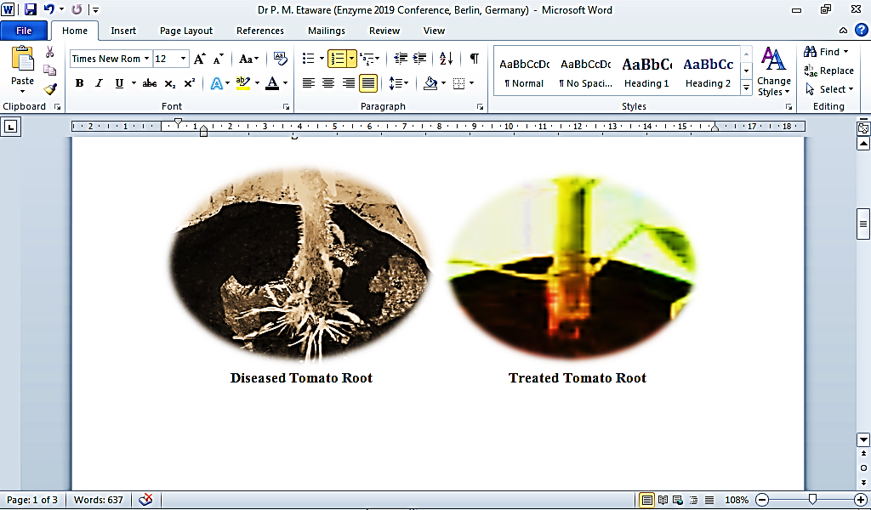

- Reference:
- Food and agricultural research organization of the united nation (FAO), 2000. Tomato integrated pests management (an ecological guide). FAO Rome. pp 204
- He, L., L. Sequeira and A. Kelman, 1983. Characteristics of strains of Pseudomonas. Journal of Applied Bacteriology. 27: 265-272
- Ijato, J.Y., S.D. Oyeyemi, J.A. Ijadunola and J.A. Ademuyiwa, 2010. Alleopathic effects of leaf extract of Azadirachta indica and Chromolaena odorata against postharvest and transit rot of tomato (Lycopersicon esculentum L.). Journal of American Science. 6(12): 1595-1599
- Joachim, H. 1996. Physic nut (Jatropha curcas L.). International Plant Genetic Resources Institute, Rome. pp 18-23
- Nahed, Z.H. 2007. Improving Biological Control of Fusarium root rot in Cucumber (Cucumis sativus L.) by allelopathic plant extracts. International Journal of Agricultural science and Biology. 1560-8530
- Owolade O.F., Y.O.K. Osikanlu, and T.A. Fadare, 2003. Control of brown blotch of cowpea using botanicals. Journal of Crop Research. 25(3): 561-566
- Paul, P.K. and P.D. Sharma, 2002. Azadirachta indica leaf extract induced resistance in barley against leaf stripe disease. Physiological and Molecular Plant Pathology. 16: 3-13
- Silva, N., S. Ganesan, N. Banumatty and Mutthuchelian, 2008. Antifungal effect of leaf extracts of some medicinal plant against Fusarium oxysporum causing wilt disease of Solanum melongena L. Ethnobotanical Leaflets. 12: 156-163
- Wilson, C.I., J.M. Solar, A. El Ghanouth and M.E. Wisniewski, 1997. Rapid evaluation of plant extracts and essential oils for antifungal activities against Botrytis cineria. Journal of Plant diseases. 81: 204-210
- Wizard Recipes, 2011. Tomato. https://www.wizardrecipes.com/blog. pp 5
- Biography:
Dr Peter Mudiaga Etaware has completed his Ph.D. at the age of 38 years from the University of Ibadan, Ibadan, Nigeria (Awaiting postdoctoral appointments in Plant Pathology and Microbiology). He is a seasoned researcher with penchant for excellence. He developed “ETAPOD” the first forecast model in Nigeria to predict black pod disease outbreak using simple analytical software. He was honoured with the prestigious award of the “University Scholar, 2004/2005”. He is the CEO of Rex-Lab, a premier data analytical company. He has published more than 10 research articles in reputed journals and he is an editorial board member of repute.
Presenting author details

Full Name: Peter Mudiaga Etaware (Ph.D.)
Contact Number: 2348032229349, 2347069021539
Twitter Account: @PeterEtaware
Linked In Account: peter-etaware@linkedin.com
Session Name/Number:
Category: Oral presentation
Passport Number: A50230608

