A Comprehensive Review on COVID-19 Pandemic: Causes, Effects, and Concerns

From Environmental Perspective

Abstract

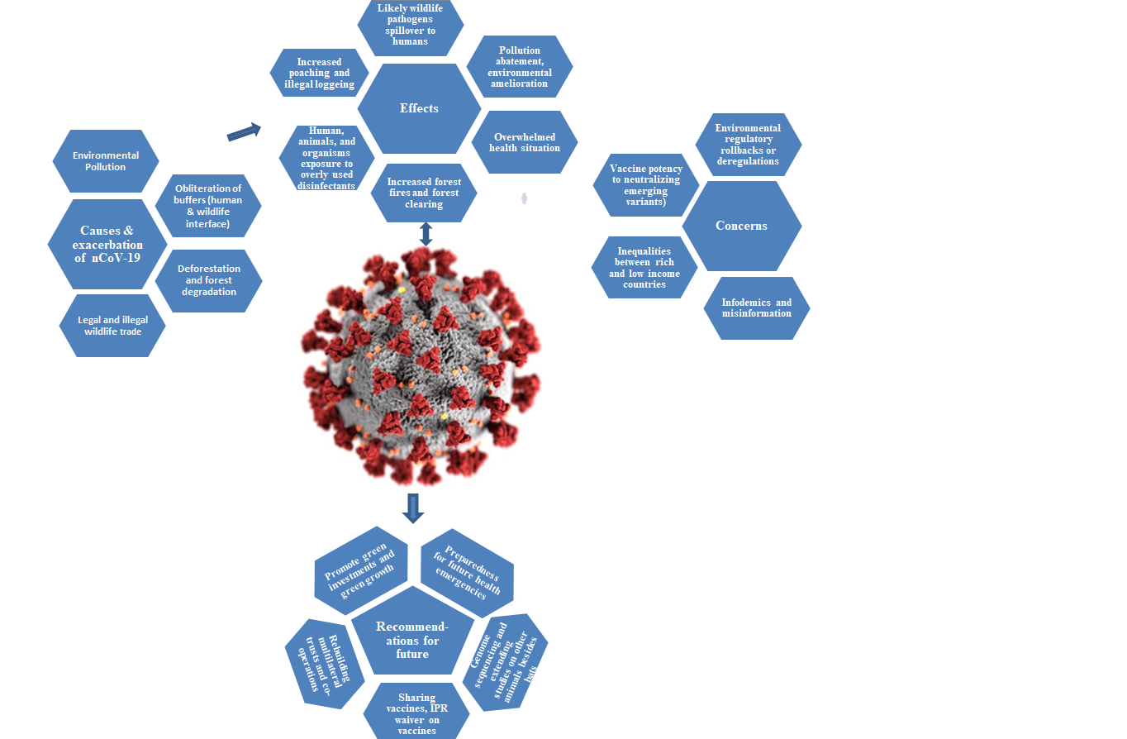

Severe acute respiratory syndrome coronavirus 2(SARS-CoV-2) and its variants are causing a humanitarian crisis globally. Zoonotic spillover followed by human to human transmission is to be blamed for the current pandemic and health crisis; however, it boils down to the long term environmental deterioration by anthropogenic activities to be the underlying cause of this predicament. Pandemic due to COVID-19 has several effects on social, economic, health and environmental fronts. There were some short-lived positive gains on environment due to COVID-19 imposed quarantines, lock downs, and shut downs; however these temporary gains couldn’t be glorified in the wake of negative consequences of COVID-19 on environmental, social, economy, and health. Green investments post-pandemic through relief packages, recovery, and rebuilding plan will spur resilient and sustained growth. This review paper is an endeavor to decipher the bidirectional nexus between environment and COVID-19 and discusses various topics on effects of COVID-19 and environment both ways from different perspectives.

Dr. Shyam Thapa
United States of America; Tel: +91 8703512544; E-Mail: shyamsirsha@gmail.com

