Small dams, big impact: The role of check dams to revive rivers and reverse climate change consequences
Govindasamy Agoramoorthy, PhD, Tajen University, Taiwan

Abstract (300 word limit)
Abstract
This paper presents data on how the eco-friendly check dams or small dams built in India’s streams and rivers revive them with water during the hot summer months and neutralize local climate change impacts. The surface and groundwater are increasingly under pressure throughout India that supports a population of over 1.3 billion inhabitants. Scientists have already warned that the looming climate change consequences will further aggravate the crisis and this paper addresses this thorny crisis. This study focused in India’s dryland districts such as Dahod in Gujarat State, Jhalawar and Banswara in Rajasthan State to assess the impacts of small dams. These districts have large areas of arid lands. Data on dams, sustainability, groundwater levels and benefits to farmers were systematically collected to analyze advantages offered by check dams with reference to climate change mitigation. The study shows that 356 check dams built during 1990-2012 across the drylands with a cost of USD 17 million benefitted over one million people belong to farming communities. The dams increased groundwater levels in villages, revived rivers during summer season, and increased forest cover along riverbanks and ultimately leading to the mitigation of local climate change imposed negative consequences. The check dam model is simple, eco-friendly and cost-effective. . If the model is followed across the vast drylands anywhere in the world, it has great potential to increase agricultural output, guarantee food security, enhance ground water and mitigate climate change impacts.

Image
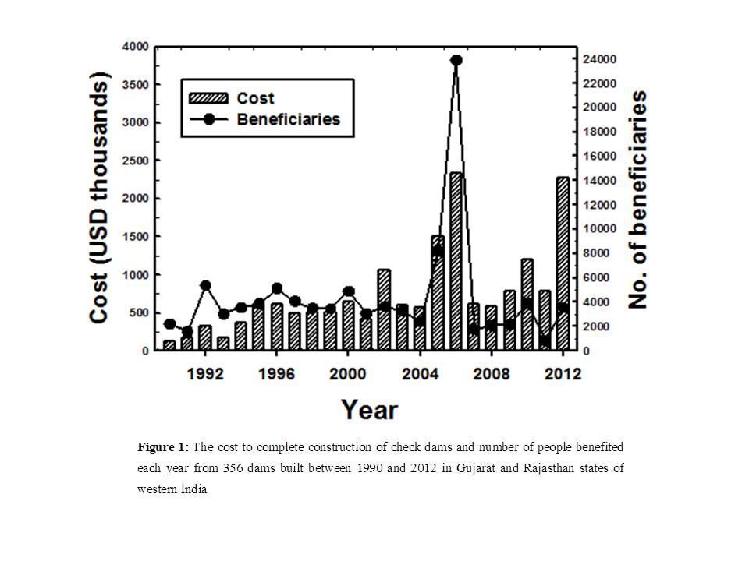
Recent Publications (minimum 5)
- Agoramoorthy G, Chaudhary S, Chinnasamy P, Hsu MJ (2017)9. Harvesting river water through small dams promotes positive environmental impacts. Environ Monit Assessm 188: 645.
- Agoramoorthy G, Hsu MJ (2016). Small dams revive dry rivers and mitigate local climate change in India’s drylands. Int J Climate Change Strat Manag 8: 271-285.
- Chinnasamy P, Agoramoorthy G (2016). India’s groundwater storage trends influenced by tube well intensification. Ground Water54:727-732.
- Agoramoorthy G, Hsu MJ (2015). Irrigation-based social work relieves poverty in India’s drylands. Int Social Work 58: 23-31.
- Agoramoorthy G (2015). Sacred rivers: Their spiritual significance in Hindu religion. Journal of Religion and Health 54:1080–1090

 Biography (150 word limit)
Govindasamy Agoramoorthy serves as Distinguished Research Professor at the College of Environment and Health Sciences, Tajen University, Taiwan. His research extensively includes integrated and multidisciplinary aspects of environmental and health sciences and he has carried out field research in Asia, Africa, and South America over the last three decades. He serves in the advisory board of several international agencies and academic journals including the Journal for Nature Conservation (Elsevier) and Frontiers in Environmental Science (Nature Group). Between 1989 and 1993, he served as Visiting Scientist at Smithsonian Institution, Washington, DC. Over the last decade, he has been involved in integrated and multidisciplinary research involving environmental science, water resource management and sustainable development focused in Asia. He also serves as Tata Visiting Chair in India for over a decade where he reviews natural resource management projects. Professor Agoramoorthy authored several books and scientific papers in high impact journals.
Email: agoram@tajen.edu.tw

