Tree diversity and soil physicochemical CHARACTERISTICS in the riparian fOrEST of a volcanic crater lake
Abstract
Problem statement: Occurring at a transition zone between the terrestrial uplands and aquatic ecosystems, riparian areas are highly productive and provide habitats for a disproportionately large range of co-existing plant and animal species. In spite of their importance, riparian forests are threatened across the world. Land use changes around watersheds and riparian areas affect species composition, species diversity and soil quality and this is usually brought about via agricultural expansion, increased pressure on land for house construction, alterations of hydrological regimes. Materials and Methods: Plant community studies and soil physicochemical properties analyses were carried out to identify possible pollutants which may eventually be leached into the lake and probably alter its ecology. Five plots (one hectare each) were laid in which tree enumeration, measurement of forestry parameters. Observed anthropogenic disturbances were recorded. Findings: A total of 70 species from 63 genera and 28 plant families were identified. Tree diversity varied across forest sites with the highest Shannon diversity recorded in Tung (3.45) and the least in Malenda (2.21). Population structure characteristics differed in the different forests, with the largest Stand Basal area of 43.78 m²/ha recorded in Bondokombo while the least was found in the Sacred Island (2.15 m²/ha). Species rich families were Malvaceae and Fabaceae (9 species each). Significant variations in concentrations of C, N and heavy metals occurred across forest sites with the Sacred Island having highest CEC, N, C and Phosphorus. The highest anthropogenic disturbances were recorded in Malenda and Bondokombo forests which also recorded highest Iron concentrations of 824.5ppm and 817.05ppm respectively. Conclusion and significance: This study shows anthropogenic disturbances have reduced tree diversity and altered soil characteristics and thus influencing the water quality of this lake. There is a need to create a riparian buffer around this lake

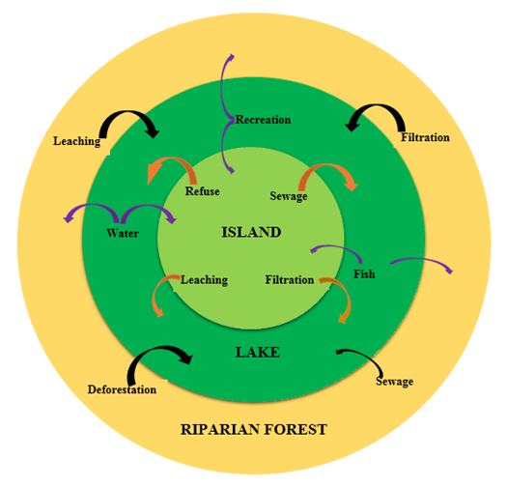

Figure 1: Onion model of Lake Barombi Kotto showing ecosystem interactions

Recent publications:
Awo, M. E., Tabot, P. T., Nso, G. and Fonge, B. A. 2018. Spatiotemporal variation of phytoplankton community structure in the crater lake Barombi Kotto, Cameroon. International Journal of Current Research I Biosciences and Plant Biology 5 (2) 36-55.
Cooper, S. D., Lake P. S., Sabater, S., Melack J. M. and Sabo J. L. 2013.The effects of land use changes on streams and rivers in Mediterranean climates Hydrobiologia 719 (1) Doi: 1007/s10750-012-13333-4.
Ding, J., Zhao, W. Daryanto, S., Wang, L., Fan, H., Qiang Feng Q. and Wang, Y. 2017 The spatial distribution and temporal variation of desert riparian forests and their influencing factors in the downstream Heihe River basin, China. Hydrology and Earth Systematic Science 21: 2405-2419.
Moffatt, S. F., McLachlan, S. M. and Kenkel, N.C. 2004. Impacts of Land Use on riparian forest along an Urban- Rural gradient in Southern Manitoba. Plant Ecology 174 (1): 119-135.
Naiman, R. J., Bilby, R. E., Bisson, P.A. 2000. Riparian ecology and management in the Pacific Coastal Rain Forest. Bioscience 50, 996 –1011.
Petrakis, R. E., Willem J. D., Villarreal, M. L., Tashjian P., Russo R. D. and Scott, C. A. 2017. Historical analysis of riparian vegetation change in response to shifting management objectives on the middle Rio Grande. Land 6 (2): 29; doi: 10.3390/land6020029

Biography:
Awo Miranda Egbe has a Ph.D. in Botany from the University of Buea, Cameroon and is currently recruited as an instructor, teaching courses in Plant physiology, Ecology and Wetland management. Her Ph.D. research project was on water quality and riparian tree ecology and this has driven her passion to investigate the interrelationship between plant communities, edaphic factors like soil and water. She is actively involved in projects which have to do with man’s role in the deterioration and management of natural resources, evaluating plant diversity in different ecosystems and their role in maintain a healthy environment. Her research cuts across lower plants especially phytoplankton to higher plants and is also interdisciplinary. She has carried out research in domains of agriculture, toxicology and ecology.
E-mail: awomiranda1@gmail.com

