The Asian Values of Guanxì as an Economic Model for Transition toward Green Growth
Yongrok Choi, Ph.D. Prof. in Inha University, Korea (S)

Abstract (300 word limit)
Most Asian countries are experiencing escalating air pollution and other environmental challenges. Many political measures, such as regulations and promotional subsidies, have not proved effective or efficient due to a lack of governance. The reason for this may come from the historical and cultural background of government-led economies. Due to the top-down approach to sustainable development, most private sector companies, as well as the general population, do not participate voluntarily in meeting these new challenges. In order for these Asian countries to become leaders in the new global trend towards green growth, this paper examines the Asian values of gu¯anxì to facilitate the interrelationship between public and private sectors, and proposes an Asian public–private partnership model with five structural principles, three functional propositions, and seven procedural factors. Using these governance elements, Asian governments should create, maintain, and utilize the progression of gu¯anxì from acquaintance via trust to loyalty. Through this stepwise approach, Asian governments could construct an innovative virtuous circle to create value based on network management, which is the ultimate paradigm of sustainable development.

Image
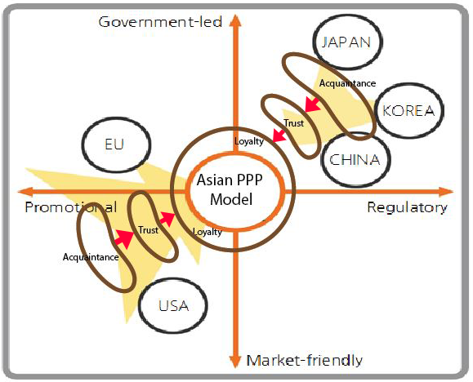
Asian Approach for the Green Growth
Recent Publications (minimum 5)
- C. Kung, Y. Choi et al. (20019) Effectiveness of crop residuals in ethanol and pyrolysis-based electricity production: A stochastic analysis under uncertain climate impacts. Energy Policy 125:267-276.
- W. Na, Y. Choi (2019) Comparative Analysis of the Energy and CO2 Emissions Performance and Technology Gaps in the Agglomerated Cities of China and South Korea. Sustainability 2019, 11, 475: 1-25.
- H.Lee, Y.Choi (2018), Greenhouse gas performance of Korean local governments based on nonradial DDF. Technological Forecasting & Social Change 135: 13–21.
- H.Lee, Y.Choi (2018), Heterogeneity and its policy implications in GHG emission performance of manufacturing industries. Carbon Management, DOI: 10.1080/17583004.2018.1469366
5. Yongrok Choi, Yu Liu, Hyoungseok Lee (2017), The economy impacts of Korean ETS with an emphasis on sectoral coverage based on a CGE approach, Energy Policy 109 (2017) 835–844.
.

Biography (150 word limit)
Prof. Yongrok Choi got his doctoral degree in University of Cincinnati. He served at Samsung and KT, largest IT companies in Korea, and Global e-business Professor’s Association as the president. He organized and has managed the Sustainable Asia Conference (http://abf.inha.ac.kr/) since 2008. He got a lot of award for the academic excellent performance such as Premier Minister of Korean government Award, Award given by the Minister of Construction and Transportation of Korea, Outstanding paper award given by Chinese Academy of Science of China, Beijing. Currently, he is a distinguished research professor of Inha University (Inha Fellow Professor).
Email: drXXXXXXX@xxxmail.com

Notes/Comments:

