The effect of pressure and temperature on the energy of ZnO Wurtzite Phase, a Molecular Dynamics Prediction

Yahia Chergui^{1, 2*}, Tahar Aouaroun^{3, 4}, Rafik Chemam¹

- Physics Department, Badji Mokhtar University, Sidi Ammar, Annaba 23000, Algeria

- IGEE Institute, University M’Hamad Bougara of Boumerdes, Boumerdes 35000 Algeria
- Faculty of Science, Physics Department, University M’Hamad Bougara of Boumerdes, Boumerdes 35000, Algeria
- Unité de Recherche (UR-MPE), University M’Hamad Bougara of Boumerdes, Algeria

Abstract (300 word limit)

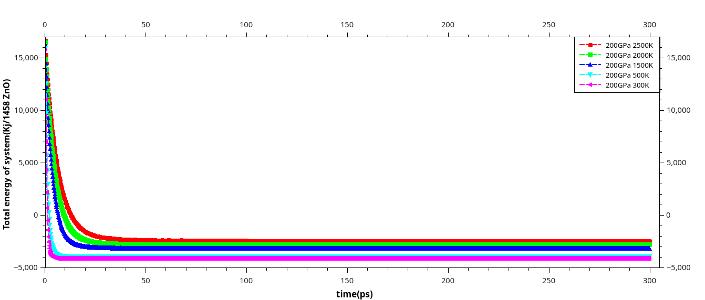
The dl_poly_4 software and Parallel Molecular Dynamics are investigated to analyze the behavior of temperature, and pressure on ZnO wurtzite phase. In this work we study the effect of the temperature and pressure in the range of 300-3000K and 0-200GPa respectively on the total energy. The interatomic interaction is modeled by the Coulomb-Buckingham pair potential, where we confirmed its validity. Our data are in agreement with some available results due to no more work under the previous extreme conditions of pressure and temperature. This work has great importance in pharmacy, medicine, nanotechnology industry and in geophysics, but needs confirmation in future.
Image

Figure1: total energy versus time of ZnO-W under 0-200GPa.

Recent Publications (minimum 5)

1) - N. Nehaoua, Y. CHERGUI and D. E. Mekki

Tandem and single organic solar cells parameters evaluation from illumination I-V plot
Journal of Electron Devices, Vol. 11, 2011, pp. 515-520
2)- N.Nehaoua, Y. CHERGUI and D. E. Mekki.

Determination of organic solar cell parameters based on single or multiple pin structures,
Vacuum 84 (2010) 326-329.
- - Y. CHERGUI, N. Nehaoua and D. E. Mekki.

The structural properties of PbF2 by Molecular Dynamics
Eur. Phys. J. Appl. Phys. 51, 20502 (2010). DIO:10.1051/epjap/2010096
- - Y. CHERGUI, N. Nehaoua and D. E. Mekki
Chapitre Solar Cells / Book 2 (first editin July 2011, InTec), ISBN979-953-307-191-5. Comparative study of dye-sensitized solar cell based on ZnO and TiO2: parameters evaluation,
Edited by Prof. Leonid Kosyachenko Yuriy Fedkovych Chernivtsi National University, Optoelectronics Department, Ukraine.
- - N. Nehaoua, Y. CHERGUI and D. E. MEKKI
Chapitre Solar Cells / Book 3 (first edition July2011, InTec), ISBN 9-953-307-192-2
A New Model for Extracting the Physical Parameters from I-V Curves of Organic and Inorganic Solar Cells Edited by Prof. Leonid Kosyachenko Yuriy Fedkovych Chernivtsi National University
6)-Y. CHERGUI, N. Nehaoua and D. E. Mekki, Low and wide gap organic solar cells parameters extraction from illumination current-voltage. Materials Science, Trade Science, MSAIJ, 8(4), 2012 [174-178]
7)- Y. CHERGUI, N. Nehaoua et D. E. Mekki, Photovoltaic characteristics of ZnO Nanotube Dye-Sensitized Solar Cells and TiO2 Nanostructure, Journal of Material Sciences,Issue 2321-6212, Page 2347-2278. 2/10/2013.
- - Y Chergui et al
Molecular Dynamics Prediction of Wurtzite ZnO Phase under High and Low Pressures and Temperatures, 2017 Mater. Res. Express 4 115016

Biography (150 word limit)

Yahia CHERGUI has completed his PhD from Badji Mokhtar University in Annaba, Algeria. He is a teacher in Boumerdes University since 2012. He has published more than 7 papers in reputed journals and has been serving as a referee with condensed matter journal (IOP) and Energy journal(Elsevier).He passed 6 months in Cardiff university and Queen University for summer school.
Email: yahia_chergiui@yahoo.com

Notes/Comments:

