Five Stages to Making The Biggest 90-Day Leap in Your Business. Why do Businesses fail at making a structured systematic leap and a successful system to making one every quarter?
Bimal Shah, CEO, Rajparth Group of Companies.

Abstract (300-word limit).
In The Biggest 90-Day Leap™ workshop, the attendees will walk away with:
✓ Who needs to do what by when to resolve your biggest pain, challenge, or frustrations and the ideal results in 90 Days?
✓ The Business Scorecard™ that scores your business and helps you identify the gaps in your Business.
✓ A one-year road map to achieve your three-year goal in one year.
✓ The Biggest 90-Day Leap™ _written plan
✓ Systems, Tools, and Strategies you would need to use to achieve that result
✓ Five stages to making an effective 90-day leap in your business.
✓ Top 10 reasons why companies fail at the biggest 90-day leap.
✓ Five stages to making an effective 90-day leap in your business.
✓ A clear-cut vision that will bring clarity in where you need to be. We can only chase what we see.
✓ Five stages to making an effective 90-day leap in your business.
✓ A roadmap on how to achieve your 90-Day “Dream Come True” Result.
A clear-cut vision that will bring clarity in where you need to be. We can only chase what we see.
✓ How to do more in less time with less.
✓ Practical exercises to put things in motion.
✓ Instant access to tools that will put you on track to make you go to the next level.
✓ Top 10 reasons why companies fail at the biggest 90-day leap.

Leaping is essential in business. Without leaps, we get stuck in linear growth and accept that as a norm. That never allows scaling. Linear growth vs exponential growth is the root cause that makes more than 80 percent of businesses fail even after 15 years in the business. This workshop boldly takes many entrepreneurs where they have never gone before.

Image
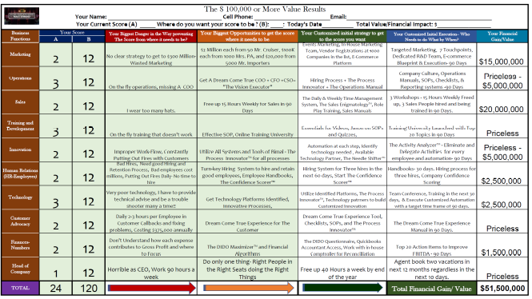
This image represents the Proprietary Business Scorecard that assists in making the Biggest 90-Day leaps for business.
Recent Publications (minimum 5)
- “Becoming A Pioneer- A Book Series- The monthly step-by-step guide to doubling your business and taking over your industry in a year. – The #1 New Release on Amazon in Dreams and Sales. February 2022
- “How to stand out from the rest?” – Thrive Global December 2021
- “Five things you need to know on how to create a successful business” – Authority Magazine
December 2021.
- “Making Pioneers out of Entrepreneurs” – Entrepreneurs in the Studio – December 2020
- “Becoming A Pioneer” Desh Videsh- January 2022.
- “Security from Seven Enemies of Wealth” – Desh Videsh – January 2022
- “The Go-To Consultant for Business” – South Florida Business and Wealth – April 2021.


Biography (150 word limit)

Bimal is a pioneer, author, and results leader delivering meaningful transformations. Bimal is the CEO of Rajparth group of companies with a mission to make a million pioneers throughout the world. Bimal has a passion for helping entrepreneurs achieve their three-year goal in one year that is closest to their 25-year vision. That is the purpose behind his book series, "Becoming A Pioneer." solving one of the biggest problems 80 percent of small businesses face becoming extinct even after 15 years in the business. Bimal has helped 26 CEOs more than double their business in a year by becoming pioneers and more than 1000 families secure their wealth to another level. He has been featured in NBC WPTV, Prestigious SFBW Magazine, Radio Entrepreneurs, I am CEO, Authority Magazine, The Entrepreneur Way, Office Hours, and much more with one goal-making your journey meaningful. Make your transformation at https://bit.ly/MyMeaningfulTransformation.
Email: bimal@theoneyearbreakthrough.com

Notes/Comments:

