Transnasal endoscopic prelacrimal recess approach in a surgical treatment of antrochoanal polyp
Abdelrahman Sheta Abdelrahman
MS.c of ORL AL-Azhar university , Faculty of Medicine ,Cairo .

Abstract
Purpose: To assess the effectiveness of endoscopic transnasalprelacrimal recess approach (ETPRA) in preventing the recurrence of antrochoanal polyps & evaluate the outcomes and possible complications of prelacrimal recess approach for treatment of antrochoanal polyps.

Methods: 40 patients with Antrochoanal polyp underwent surgery with a transnasal endoscopic prelacrimal recess approach. The approach is evaluated for the ability to visualise the origin of the polyp in the maxillary cavity, complications and recurrence of the polyp.
Results: Transnasalprelacrimal recess approach was successful in 80% of the patients (32/40), 80% of patients (32/40) did not encounter epiphora postoperatively, 85% of them (34/40) had no epistaxis, 90% ofthem(36/40)hadnocheekedema.Noneofthemhadnasalobstruction, nasalstenosisoradhesions,all of them had the flap healed and all of them had the inferior turbinate preserved. During the follow-up period (1 year) no recurrence haddeveloped.
Conclusion: prelacrimal recess approach is a safe procedure which allows for complete removal of the antral part of the antrochoanal polyps to prevent recurrence without major complications.
Keywords: prelacrimal recess approach, antrochoanal polyp .

Images
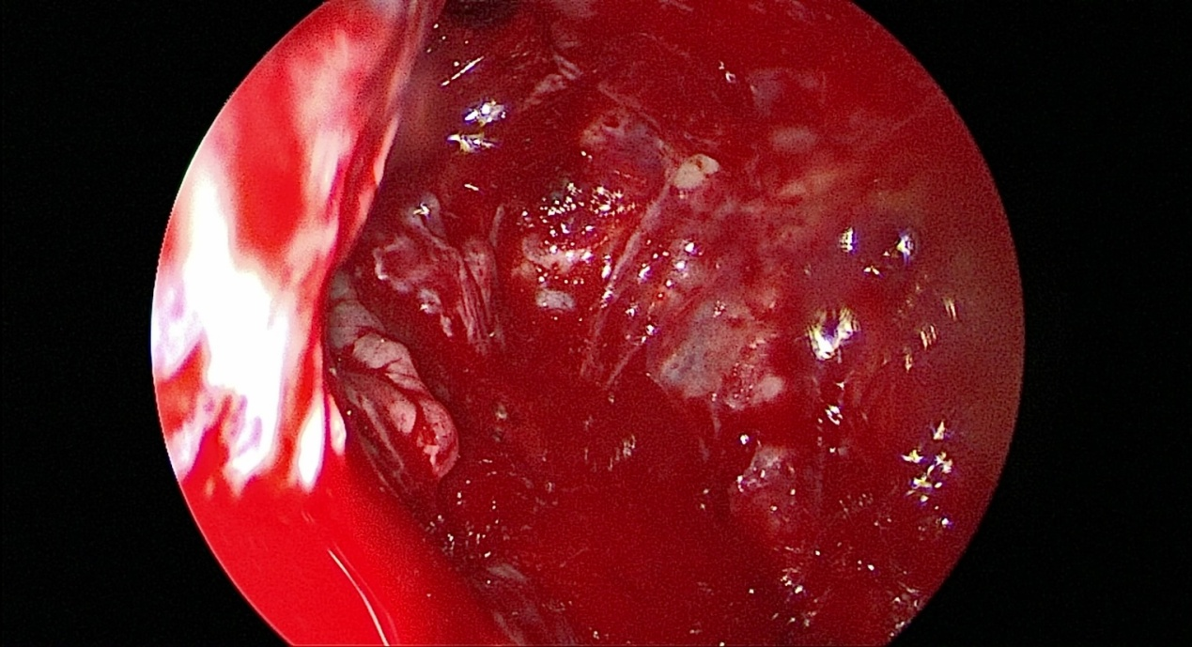
Figure 1 : The view of maxillary antrum after prelacrimal recess approach .
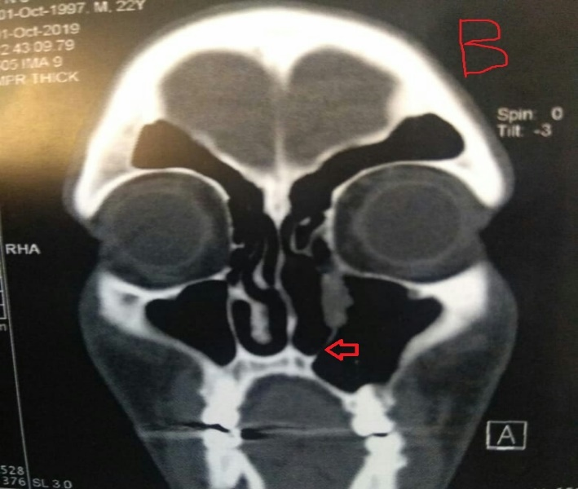
Figure 2 :The red arrow show the site of prelacrimal recess approach.
Recent Publications
1.Sheta A.,(2020):Transnasal endoscopic prelacrimal recess approach in a surgical treatment of antrochoanal polyp . DOI: 10.21608/amj.2020.82594 ,volume 49,issue 2 : 807-814
2.Atighechi S., Baradaranfar M., Karimi G. and Jafari R. (2010): Antrochoanal polyp: a comparative study of endoscopic endonasal surgery alone and endoscopic endonasal plus mini- Caldwell technique. Eur Arch Otorhinolaryngol, 266(8): 1245-1248.
3.Eladl H. and Elmorsy S. (2011): Endoscopic surgery in pediatric recurrent antrochoanal polyp, rule of wide ostium. Int J Pediatr Otorhinolaryngoly, 75:1372–1375.
4.El-Sharkawy, A. A. (2013): "Endoscopic management of paediatric antrochoanal polyp: our experience. Acta Otorhinolaryngologica Italica, 33(2): 107-113.

5.Zhou B, Han D. and Cui S. (2013): Intranasal endoscopic prelacrimal recess approach to maxillary sinus. Chin Med J, 126: 1276–1280.
Biography
I am Abdelrahman Sheta Abdelrahman & Iam a specialist in the field of otorhinolaryngology Department Al-Azhar university , looking to further my medical career. I have extensive experience in both the private and public sector having four years of clinical practice.

I was Graduated from faculty of medicine at DEC.2015 with M.B.B.CH from AL-Azhar university then became houseofficer at al-azhar university hospital (Sayed galal hosp.) on 2016 then became resident at otorhinolaryngology Department in al-azhar university hospitals from 2017 till 2020 & Iam waiting for anomination as assistant lecturer of O.R,L in al-azhar university (Master Degree was achieved on November 2020) .

**Contact detalies**

E-Mail : boodysheta2021@gmail.com

Phone : 00201018226826
‏

