Pediatric Adenoidectomy: A Comparative Study Between Cold Curettage and Coblation Technique
Vaibhav B. Hapaliya, M.S ENT, SMIMER, Surat, India
Ajay J. Panchal, M.S ENT, SMIMER, Surat, India
Rakesh Kumar, M.S ENT, SMIMER, Surat, India
Parth B. Kapadiya, M.S ENT, SMIMER, Surat, India
Mitanshi A. Bhiryani, M.S ENT, SMIMER, Surat, India

Abstract

The objective of the study was to assess endoscopic coblation adenoidectomy and conventional cold curettage adenoidectomy in terms of safety and efficacy in pediatric patients. Study included 40 pediatric patients, aged between 4–17 years. 20 patients underwent cold curettage adenoidectomy and 20 underwent Coblation adenoidectomy. The 2 procedures were compared on various parameters like duration of surgery, intra—operative blood loss, and post –operative pain. To further the comparison, follow -up Nasal Endoscopy was done after 1 week and after 1 month to assess for injury to peripheral tissues and completeness of removal of adenoids. There was statistically significant difference, favouring Coblation adenoidectomy in terms of lesser intra-operative blood loss (mean blood loss of 19 mL Vs 28.5 mL) and lesser post operative pain measured on Visual Analogue Scale (median VAS score of 2 Vs 2.67). Shorter duration of surgery (mean operative time of 10.3 min Vs 15.5 min) was the only parameter in favour of conventional cold curettage method. Injury to peripheral tissue and residual adenoid were seen in patients who underwent curettage adenoidectomy. The overall advantages of Coblation adenoidectomy when compared with cold curettage adenoidectomy are less intra-operative bleeding, less post operative pain, completeness and preciseness of adenoid removal with minimal injury to adjacent tissues. For these reasons, Coblation adenoidectomy should be the standard technique adopted for adenoidectomy.
Image
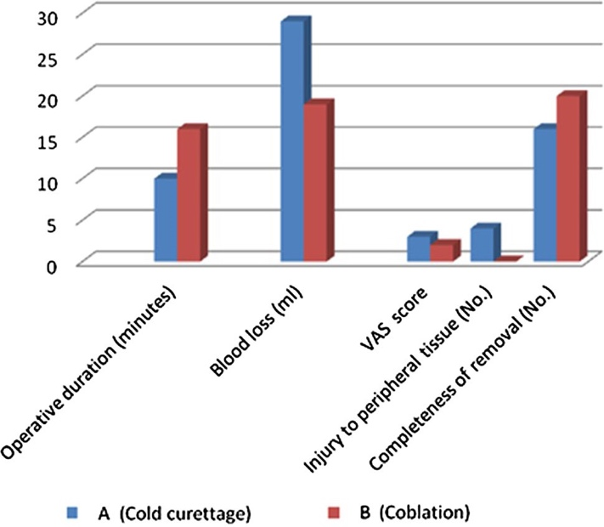
Recent Publication
- Hapalia, Vaibhav & Panchal, Ajay & Kumar, Rakesh & Kapadia, Parth & Bhiryani, Mitanshi & Verma, Ridham & Parmar, Neel. (2020). Pediatric Adenoidectomy: A Comparative Study Between Cold Curettage and Coblation Technique. Indian Journal of Otolaryngology and Head & Neck Surgery. 10.1007/s12070-020-02247-4.

Biography
Mitanshi Bhiryani has done her MBBS in 2016 and MS ENT post graduation residency in 2021 from SMIMER, Surat. During my training years I was responsible for the delivery of highest possible standards of patient care during treatment. I am at providing comprehensive and individualized medical and surgical care for the diagnosis, treatment and management of ear, nose, throat and head and neck disorders. I am currently working as Senior Resident at SMIMER, Surat, India and looking for fellowship opportunities in India and abroad.
Email: mitanshib@yahoo.co.in

Notes/Comments:

