Thyroid Nodules Minimally-Invasive Ultrasound Guided Radiofrequency Ablation
Roberto Valcavi, MD, FACE, ECNU, Endocrine & Thyroid Clinic (E.T.C.), Reggio Emilia, Italy

Abstract

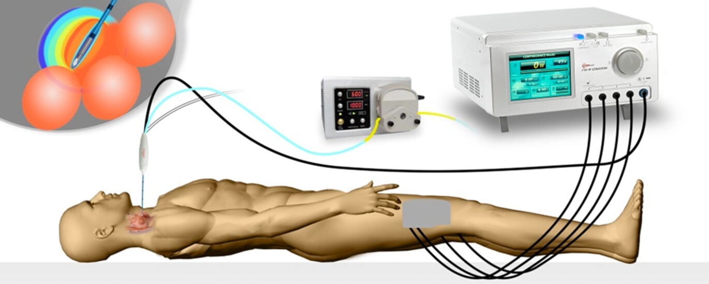
Ultrasound-guided minimally-invasive RFA surgery takes place in a surgical room. Benign thyroid nodules, goiter, hyperfunctioning nodules (toxic adenomas), non-metastatic malignant micro-papillary tumors [1] (<1cm), lymphatic metastases that cannot be treated surgically or with radioiodine can be treated by means of an innovative approach, which complement open surgery. RFA uses radiofrequency waves generated by a special needle-electrode, which generate elevation of the localized temperature inside the nodule, destroying it [2]. The intervention takes place by introducing a radiofrequency (RF) needle-electrode into the nodule under ultrasound assistance, which, thanks to an internal cooling system, produces thermal elevation at the tip while maintaining a non-harmful temperature along the rest of the needle in contact with other healthy structures of the neck. The most used technique is monopolar radiofrequency. During the surgery, the patient is part of a circuit that includes a radiofrequency generator, a needle-electrode and two dispersion plates positioned on the patient's legs (Fig 1). Local pericapsular thyroid anesthesia and sedation with midazolam and propofol are performed under monitoring of vital parameters and the assistance of an anesthetist / resuscitator. The patient does not feel any discomfort during the procedure. Intubation is not necessary. In the weeks and months following RF ablation, a progressive volumetric reduction of the treated nodule will be obtained, with a consequent reduction in compression symptoms and visible swelling. Remarkable is the improvement in the quality of life [3-4]. The reduction is on average 80% compared to the initial volume [3-4] but can vary according to the type of ablated tissue, the conformation and the size of the nodule. The treatment can be repeated after some time if necessary. Initially thyroid nodule ablation was performed through the laser. However the laser can obtain an average of 45-50% volume reduction rate of the nodule [5]. The administration of analgesics (paracetamol) and corticosteroids (methylprednisolone) effectively prevents local pain and discomfort after the procedure. In very rare cases, the operation can cause dysphonia (hoarseness due to paralysis of a vocal cord) due to overheating of the recurrent laryngeal nerve, which is transient in almost all cases. In the outpatient context in which the intervention is carried out, all the necessary tools are available to deal with any side effects described. Thermoablation treatment of thyroid nodules using RFA represents a cutting-edge therapeutic alternative to a traditional surgical solution or radioactive iodine therapy. The advantages of ultrasound-guided radiofrequency over traditional “open” surgery are: absence of scars, organ preservation and normal function of the thyroid, no need to take any therapy, minimal side effects, absence of general anesthesia, drainage tubes, hospitalization, much faster recovery, minimized aggression, improvement of the quality of life.

Image

Figure 1: Starmed ® monopolar radiofrequency circuit
The generator (top right) produces an electric current that causes overheating at the tip of the needle-electrode (top left) inserted into the thyroid under ultrasound guidance. Internally the needle is cooled by sterile physiological solution at 2 ° C pushed by a peristaltic pump (top center). The circuit is closed by the grounding pads adhered to the front face of the thighs. The needle performs the single ablation of a sphere of 1 cm of tissue around the tip and must subsequently be moved until it progressively forms coalescing spheres (fused together) of ablation. Under real-time ultrasound guidance, the entire nodule is completely ablated with gentle manual skill.
Recent Publications
- Valcavi R, Piana S, Bortolan GS, Lai R, Barbieri V, Negro R. Ultrasound-guided percutaneous laser ablation of papillary thyroid microcarcinoma: a feasibility study on three cases with pathological and immunohistochemical evaluation. Thyroid. 2013 Dec; 23 (12): 1578-82.
- Baek JH, Lee JH, Valcavi R, Pacella CM, Rhim H, Na DG. Thermal ablation for benign thyroid nodules: radiofrequency and laser. Korean J Radiol. 2011 Sep-Oct; 12 (5): 525-40.
- Roberto Valcavi, Petros Tsamatropoulos. Health-Related Quality of Life after Percutaneous Radiofrequency Ablation of Cold, Solid, Benign Thyroid Nodules: a 2 Year Follow-up Study in 40 Patients. Endocr Pract. 2015 Aug; 21 (8): 887-96.
- Mark A Lupo. Radiofrequency Ablation for Benign Thyroid Nodules-A Look Towards the Future of Interventional Thyroidology. Endocr Pract. 2015 Aug; 21 (8): 972-4.
5. Valcavi R, Riganti F, Bertani A, Formisano D, Pacella CM. Percutaneous laser ablation of cold benign thyroid nodules: a 3-year follow-up study in 122 patients. Thyroid. 2010 Nov; 20 (11): 1253-61.



Biography
Dr. Roberto Valcavi, Specialist in Endocrinology. From 1996 to 2014 was Director of the Department of Endocrinology at IRCCS-Arcispedale Santa Maria Nuova in Reggio Emilia, Italy. In 1999 he founded the AME (Association of Italian Endocrinologists). In 2004 in Boston he received the "International Clinician Award" in recognition of the advances achieved in favor of clinical endocrinology and for the benefit of all endocrine patients. Since November 2020, Dr. Roberto Valcavi has opened the E.T.C. CLINIC (Endocrine Thyroid Clinic) in Reggio Emilia dedicated in particular to the diagnosis and ultrasound-guided therapies of the endocrine neck (thyroid, parathyroid, lymph nodes). Among the latter, the ultrasound-guided ablative therapy of thyroid nodules by radiofrequency (RFA), minimally invasive surgery that is able to effectively treat over 95% of benign thyroid nodules and 90-95% of malignant thyroid nodules, saving the thyroid gland.

Email: roberto.valcavi@gmail.com

