Solar PV parking lots to maximize charge operator profit for EV charging with minimum grid power purchase
Abstract: The paper proposed the charging algorithm for the rooftop solar PV parking lots. The aim of the paper is to promote the Solar PV usage for the EV parking with the profit maximization to the system operator along with the quality service to the customer. Although the existing work exist for profit maximization to the system operator depending upon the grid tariff rate, we develop the charging strategy to maximize the usage from the renewable power availability with reduced grid power purchase. The real time coordination of dynamic arrival and departure time of the EV is done with the dispatch algorithm, to ensure the required charging of the EV at the time of departure. Although the installation cost of the Solar PV at the parking lot may be a problem concern for the commercial acceptance but the reduced carbon emission, profit margin and the low payback period are tempting factors for the need of tomorrow.
Introduction
In every sector the government is taking incentives to promote the clean and efficient technologies to meet the carbon emission reduction for eco-friendly and sustainable future. The electric vehicle usage is expected to dominate the transportation market in near future. This demand can be fulfilled by the utility planning of installing EV charging stations at residential and commercial level. But the charging stations at commercial level are at initial stage of development thus the only option seems to exist is the residential level charging. [1] But due to the widespread adoption of the EV’s at residential level significantly increases the load demand at substation transformer. [2]- [4] Which further leads to the overheating of the service transformer, deteriorate the transformer life and increases the economic burden on the distribution utility. Also the increased EV penetration leads to the secondary voltage fluctuations and three phase power supply fluctuations. This increased load demand at substation transformer can be solved either by increasing the size of the service transformer, which require labor and cost or by controlling the charging time of EV’s [5] depending upon the power rate [6] depending upon the dynamic electricity pricing for optimizing the charging cost. [7][8] Also the flexibility in power charging of EV is explored [9]-[10] to better match with the intermittent renewable generation. Although these techniques provides the better strategies without overloading any system component but ignores the customer convenience and the availability of vehicle. [11] The opportunities and challenges are present with the vehicle-to-home (V2H), vehicle-to-vehicle (V2V) and vehicle-to-grid (V2G). [12] Vehicle-to-grid- concept is explored in many papers [13] to maximize the revenue for the PEV user [14] projected the economic benefits to the vehicle owner and grid operator [15][16] monitoring real time status of every plug-in electric to provide reliable and efficient service [17]-[19] shifting the load profile using V2G. But the V2G functionality cause the loss of battery cycle life and may cause an early battery replacement also the V2G require special hardware allowing bi-directional power transfer, which is currently not available in most of the market vehicles yet and the lack of established EV integration protocol and market agreement are barrier for deployment for V2G technology. [20] Although the commercial electric vehicles are not designed with comprehensive V2G functionality at the moment, this may be available as an optional feature in near future at extra cost.
EV’s are also an effective way to reduce the CO2 emission in development, and maintain a sustainable energy security and to address the air quality and climate change issue [21]. But the charging requirement dependency on grid power further comes with many barriers. As the emission impact of EV charging are sensitive to the generation mix of particular region [22]-[24]. Solar energy is green and renewable, so using Photovoltaic Power (PV) to charge EVs is promising, more specifically for the workplace parking lots as there is large space available for installing the PV system and the availability of the EV is also high during daytime [25]. The various studies has been reported related to the charge scheduling problems powered by the grid with and without renewable generation[26], to increase the system reliability and reduced cost of system[27]-[29], to increase the overall benefit [30], to increase the operational efficiency [31] and other objectives [32]. The solution are based on the combine approach of current data and the forecasted data, which leads to the highly dynamic charging for renewable intermittency, thus the optimization and scheduling to real time response remains a critical issue.
To deal with this issue the real time charging scheduling approach is proposed without need of renewable forecasting. To reduce the grid power purchase and maximize the solar power usage for EV charging for profit maximization. To ensure the required charging state of battery before departure with controlled charging rate.
Symbol | Description
P_{PV}^{i} | Solar Power at i^{th} hour
CR_{req}^{EVn} | Charging rate requirement for n^{th} EV
CR_{min} | Minimum Charging rate
CR_{max} | Maximum charging rate
SOC_{dep}^{EVn} | State of charge of n^{th} EV at departure time
SOC_{ini}^{EVn} | State of charge of n^{th} EV at arrival time
t_{av}^{EVn} | Arrival time of n^{th} EV
t_{dep.}^{EVn} | Departure time of n^{th} EV
_{i}P_{def}^{EVn} | Deferrable power of n^{th} EV at i^{th} hour
PP_{i}^{EVn} | Grid power purchase for n^{th} EV at i^{th} hour
T_{av.}^{EVn} | Availability period of n^{th} EV
N^{EV} | Number of EV at parking lot

Problem Statement:
As the EV can be promising solution to the transportation pollution dominated cities like Delhi, the largest commercial center in northern India. The installation of solar PV is already promoted by the government. The parking lots with the solar PV seems to be the sustainable solution for both the transportation pollution and green energy utilization for such cities. According to the parking policies of Delhi there are 264 surface parking site available in Delhi with the parking capacity of 54982 ECS. So the parking space availability for solar installation is quite high for the sustainable EV charging schemes. So there are vast opportunities to meet the EV charging load with the solar PV parking lots sustainably. According to the parking standards of Delhi 3ECS require 100 m sq. The average parking space accommodation is generally for 50 ECS, requires 1666.67 m sq. The solar PV installation potential for this space is 17939.88657 sq feet.

Charging Objective: The objective of the proposed charging strategy is to maximize the charging operator profit by minimizing the grid power purchase, along with the satisfactory service to the charging customer. In practical charging situation with the dynamic arrival and departure time of the vehicle, it become difficult and costly to satisfy the charging requirement without a proper charge scheduling algorithm, which is not acceptable for both the charge operator and customer. So in proposed work the charging algorithm is derived in coordination with the real time information of the dynamic arrival and departure of the EV. The satisfactory service is ensured with the flexibility of the charging rate within specified range of charger rating depending upon the availability period of EV.

Methodology: To demonstrate the proposed strategy a parking lot with the ECS capacity of 50 vehicles is considered. Real time charging with controller.-----------------------
For every hour the number of EV’s arriving at the parking lot is considered with the departure time and the charging requirement of the EV. Depending upon the availability period of the nth EV the charging rate requirement is calculated for the required charging state before departure. Depending upon the charging rate limit of the battery charger the charging rate requirement can be further defined as in eq. If the charging rate requirement is more than the maximum charging rate defined for the EV the required charging state of the battery cannot be achieved. All the electric vehicle arriving at the parking lot need to be charged to the desired charging level before the departure time. Depending upon the arrival and departure time of the EV the charging rate requirement is calculated for the availability period. If the required charging rate is more than the maximum charging level of EV charger the EV is declined of service otherwise it is admitted for the requested charging level.
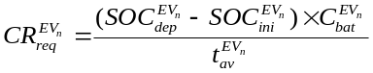 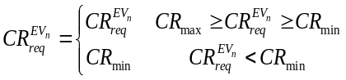… (1)
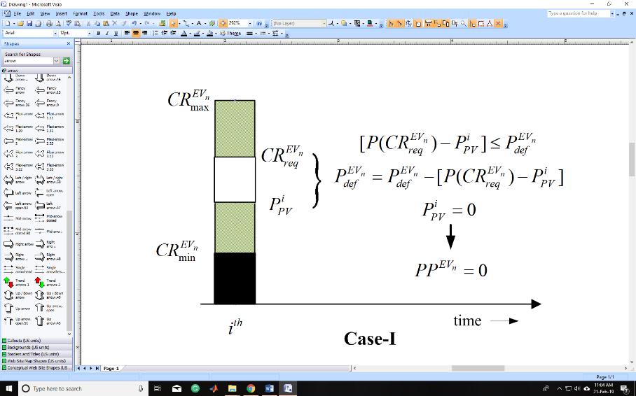
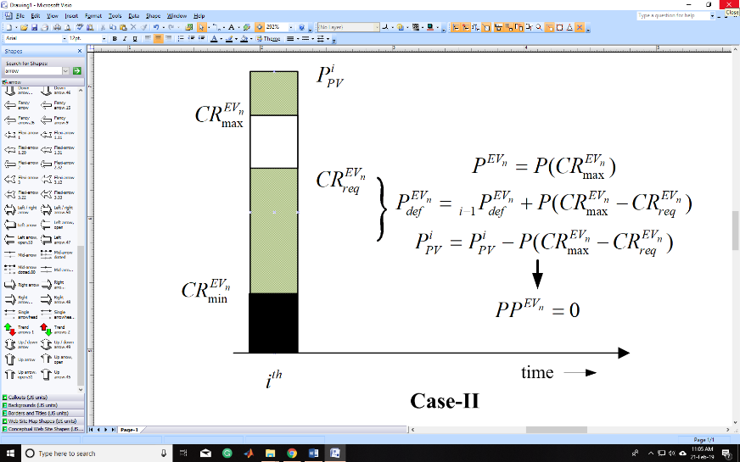
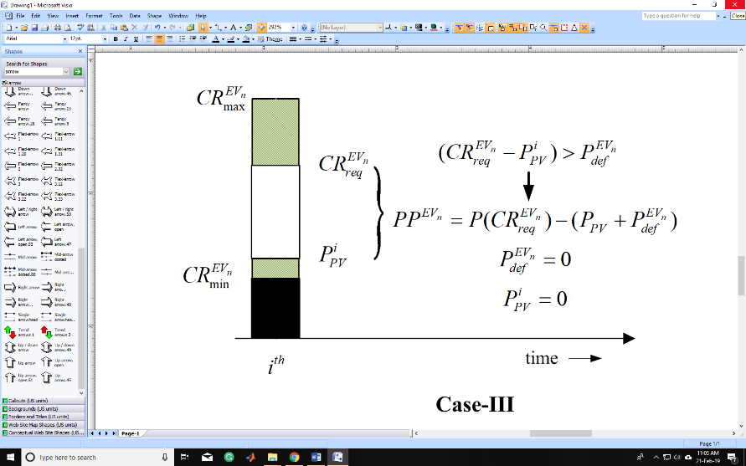
Charging Strategy: As the availability period of each EV arriving at particular hour is varying. To ensure the required charging of the parked vehicle before departure, and avoiding the grid power purchase for the charging. Charging strategy is implemented for each vehicle according to the availability period of the EV. For each hour the vehicle with the minimum availability period is served first. For each hour the charging power for each EV is allocated as shown in flow chart , giving priority to the solar power availability. To maximize the solar power utilization, the deferrable power factor is considered. The deferrable power of each EV with initialized zero value is updated every hour depending upon the solar power availability. When the renewable power is high during day time the solar power available is more than the required charging rate, So the charging rate of EV can be increased depending upon the excess power availability of renewable. The power corresponding to this increased charging rate can be deferred when the renewable power is not sufficient for the EV charging to minimize the grid power purchase. The three cases of the solar Power availability and the deferrable power are shown in figure 1 and the corresponding power discharge strategy for the EV charging is formulated. The charging strategy is follows by each vehicle available at time ith hour following their availability period. After charging of each vehicle the P_{pv}^{i} gets updated for the next vehicle charging. Similarly the P_{def}^{EVn} get updated for next hour utilization.
Figure 1: Power Dispatch strategy for EV charging at i^{th} hour for three possible cases

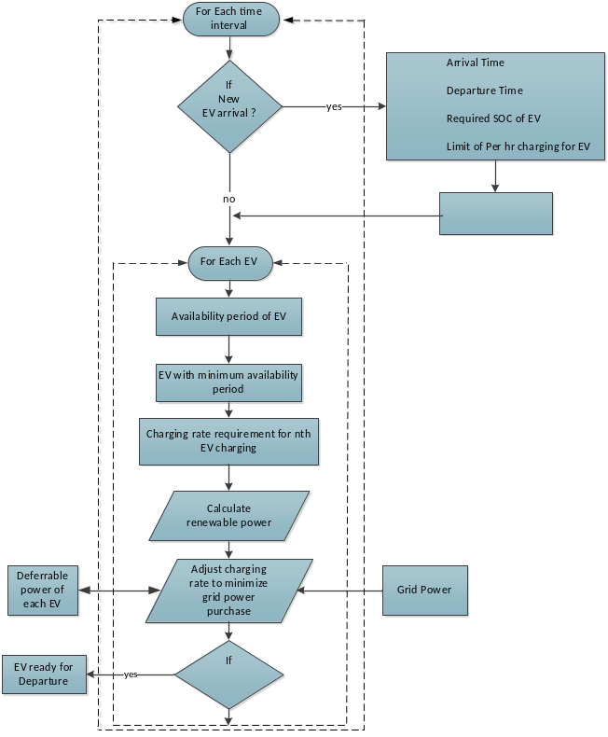
Results and Discussion:
Conclusion: The multi charging scheme with the solar power is proposed for the parking lots with the combined objective of charging station profit and customer satisfaction. The strategy maximize the charging during the solar availability period depending upon their dynamic arrival and departure time.

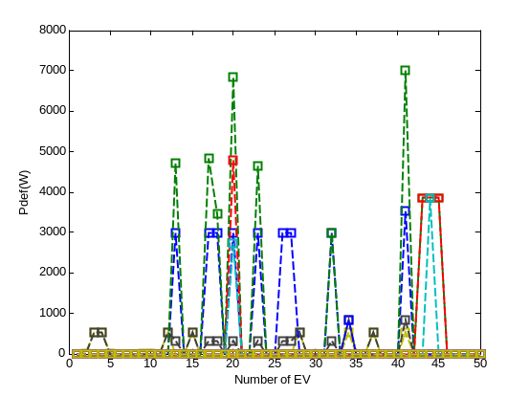
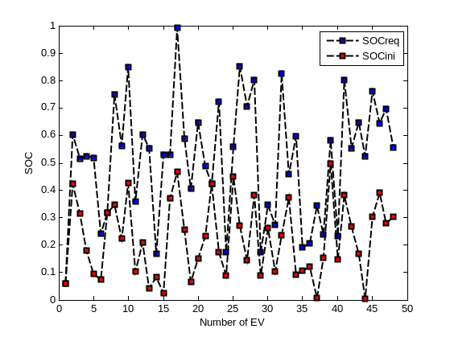
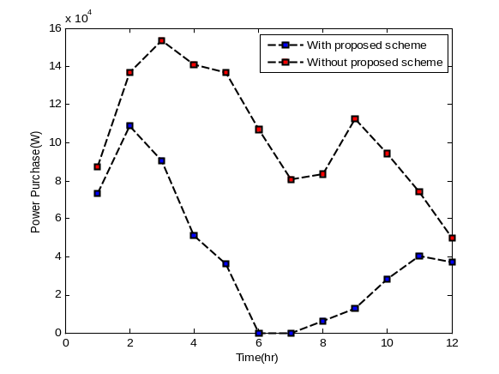
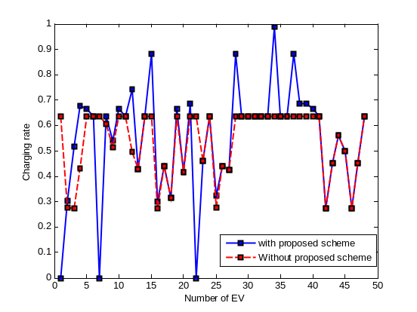

[1] A. Dubey and S. Santoso ,”Electric Vehicle Charging on Residential Distribution System: Impacts and Mitigations”, IEEE Access, vol. 3, 2015.

[2] J.C. Gomez and M.M. Morcos ,”Impact of EV battery charger on the power quality of distribution system,” IEEE Trans. Power Del., vol. 18, no. 3, pp. 975-981, Jul. 2003.

[3] O. Warweg, F. Schaller, S. Ritter and P. Bretschneider ,”Technical and regulatory challenges for the integration of electric vehicle into energy system,” in Proc. 2nd IEEE PES Int. Conf. Exhibit. Innov. Smart Grid Technol. (ISGT Europe), Dec. 2011.

[4] S. Shao, M. Pipattanasomporn and S. Rahman ,”Challenges of PHEV penetration to the residential distribution network,” in Proc. IEEE Power Energy Soc. General Meeting, Jul. 2009.

[5] G.R.C. Mouli, J. Kaptein, P. Bauer and M. Zeman ,” Implementation of dynamic charging and V2G using CHAdeMO and CCS/Combo DC charging standard ,”in Proc. IEEE Transport Electrific. Conf. Expo., Jun 2016.

[6] C. Jin, J. Tang and P. Ghosh ,” Optimizing electric vehicle charging: A customer’s perspective,” IEEE Trans Veh. Technol., vol. 62, no. 7Sep. 2013.

[7] M. Georgiev, R. Stanev and A. Krusteva ,” Flexible load control in electric power systems with distributed energy resources and electric vehicle charging ,” 2016 IEEE International Power Electronics and Motion Control Conference (PEMC), 2016.

[8] L. Gan, U. Topcu and S. H. Low,”Stochastic distributed protocol for electric vehicle charging with discrete charging rate “, in Proc. IEEE Power Energy Soc. General Meeting, July 2012.

[9] P. Liu, J. Yu, S. Fan, K. Bi and Q. An ,”PEV Charging Coordination Using Adaptive Time-of-use Tariff to Reduce Wind Energy Curtailment,” IEEE Transportation Electrification Conference and Expo., Asia-Pacific (ITEC Asia-Pacific) 2018.

[10] T. Wu, Q. Yang, Z. Bao and W. Yan ,”Coordinated Energy dispatch in microgrid with wind power generation and plug-in electric vehicles ,” IEEE Trans. Smart Grid, vol. 4, no. 3, Sep 2013.

[11] C. Liu, K.T. Chau, D. Wu and S. Gao,” Opportunities and Challenges of Vehicle-to-Home, Vehicle-to-Vehicle, and Vehicle-to-Grid Technologies”, Proceedings of IEEE, vol. 101, No. 11, November 2013.
[12] H. N.D. Melo, J.P.F. Trovao, P.G. Pereirinha, H.M. Jorge and C.H. Antunes,” Controllable Bidirectional Battery Charger for Electric Vehicles with Vehicle-to-Grid Capability”, IEEE Trans. Veh. Technol., vol. 67, no. 1, January 2018.

[13] D.T.Hoang, P. Wang, D. Niyato and E. Hossain ,”Charging and Discharging of Plug-in Electric Vehicles in Vehicle-to-Grid Systems: A Cyber Insurance-Based Model”, IEEE Access, Vol. 5, 2017

[14] M. Yilmaz and P.T. Krein ,”Review of the Impact of Vehicle-to-Grid Technologies on Distribution Systems and Utility Interfaces” IEEE Transaction on Power Electronics, Vol. 28, No. 12, December 2013.

[15] C. Jie, Z. Yueyu and S. Wencong ,”An Anonymous Authentication Scheme for plug-in Electric Vehicle Joining to Charging/Discharging Station in Vehicle-to-Grid (V2G) Network”, Smart Grid Communications, March 2015.

[16] H. Zhang, Z. Hu, Z. Xu and Y. Song,” Evaluation of Achievable Vehicle-to-Grid Capacity Using Aggregate PEV Model”, IEEE Transaction on Power Systems, Vol. 32, No. 1, January 2017.

[17] A.S. Masoum, S. Deilami, P.S. Moses, M.A.S. Mausoum and A. Abusiada ,”Smart Load management of plug-in electric vehicle in distribution and residential network with charging stations for peak shaving and loss minimization considering voltage regulation”, IET Gener. Transmiss. Distrib., vol. 5,no. 8, Aug 2011.

[18] Z. Wang and S. Wang ,”Grid Power Peak shaving and valley filling using vehicle-to-grid systems”, IEEE Trans. Power Del., vo. 28,no. 3, July 2013.

[19] M.C. Kisacikoglu, M.Kesler and L.M. Tolbert ,”Single-phase on-board bidirectional PEV charger for V2G reactive power operation”, IEEE Trans. Smart Grid, vol. 6, no. 2, March 2015.

[20] M.J.E. Alam, K.M. Muttaqi and D. Sutanto ,”Effective Utilization of Available PEV Battery Capacity for Mitigation of Solar PV Impact and Grid Support with Integrated V2G Functionality”, IEEE Trans. Smart Grid, vol. 7, no. 3, May 2016.

[21] Comparing the Benefits and Impacts of Hybrid Electric Vehicle Options, EPRI, Palo Alto, CA, 2001. 1000349.

[22] R. Sioshansi, P. Denholm, Emissions impacts and benefits of plug-in hybrid electric vehicles and vehicle-to-grid services? Environmental Science & Technology (2009) 43.

[23] EPRI, Environmental Assessment of Plug-In Hybrid Electric Vehicles, vol. 1, Nationwide Greenhouse Gas Emissions; 1015325; EPRI: Palo Alto, CA, 2007.

[24] T. Bradley, A. Frank, Design, demonstrations and sustainability impact assessments for plug-in hybrid electric vehicles, Renewable & Sustainable Energy Reviews 13 (2009) 115–128.

[25] P. Nunes, R. Figueiredo, and M. C. Brito, ‘‘The use of parking lots to solar-charge electric vehicles,’’ Renew. Sustain. Energy Rev., vol. 66, pp. 679–693, Dec. 2016.

[26] R. Deng, Z. Yang, M. Chow, and J. Chen, ‘‘A survey on demand response in smart grids: Mathematical models and approaches,’’ IEEE Trans. Ind. Informat., vol. 11, no. 3, pp. 570–582, Jun. 2015.

[27] A. Mohamed, V. Salehi, T. Ma, and O. Mohammed, ‘‘Real-time energy management algorithm for plug-in hybrid electric vehicle charging parks involving sustainable energy,’’ IEEE Trans. Sustain. Energy, vol. 5, no. 2, pp. 577–586, Apr. 2014.

[28] W. Tushar, C. Yuen, S. Huang, D. B. Smith, and H. V. Poor, ‘‘Cost minimization of charging stations with photovoltaics: An approach with EV classification,’’ IEEE Trans. Intell. Transp. Syst., vol. 17, no. 1, pp. 156–169, Jan. 2016.

[29] H. Liang, B. J. Choi, W. Zhuang, and X. Shen, ‘‘Optimizing the energy delivery via V2G systems based on stochastic inventory theory,’’ IEEE Trans. Smart Grid, vol. 4, no. 4, pp. 2230–2243, Dec. 2013.

[30] C. Jin, X. Sheng, and P. Ghosh, ‘‘Optimized electric vehicle charging with intermittent renewable energy sources,’’ IEEE J. Sel. Topics Signal Process., vol. 8, no. 6, pp. 1063–1072, Dec. 2014.

[31] T. Zhang, W. Chen, Z. Han, and Z. Cao, ‘‘Charging scheduling of electric vehicles with local renewable energy under uncertain electric vehicle arrival and grid power price,’’ IEEE Trans. Veh. Technol., vol. 63, no. 6, pp. 2600–2612, Jul. 2014.

[32] W. Lee, L. Xiang, R. Schober, and V. W. S. Wong, ‘‘Electric vehicle charging stations with renewable power generators: A game theoretical analysis,’’ IEEE Trans. Smart Grid, vol. 6, no. 2, pp. 608–617, Mar. 2

