[[Bioenergy as an alternative energy source and Biotechnology
Gemechu Yadeta, Chemical engineer, EEFRI, Ethiopia

Statement of the problem: Demand for energy and its resources, is increasing continuously due to the rapid outgrowth of population and urbanization. The world energy consumption would increase by 35% over the next 20 years in order to meet the growing demand of industrialized countries and the rapid development of emerging economies. Energy comes in a variety of renewable forms; wood, biomass, wind, sunlight. It also comes in the non-renewable form of fossil fuels- oil and coal and their use is a major source of pollution of land, sea and above all the air we breathe. Two centuries of unprecedented s industrialization, driven mainly by fossil fuels, have changed the face of this planet. The consumption of fossil fuels is the main source of environmental pollution through the emission of greenhouse gases such as carbon dioxide, methane, and nitrous oxide that cause global warming. The gradual rising of global warming and air pollution is also exacerbating the power deficiency throughout the world. Bioenergy is the clean and sustainable energy generated from biomass conversion through biological processes using various biotechnologies. Biomass resources include any organic matter available on a renewable basis, including dedicated energy crops and trees, agricultural food and feed crops, agricultural crop wastes and residues, wood wastes and residues, aquatic plants, animal wastes, municipal wastes, and other waste materials.
Image: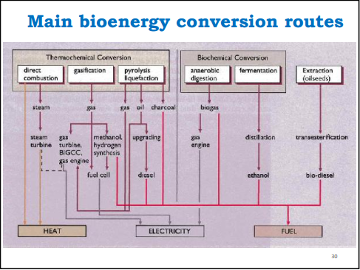
Fig 1: Bioenergy conversion routes

Recent publications
- Strezov, V.; Moghtaderi, B.; Lucas, J.A. Computational calorimetric investigation of the reactions during thermal conversion of wood biomass. Biomass & Bioenergy 2004, 27, 459-465.
- IEA Bioenergy, 2007, Global Wood Pellets Markets and Industry: Policy Drivers, Market Status and Raw Material Potential, IEA Bioenergy Task 40
- J. S. Tumuluru, C. T. Wright, K. L. Kenney, and J. R. Hess, “A technical review on biomass processing: densification, preprocessing, modeling and optimization,” Paper #1009401, ASABE, St. Joseph, Mich, USA, 2010.
- Muche A, Sahu O, Biofuels from Biomass in Rural Area, J. Biotechnol. Bioinformatics Bioeng. 1, 2014, 9-13.
- Hung, C. & Solli, C., 2012. Biogas from Municiapal Organic Waste–Trondheim’s
Environmental Holy Grail? Energy Procedia, 20, pp.11–19.

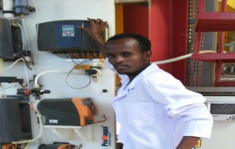
Gemechu Yadeta has his expertise in research and product development areas. He has practised his intern in different process industries for instance Sugar idustries, brewery industries and other manufacturing plants found in Ethiopia. He has an experience in ministry of industry benig evaluation and monitoring team where he has contributed his best knowledge he earned from Addis Ababa University institute of technology. Now days, he is a biochemical and Bioenergy researcher at Ethiopian Environment and Forest Research Institute ( EEFRI). Gemechu has experienced in research proposal development and data processing. Currently he is leading the bioenergy mega project titled ” Production of different biofuels from selected lignocellulosic biomass and performing life cycle assessment”. Besides to this he is a participant in Global bioenergy project(GBEP).

Email: gemechyade@gmail.com

