Energy Performance Analysis of the Design Built, in the Future due to Climate Change.
Aishwarya Koparde, LEED Green Associate, MS in Built Environment, USA

Abstract
This research is about how current buildings should be designed keeping the future prospect and studied results of the climate change in mind and why renewable sources of energy and water are important, and strategies to apply in the built environment. It reviews available climate change models for use, in forecasting a likely range of change in dry-bulb temperatures due to expected change in climate overall.
I will present the methodology used to study and calibrate the impacts of future climate variability on energy consumptions and peak demand electricity for a two-storied office building at Albuquerque, New Mexico which is compliant with ASHRAE 90.1.2013. I then coupled a representative set of energy models; for each climate type; each with low and high impact climate change scenarios. I was able to identify the most impacted ASHRAE climate zone after 40 years, through simulation. My analysis of the Albuquerque office building indicates an impact of 1% and for San Francisco with the most impact of about 30% increase for electricity consumption. I was able to identify few mitigation strategies for these geographical climate types with the most climate resilience. I demonstrated that this method could be replicated with other building types and geography with few case studies. Engineers, designers, building energy analysts and owners will find this research useful in informing climate mitigation and resiliency through building design. This process of analyzing the impact of the future weather conditions on existing designed buildings will help utilities understand the measures that allow greater flexibility in future extreme degree days.
I conclude with the high performance, renewable and sustainable design strategies for net positive energy; and building materials designed with least embodied carbon content and emissions. Showcasing a living building certified by International Living Future Institute, office building ‘Architectural Nexus’ at Sacramento, CA, USA.

Image
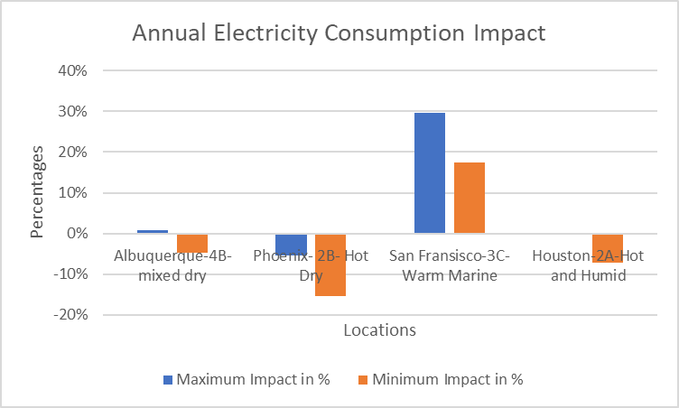
Figure 1Annual Electricity Consumption Impact in various climate zones due to climate change.
Recent Publications
- Publications in American Society of Heating, Refrigerating and Air Conditioning Engineers (ASHRAE) magazine on ‘Effects of climate change on the Built Environment and applied sustainable strategies.’
- Applied Project, (May 2018) at Arizona State University, MS in Built Environment.


Biography (150 word limit)
Aishwarya Koparde is an architect with Master’s of Science in Built Environment graduated from Arizona State University, currently is an energy analyst at Architectural Nexus, USA. She has proven interest in sustainability practices and has acquired LEED green associate title from the US Green Building Council. Designing high performance sustainable buildings, analyzing the energy consumption and generation of renewable energy; and applying building design strategies is the fundamental work in her professional job. She plays a great role in furthering the firms American Institute of Architect’s 2030 Commitment goals by strategizing the construction projects with the lowest possible energy use intensity, guiding principles of sustainability practices along with licensed architect and engineers.
Email: akoparde@archnexus.com

Notes/Comments:

