

Abstract

Title: Methanol enrichment - a prerequisite for biodiesel production in a foam column

Salihu D Musa, ^{1*} Jonathan G M Lee, ¹ Gary Caldwell, ²

¹ School of Engineering, Newcastle University, Newcastle upon Tyne, UK
² School of Natural and Environmental Sciences, Newcastle University, Newcastle upon Tyne, UK

- Abstract
As a prerequisite for biodiesel production from algae in a flotation column, foam stability as well as methanol enrichment must be guaranteed. In this chapter, the development and optimisation of methanol enrichment in a foam flotation column was successfully achieved using a methanol distributor as a means of supplying methanol at the top part of the column. This countercurrent methanol delivery system was more efficient than co-current methanol flow, which guarantees more efficient and economic methanol usage. However, the co-current methanol process allowed for longer contact time between methanol and algae. Stable foam was possible as long as the percentage of methanol in the mix was not more than 50%. Seawater was better suited for the process of enriching methanol than freshwater but within the operating conditions of this study, both media were able to produce the required level of enrichment appropriate for transesterification.

Keywords: Continuous foam flotation, methanol distributors, riser, Design of experiments

Description
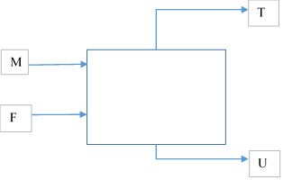Figure 1: Process flow diagram for methanol concentration using foam column; ^{M}Methanol, ^{U}Underflow, ^{F}Feed, and ^{T}Top

Biography
Salihu D Musa is a final year PhD student at the School of Engineering in the Newcastle University, Newcastle upon Tyne, United Kingdom. His research is focused on process intensification of biodiesel production from microalgae, using foam flotation column.
Salihu had completed his bachelor’s degree in Chemical Engineering and also has a Masters of Engineering in Environmental Engineering from the Federal University of Technology, Minnna Nigeria and the China University of Geosciences, Wuhan, Respectively. He is currently a lecturer at the Materials Science and Engineering Department of the Kwara State University, Malete, Kwara State, Nigeria.



