

Quantitative Risk Assessment of Natural Gas Distribution Pipeline Networks in Urban Areas

Makonelah, F. V1, Kimambo, C. Z. M. 1, Kihedu, J. H1,

1Department of Mechanical and Industrial Engineering, College of Engineering and Technology, University of Dar es Salaam, Tanzania

- Abstract
Natural gas is considered as clean and efficient fossil energy and its consumption is increasing worldwide. Pipelines are widely used as the most economical means of transporting and distributing natural gas over short distances. The distribution pipelines are usually pressurized, and they may become disastrous when gas is accidentally released to the atmosphere. Also, natural gas is volatile and highly flammable, unintentional gas release in urban areas can lead to severe consequences and losses in society. Therefore, it is important to assess the risk of natural gas pipeline in urban areas. In this paper analysis of risks in different parts of the Dar es salaam Natural gas distribution network is conducted. Newton's nodal method was used to analyze the network and an integrated quantitative risk analysis method used to estimate incident losses. The results obtained are useful in understanding the risks, decisions making and taking measures towards ensuring the safety of Dar es salaam natural gas distribution pipeline.

Image:
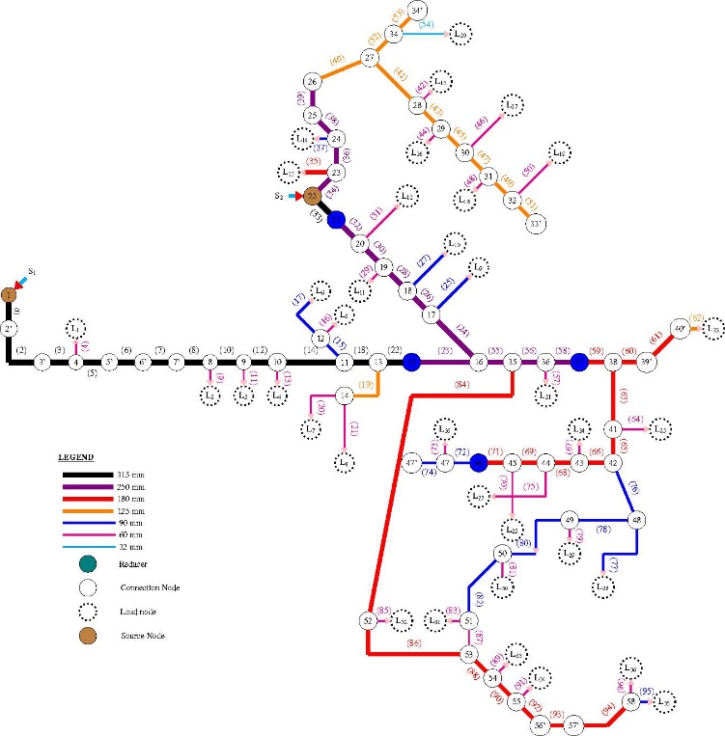

Biography
Fulgence V. Makonelah is a PhD candidate at University of Dar es salaam conducting research on Natural gas pipeline and transients’ effects mitigation in Natural gas distribution networks. He holds Masters of Energy engineering and BSc in Production Engineering from University of Dar es salaam. He is working as Assistant lecturer at the department of mechanical and Industrial Engineering, University of Dar es Salaam, Tanzania.

Presenting author details

Full Name: Fulgence V. Makonelah
Contact number: 255756264103
Twitter account: -
Linked In account: -
Session name/ number: Petroleum Engineering and Natural Gas Recovery
Category: (Oral presentation/ Poster presentation) Passport Number: AB532117



