

Abstract

Title: Performance Improvement of Small Wind Turbine under Low Speed Conditions

Joel Mbwiga1, Cuthbert Z. Kimambo 2, Joseph Kihedu 2

1Department of Mechanical and Industrial Engineering, Mbeya University of Science and Technology, Mbeya, Tanzania
2Department of Mechanical and Industrial Engineering, University of Dar es Salaam, Dar es Salaam, Tanzania

- Abstract Body (up to 250words)
Being simple and cost-effective, small wind turbines are mainly used as energy option for decentralized rural electrification in developing countries. Since installation site of small wind turbine is normally decided based on the areas where electrification is needed rather than where there is best wind resource, low wind speed sites can not be avoided. However, under low wind speed conditions, energy output has been found to be lower than one which can be predicted. Many researchers have attempted to identify the reasons for such low performance and suggest requisite improvement. Poor starting behavior has been found to be one of the major drawbacks of which there had been many attempts to improve it. Never the less, still commercial small wind turbines depict low performance in low speed wind regimes. In this paper, the rotor parameters responsible for enhancing turbine starting were analyzed and the results used in innovative processes to come up with the rotor having high starting torque and high maximum power performance. Unlike conventional rotor of the horizontal axis wind turbine, the rotor comprises of extra shorter blades mounted on same hub circumference. Blade Element Momentum theory was used to predict the power performance of the novelty rotor.

Image:
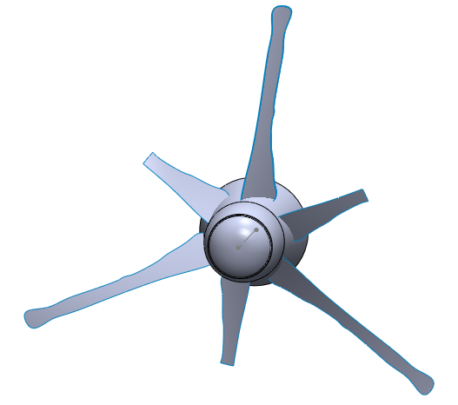

Biography (Up to 100 words)
Joel Mbwiga is the assistant lecturer in the department of Mechanical and Industrial Engineering at Mbeya University of Science and Technology. He is currently pursuing PhD in Renewable Energy at the University of Dar es Salaam. He is doing a research in wind energy specifically optimizing power performance of small wind turbines in low speed wind regimes. He has patented a novelty rotor for low speed conditions.

Presenting authordetails

Full Name: Joel Mbwiga
Contact number: + 255 754 940 358, jmbwiga@gmail.com
Session name/ number: Any
Category: Oral presentation
Passport Number:



