

Abstract

Title: Flow Development Length and Inlet Effect in Vertical Two-phase Flow

Adela Syikilili1,2, Cuthbert Kimambo1, Joseph Kihedu1, Ole Nydal2,

1Department of Mechanical Engineering, College of Engineering Technology, University of Dar es Salaam
2Department of Energy and Process Engineering, Norwegian University of Science and Technology

- Abstract Body

The aim of this work was to analyze inlet effect and patterns development length of the vertical gas-liquid flow experimentally. The study was conducted in multiphase rig with a test section of 18m long pipeline and 60 mm internal diameter. Two types of inlets were considered. Four conductivity probe rings were installed at four different positions along the test section. Water flow rate was kept at 0.07 m/s by adjusting pump frequencies and water inlet valve. Air was varied from 4 m/s to 22 m/s at atmospheric pressure and temperature so that to attain different types of flow pattern. Recognition of flow patterns was done by considering four methods; observation with aid of high-speed camera, time series of conductance signals, signals probability density functions and distribution moments about mean. Conductance signals were collected for about two minutes for each test after attaining steady state flow. The results show that with steady state flow, patterns transition can occur within a test section while the inlet effect is very small for slug propagation within a test section.

Image:
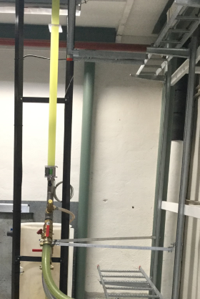
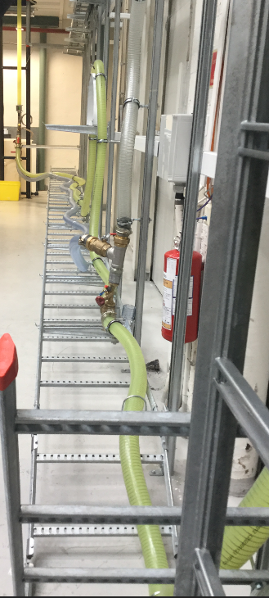

Biography
Adela Syikilili is a PhD candidate under a sandwich program between University of Dar es Salaam, Tanzania and Norwegian University of Science and Technology (NTNU). She has a bachelor’s degree in Chemical and Process Engineering, a Master of Science in Petroleum Engineering and now she is doing her PhD in Multiphase flow issues. Apart from being a PhD candidate Adela is an Employee at the University of Dar es Salaam as an assistant lecturer where she acquired a study leave.

Presenting author details

Full Name: Adela Musa Syikilili
Contact number: +255 716 788140
Session name/ number: Petroleum Engineering and Natural Gas Recovery
Category: Oral presentation
Passport Number: TAE018782



