

Abstract Template

Title: Performance of chemisorption refrigeration system

MICHAEL JOHN¹, CUTHBERT Z. M. KIMAMBO¹, OLE J. NYDAL² AND JOSEPH KIHEDU¹,

1Department of Mechanical and Industrial Engineering, University of Dar es Salaam, Tanzania
2Department of Energy and Process Engineering, Norwegian University of Science and Technology, Trondheim, Norway

- Abstract Body (up to 250 words)
An experimental study of the adsorption performances of ammonia on calcium chloride was described. A single bed water cooled condenser adsorption refrigerator prototype, which utilises Calcium chloride-ammonia pair has been developed and tested in the laboratory. Experiments have been conducted for desorption temperatures of 100 °C with desorption time varying from 1hour to 4 hours using an electric tape heater and timer. The adsorption temperature profile, adsorption rate and the prototype performance have been analysed and discussed. For the tested heating desorption temperature of 100 °C and heating desorption time of 1 hour to 4 hours, the cold chamber of the prototype obtained temperature between -0.8 °C to 8.3 °C which is in line with the vaccine requirement of 2 °C to 8 °C. The estimated system COP ranges from 0.025 to 0. 076.

Image: Chemisorption refrigeration system
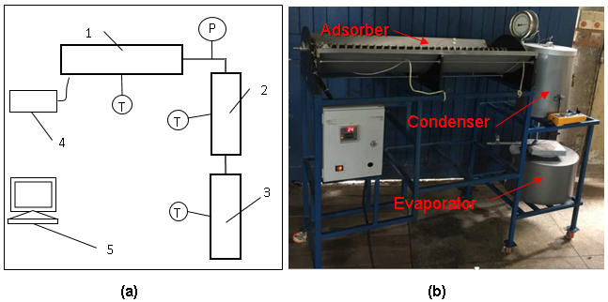

Biography (Up to 100 words)
MICHAEL JOHN is PhD student at the age of 38 years at the University of Dar es Salaam, Tanzania. He is the Assistant Lecturer at the Department of Mechanical and Industrial Engineering. He has published 1 book chapter and international conferences papers.

Presenting author details



Full Name: Michael John Mvungi
Contact number: +255713777607
Twitter account: markmycle
Linked In account: markmycle@yahoo.com
Session name/ number: Advancing Materials for Energy Storage, Generation and Transmission
Category: (Oral presentation/ Poster presentation) Passport Number: AB907440



