The study of the influence of load’s chemical composition in the coking process on the efficiency and the quality of coke
Dr. H. MIMOUN^{*,a}, F. HENNAOUI^{b}, M. KERBOUA^{c},
ª Maitre de conferences, Boumerdes, Algerie ; ^{b} Magister, Boumerdes, Algerie ;
^{c} Ingénieur, Boumerdes, Algerie.
Laboratoire de recherche Technologie des hydrocarbures ; Faculté des hydrocarbures et de la chimie ; Université de Boumerdès
Mimounhadj@yahoo.fr
Abstract:

This research was performed in order to allow the study of the chemical composition influence of the coking process load on the efficiency and the quality of coke. For this reason, the coking of the following loads was realized: Atmospheric residue (RAT), vacuum Residue (RSV) and catalytic Residue of cracking (RCC). (The residues are obtained from an Algerian crude oil).As the oil residues are rich for their strongly polar composition, such as the asphaltene resins, and complex structures units (SCU), which has a role in the formation of coke, and as the dispersion of these latter improves the quality of coke, a study on the stability of aggregation was carried out by the addition of one stabilizer (oil Extract) in the coking process load. The Compounding (Extracted from /RCC oil) has been drived to the best efficiency of coke. The study consists of the influence…., this is characterized by the analyses Infra-red (IR) and x-ray diffraction (XRD).
Keywords: Coking; oil residue; dispersant; aggregation stability

Introduction
The coking of the oil residues consists of the decomposition of this latter by the delayed coking process, or by fluidized bed coking [1].
The units of coking, are generally biased by heavy residues, such as: vacuum residue, catalytic residue of cracking, residue of viscoreduction and asphalt or extracted from lubricating oils [2,3]. Coking develops these oil residues, it produces:
-Gas: they consist of a fuel gases used as fuel in the unit of coking, or sent after washing towards fuel gases of the refinery.
-Naphtas: light naphtha, after a hydro-processing is sent to the pool gasoline, heavy naphtha constitutes a catalytic load of reforming.
-Distillates: the light distillate, after a hydro-processing is sent to the pool gas oil of the refinery, and heavy distillate is used like charges with FCC, in mixture with the products of distillation [4].
-Coke: several types of coke can be produced: Coke sponges (Sponge coke), needle coke (Needle coke), Coke with balls (Shot coke) and combustible Coke [5].
The use of coke is directed according to the quality of this latter. The four aspects which affect the quality and the price of coke are:
Sulphur content, content of metals, hardness and the physical structure [4].
The coke of best quality is used for the manufacture of the anodes, the production out of aluminum or of the electrodes for the production out of steel, is the needle coke, which must be calcinated before its use [2].
The parameters influencing the quality and the efficiency of coke are: the nature of the load and operating conditions of the coking process [6].
The main objective of this research consists of the realization of a coking (thermal decomposition) of the oil residues for:
- To produce a coke of a precise quality.
- To optimize the load which gives the best efficiency, by coking of various compounding (oil Extract /Residue)?
- Valorization of its residues by recovery of a distillate and gasoline of characteristics defines.
Experimental part:
A coking of the following loads has been realized: RAT of Hassi Messaoud’s refinery, RSV of Arzew’s refinery of, RCC of Adrar’s refinery. (Analysis SARA of the residues is represented in table I). The coking process is carried out at a temperature of 500 °C and the calcination of coke at 550°C according to fig 1.
The products of the coking process are: Gas, Distillate and coke. We will recover the gasoline from distillates of the coking process by atmospheric distillation.

- Discussion :
The following order shows a decreasing tendency of the coke formation during the thermal processing: Asphaltenes > resins > aromatic compounds > olefin > naphtenes > light paraffin.
According to the activation of formation energy of coke [7,8].
The residue of catalytic cracking gives the best coke efficiency of 36%. SARA Analysis showed a low content of resin in the different loads of coking (Table 1), Therefore the principal factor which influences the coke formation is the content of aromatic. Such as the RCC which is composed of 74,689% of aromatics. To orient the deposit of the SCU and to avoid their deposit blocks during the formation of coke, it was performed a compounding of RCC/ oil extract, the coke efficiency is represented in fig
The aggregation stability study:
The principle of this method is to determine the stability of asphaltenes and the complex unit structures (SCU) in the catalytic cracking residue by the addition of a dispersing agent by measuring the absorptance in UV/Visible according to the report/ratio (residue/dispersant).
In test tubes we will vary the volume of the RCC according to the volume of the oil extract, we all respect the fact that the total volume is of 1 ml. The following percentages are used:
(100% / 0%), (90% / 10%), (80% /20%), (70% / 30%), (60% / 40%), (50% /50%) et(0% /100%) (Catalytic residue of cracking, oil extract) (% mass).
- We add in each tube 1ml toluene and N-heptane 4ml .we all install in a centrifugal machine, at a predefined angular speed of 4000 tr/min during 10 min;
- We will determine the optical density (absorptance) of the upper part and the lower part by the spectrophotometer’s analysis, in the UV-Visible spectrophotometer [9];
- We will determine F;

F = A_{sup} / A_{inf}
Where:
A_{sup} : absorptance (optical density) of the higher phase.
A_{inf} : absorptance (optical density) of the lower phase.
Results:
The increase of the stability factor (F), can be explained by the stability of the asphaltenes in the samples by the addition of the extract;
- the reduction of the stability factor (F), depends on the quantity of the extract added, such as the addition of a dispersant in the residue, acts on the stabilization of asphaltenes in three ways: (all depends on the added quantity);
- adsorption on the surface of the resins which envelop the particles of asphaltenes and the formation of an asphaltene envelope, from where, the increase of stability factor; the dissolution of the adsorbed resins on the surface of asphaltenes, therefore the latter tend towards association, from where reduction in the factor of stability.
Analyses of produced coke
- The density of the obtained cokes of compounding (oil RCC/Extract) is: 2, 05.
- A magnifying glass interconnected to software will provide images of coke, to know the physical aspect of this latter; the form, the color and porosity.
IR Analysis:
The infra-red analysis (IR) on coke, showed the presence of the connections: CH, C=N, C=C, C=O and the presence of aromatic cycles and alkanes.
The structure is practically amorphous; however, there is a beginning of the structure arrangement `crystalline', which results in a pretence of very large peaks with approximately 3,45 Å and 2,065 Å. We note the presence of a compound of crystalline structure to 1, 81921 [A°].
Conclusion :
We have been realized a coking process of following compounding: (Oil RAT/Extract), (oil RSV/Extract) and (oil RCC/Extract).
The initial objective points out the use of a dispersant (Extracted from oil) at in order to direct the deposit of the aggregates formed from the asphaltenes and complex Structures units (SCU) characterized by the stability of aggregation, which is the objective end-up by a coke of a crystalline structure.
The study of the various loads of coking is to be added to the following mass efficiency: More than 36% from 100% RCC, between 25% and 26% starting from the following loads:
95% RCC + 5% Extract of oil, 90% RCC + 10% Extract of oil, 50% RCC + 50%RSV and 40% RCC + 40% RSV + 20% Extract of oil.
The coke efficiency depends on the content of the load of heavy aromatic compounds, such as SARA analysis of the oil residues which has been demonstrated .
The best efficiency of gasoline that can be recovered is 20,69%, it was obtained starting from the distillate of the coking process of the load (40% BRA+ 60% oil Extract ). The CPG of the gasoline revealed a content olefin higher than 9%, and more than 30% of aromatics. The x-rays diffraction showed an amorphous structure, however, with a beginning of their crystalline structures arrangement. The DRX of the coke obtained from (95% RCC + 5% Extract of oil), proves the presence of peaks corresponding to components of crystalline structures, 1,81921 [A°].
References :

[1] Surinder Parkash, Refining processes handbook, 2003;
[2] P. Le prince, Le raffinage du pétrole procédés de transformation, Tome 3;
[3] N. P. Lieberman, Troubleshouting Process Operations, 1991,
[4] N. P. Lieberman, Troubleshouting Process Operations, 1991, pp 30-38;
[5] E. Totten. George; R. Steven Westbrook; J. Rajesh. Shah, Fuels and lubricants
Handbook technology properties performance and testing, 2003;
[6] J.F. Le page ; S.G. Chatila ; M. Davidson, Raffinage et conversion des produits lourds
du pétrole, édition Technip, 1990.
[7] V. Simanzhenkov; R. Idem, Crud oil chemistry, CRC Press, 2003, pp 337-344.
[8] T. Nakajima; I. Shikura; T. Asuka; I. Hand Yamakawa, Thermal cracking of Asphaltènes
fractionated from khafjji asphalt, Oil & Gas Science and Technology, Rev IFP, Vol 14, N1,
1981
[9] H. MIMOUN, Etude de la stabilité d’agrégation des résidus pétroliers, Masla et Topliva
Moscou, 1983.

% massique | Saturés | Aromatiques | Résines
RAT | 73,259 | 19,805 | 6,936
RSV | 49,274 | 41,025 | 9,701
RCC | 23,336 | 74,689 | 1,975
Extrait  d’huile | 27,134 | 71,288 | 1,578
Table 1: analysis of SARA’s coking process loads.

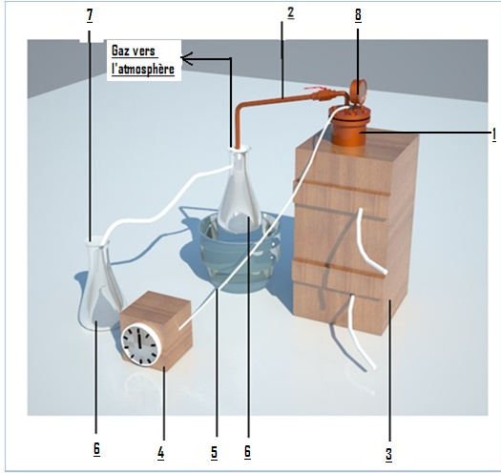
Fig 1: Installation of the coking process.
1. Steel reactor of 76 mm diameter and 150 mm height. 2. gas Control.
3. Electric oven 4. Temperature control.
5. The drill (to detect the reactor temperature).
6. Receipt Flask of the liquid products. 7. Gas toward the atmosphere. 8. Manometer.

Fig 2: coke efficiency Fig 3 : gas and distillate efficiency
Efficiency of gas, distillate and coke for compounding
(RCC/RSV/oil extracts) :

Fig 4: Efficiency of Coke, Distillate and Gas of compounding.
(RCC/RSV/oil Extract).
1 100% RSV
2 50% RCC + 40% RSV + 10 % oil Extract
3 40% RCC + 40% RSV + 20 % oil Extract
4 50% RCC + 50% RSV
5 100% RCC

Fig 5: Efficiency of coke with respect to the load (RCC/ oil Extract)
λ
λ
λ
λ
λ
Fig 6 : F with respect to % (RCC, oil extract) for different wave lengths (λ en nm)

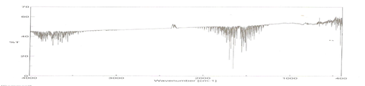
Fig07 : The IR Band of a coke sample obtained from 10% oil Extract + 90% RCC
(% of Transmittance (T) with respect to the number of wave cm-1).
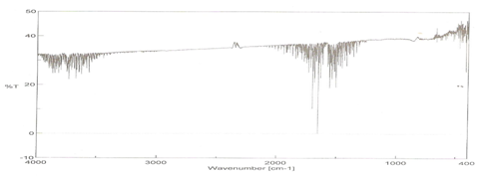
Fig08: The IR Band of a coke sample obtained from 50% from Extract + 50% RCC
(% of Transmittance (T) with respect to the wave number cm⁻¹)

X-rays diffraction:
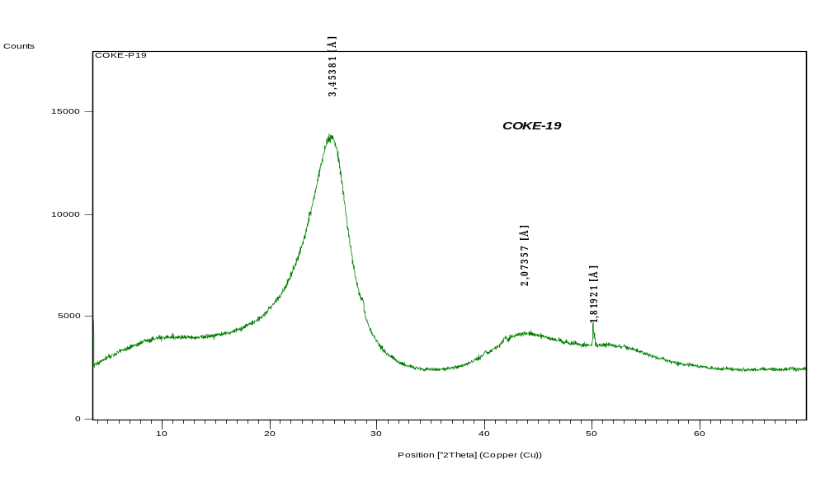
Fig09: DRX Spectrum of a coke obtained from 95% RCC + 5% oil extract
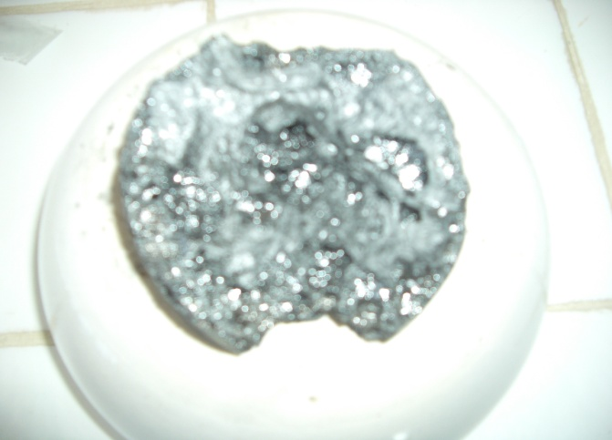
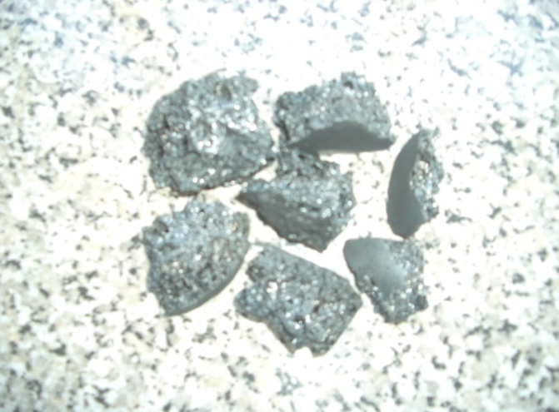
Fig10: Coke obtenu du RCC

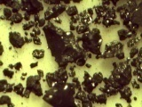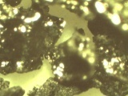Fig11: Photograph of a Coke obtained from: Fig12: Photo d’un échantillon de Coke obtenu du
5% oil extract +95% RCC RSV

