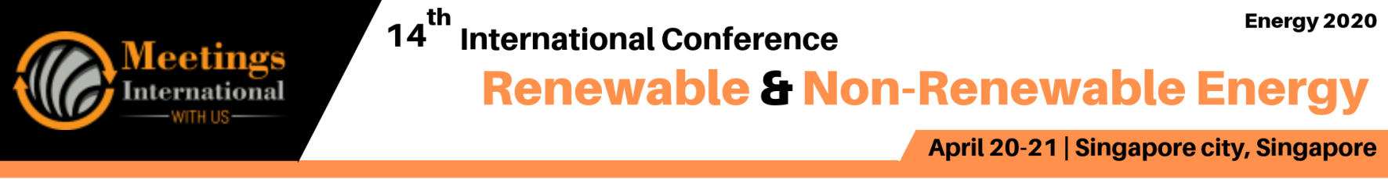

Abstract Template

Title: Solar Photocatalysis for Hydrogen Power and Fuel Cell

Michael K.H. LEUNG 1

1School of Energy and Environment, City University of Hong Kong, Hong Kong, China

- Abstract Body (up to 250 words)
Solar photocatalysis is a promising approach to achieve production of renewable hydrogen fuel for future sustainable energy. Photocatalysis (PC) can also be integrated with fuel cell (FC) to form photocatalytic fuel cell (PFC) that effectively utilizes solar energy for simultaneous wastewater treatment and recovery of energy chemically stored in wastewater. PFC using photoanode and photocathode can utilize solar energy effectively for hydrogen production, carbon reduction, wastewater treatment and recovery of the energy chemically stored in wastewater. Solar PC can decompose organic compounds while the FC component provides an electrical potential bias to drive the transport of the photogenerated electrons. In this talk, the speaker will first discuss the properties and fundamental mechanisms of solar photocatalysis followed by the development of effective visible-light activated nano-photocatalysts. Then, different reactor configurations, designs and control strategies for various applications will be presented. The talk will also cover upcoming R&D challenges for enhancing the solar photocatalysis technologies.

Image:
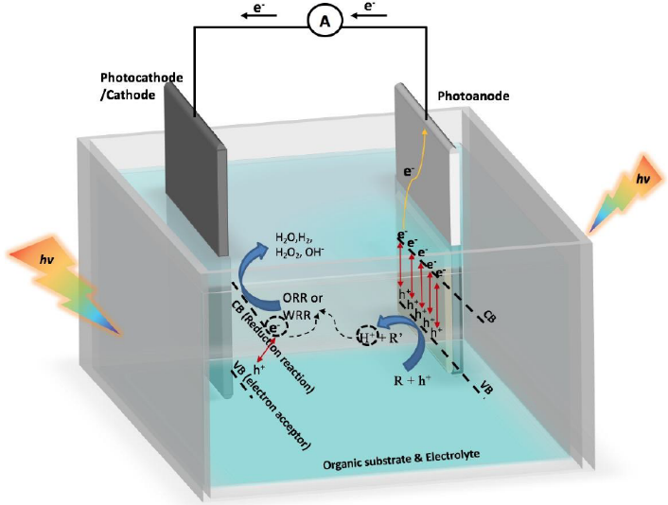

Biography (Up to 100 words)
Prof. Michael LEUNG's research areas include solar photocatalysis, fuel cell and advanced air-conditioning. His research emphasizes the development of modified nanostructured materials to perform various functional photoelectrochemical activities. He has also developed photocatalytic fuel cell reactors by integration of photocatalytic and electrochemical systems to achieve simultaneous waste water treatment and generation of free electricity. His research works are impactful and have received international recognition as he is recently listed as a Highly Cited Researcher by Clarivate Analytics in 2018. He is also listed as a Most Cited Scholar in Energy Science and Engineering by ShanghaiRanking Consultancy in collaboration with Elsevier. Prof. LEUNG has received total HK$40M+ research grants as a PI from NSFC, ITF, RGC, ECF, SDF, industrial sponsorships, university internal grants, donations, etc. He has published 150+ journal papers, 80+ conference papers, 15 books/book chapters, and 7 patents.

Presenting author details

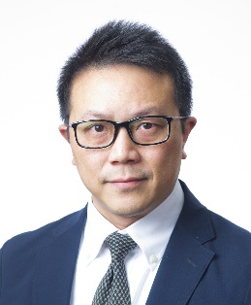
Full Name: Michael K.H. LEUNG
Contact number: +852 3442 4626
Twitter account: Linked In account:
Session name/ number:
Category: (Oral presentation/ Poster presentation)
Passport Number:



