

Title: Lead-free perovskites based nanostructured tandem solar cell

Mohammad Kamal Hossain1,*, Billel Salhi1, Ayman Wajeh Mukhaimer2,

1Center of Research Excellence in Renewable Energy (CoRERE), King Fahd University of Petroleum and Minerals (KFUPM), Dhahran 31261, Dhahran, Kingdom of Saudi Arabia
2School of Engineering, RMIT University, GPO Box 2476, Melbourne VIC 3001, Australia
*kamal.hossain.m@kfupm.edu.sa

- Abstract
Tandem solar cell combining silicon and perovskites is known to be a wonderful match for efficient solar cell design. However, perovskites is suffering for its stability and silicon is supposed to be superior in nanostructure features. Therefore, in this communication, we are proposing an innovative approach to devise silicon based nanostructures fabricated from top-down strategy and combining the same with lead-free perovskite that was synthesized in ambient environment. Preliminary results confirmed successful and reproducible fabrication of silicon nanopyramids (Si-NPys) and nanowires (Si-NWs). Morphology of the same nanostructures was confirmed by scanning electron microscopy. Further finite different time domain (FDTD) analysis in different solar spectrum was carried out to understand absorption depth profile, energy flux distribution, electromagnetic field localization and exciton generation rate distribution happened to be available in such nanostructures and influence in exciton generation in perovskite absorbing materials deposited atop in tandem configuration. Figure as shown below depicts the evidence of Si-NPys of Si-NWs growth using Si wafer as initial materials. It is noteworthy to mention that the dimension of such silicon nanostructures depends on experimental conditions such as temperature, precursor concentration, etching time etc. FDTD simulation suggested confined exciton generation rate distribution in such nanometric structures and thus active absorbing material such as perovskite would get enormous influence thereof. Authors acknowledge CoRERE, RI, KFUPM, Dhahran 31261, Saudi Arabia. MKH acknowledges Deanship of Scientific Research (DSR) at King Fahd University of Petroleum & Minerals (KFUPM) for funding this work through project No. IN151003.

Image:
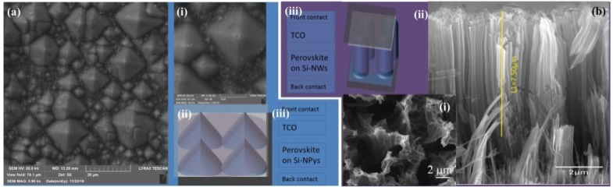
Figure: (a) and (b) Typical SEM image of silicon nanopyramids (Si-NPys) and silicon nanowires (Si-NWs) respectively; inset (i): high resolution SEM micrograph of the same, inset (ii): free-hand schematic of Si-NS/perovskite tandem cell and inset (iii): device configuration

Biography
Dr. Mohammad Kamal Hossain is a recipient of K.A.CARE (King Abdullah City of Atomic and Renewable Energy) Research Fellowship and has been working in Center of Research Excellence in Renewable Energy (CoRERE), King Fahd University of Petroleum and Minerals (KFUPM), Kingdom of Saudi Arabia since 2010. Dr. Hossain completed his D. Engg. at Tsukuba University, Tsukuba, Japan (in collaboration with National Institute for Materials Science, NIMS) in 2007, Masters in Microelectronics (School of Advanced Technology) at Asian Institute of Technology (AIT), Bangkok, Thailand in 2003. The area of specialization includes, but not limited to, optoelectronics and nanoplasmonics using nanoscale materials in multidimensional features suitable for solar cell, sensor, catalyst, hydrogen production, etc. Dr. Hossain possesses 15+ patents and 110+ research articles in the field of nanoplasmonics and nanostructured materials along with a book and several book chapters. Dr. Hossain has been employed and collaborated with many international and highly reputed groups in Japan, New Zealand and Australia. More than 15 projects has accomplished successfully along with MIT (USA), VUW (New Zealand), MI (New Zealand), CI (New Zealand), NIMS (Japan), IMS (Japan), KGU (Japan), NSTIP (KSA), etc. and has been secured more than 10 million USD as research grant. Dr. Hossain has several joint research projects and collaboration ongoing with reputed experts within KSA and beyond.

Presenting author details

Full Name: Mohammad Kamal Hossain
Contact number: +966 572687563
Twitter account:
Linked In account:
Session name/ number: Advanced Materials for Energy Storage, Generation and Transmission/Track 11
Category: Poster presentation
Passport Number: BT0605847



