

Title: Silicon nanowires for solar cell: fabrication and size dependent exciton generation rate distributions at different solar spectral wavelengths

Mohammad Kamal Hossain1,*, Billel Salhi1, Ayman Wajeh Mukhaimer2,

1Center of Research Excellence in Renewable Energy (CoRERE), King Fahd University of Petroleum and Minerals (KFUPM), Dhahran 31261, Dhahran, Kingdom of Saudi Arabia
2School of Engineering, RMIT University, GPO Box 2476, Melbourne VIC 3001, Australia
*kamal.hossain.m@kfupm.edu.sa

- Abstract
Silicon nanowires (Si-NWs) are known to be an excellent photon absorber for next generation of solar cell technology, although the underneath mechanism in view of photon confinement that lead to huge exciton generation rate is not clear enough. Here in this work, we have reported fabrication of vertically aligned Si-NWs using gold catalyzed chemical vapor deposition technique and finite-difference time-domain (FDTD) simulation to understand the inherent spectral characteristics. Based on the experimental observations, a detailed simulation has been carried out to understand the mechanism how Si-NWs interact with solar spectral wavelengths and contribute to exciton generation rated distribution. Further detailed cross-sectional analyses as well as spectral generation rate distributions for different size of the Si-NW have been investigated. At 700 nm wavelength of solar spectrum, 150 nm diameter of Si-NW was found suitable to hold higher exciton generation rate distribution. On the other hand, at 1100 nm wavelength of solar spectrum, 100 nm diameter of Si-NW was found suitable to hold higher exciton generation rate distribution. The choice of the parameter was very specific and reasonable that coincided well with the dimensions of vertically grown Si-NWs fabricated by gold catalyzed chemical vapor deposition technique. High resolution scanning electron microscope revealed the diameter of the as-grown Si-NWs to be in the range of 50 to 200 nm along with coverage of ca. 6.5×10⁸/cm². Such insights not only indispensable to understand the mechanism behind but also open up new possibilities in various applications.

Image:
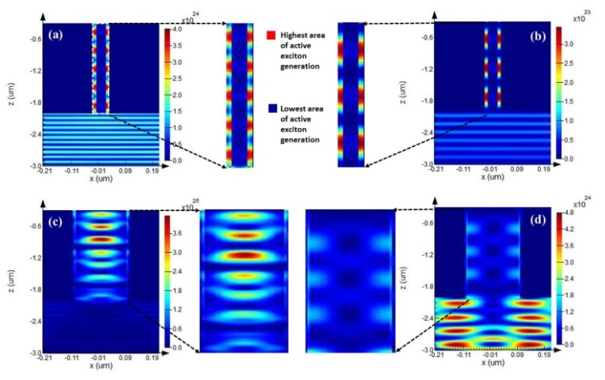
Figure: (a)-(b) Exciton generation rate distributions of vertically aligned Si-NW of 50 nm diameters at 700 and 1100 nm solar spectral wavelengths respectively, insets: corresponding magnified area confirming areas confirming active portion of exciton generation and (c)-(d) that of same Si-NW of 200 nm diameters at 700 and 1100 nm solar spectral wavelengths respectively, insets: corresponding magnified areas confirming active portion of exciton generation.

Biography
Dr. Mohammad Kamal Hossain is a recipient of K.A.CARE (King Abdullah City of Atomic and Renewable Energy) Research Fellowship and has been working in Center of Research Excellence in Renewable Energy (CoRERE), King Fahd University of Petroleum and Minerals (KFUPM), Kingdom of Saudi Arabia since 2010. Dr. Hossain completed his D. Engg. at Tsukuba University, Tsukuba, Japan (in collaboration with National Institute for Materials Science, NIMS) in 2007, Masters in Microelectronics (School of Advanced Technology) at Asian Institute of Technology (AIT), Bangkok, Thailand in 2003. The area of specialization includes, but not limited to, optoelectronics and nanoplasmonics using nanoscale materials in multidimensional features suitable for solar cell, sensor, catalyst, hydrogen production, etc. Dr. Hossain possesses 15+ patents and 110+ research articles in the field of nanoplasmonics and nanostructured materials along with a book and several book chapters. Dr. Hossain has been employed and collaborated with many international and highly reputed groups in Japan, New Zealand and Australia. More than 15 projects has accomplished successfully along with MIT (USA), VUW (New Zealand), MI (New Zealand), CI (New Zealand), NIMS (Japan), IMS (Japan), KGU (Japan), NSTIP (KSA), etc. and has been secured more than 10 million USD as research grant. Dr. Hossain has several joint research projects and collaboration ongoing with reputed experts within KSA and beyond.

Presenting author details
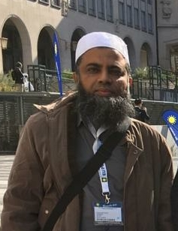
Full Name: Mohammad Kamal Hossain
Contact number: +966 572687563
Twitter account:
Linked In account:
Session name/ number: Advanced Materials for Energy Storage, Generation and Transmission/Track 11
Category: Oral presentation
Passport Number: BT0605847



