

Abstract Template

Title: Theoretical and Experimental Analysis of an Atmospheric Water Harvesting Solar Powered Device
Adeyanju Anthony A.
Mechanical Engineering Department, University of the West Indies, St. Augustine Campus, Trinidad and Tobago

- Abstract Body
Two-thirds of the world’s population is experiencing water shortages. The water in the form of vapor and droplets in the atmosphere, estimated to be about 13 thousand trillion liters (Schneider, 2011), is a natural resource that could address the global water problem. Although there has been interest in dewing from moist air and fog capture, these processes require either the frequent presence of 100% relative humidity or a large amount of energy and thus are not viable solutions for the capture of water from air. Ideally a water harvesting system should operate with a material that can capture and release water with minimum energy requirements and that is powered by low grade energy sources.
This study designed, analyzed and tested a semi-open atmospheric water harvesting solar powered device using atmospheric water vapor membrane technology.
The processor is a device which extract water molecules from the atmosphere, ultimately causing a phase change from vapor to liquid. The research focuses on the development of a correlation for the amount of desiccant to the amount of water produced to determine the sufficient amount required for the specific application.
This correlation was found to be M_{W} = 1.0776M_{S} – 0.4752, with a solar panel efficiency of 10.7%.
Using this relationship amount of desiccants needed to produce certain amount of water was determined.

Image:
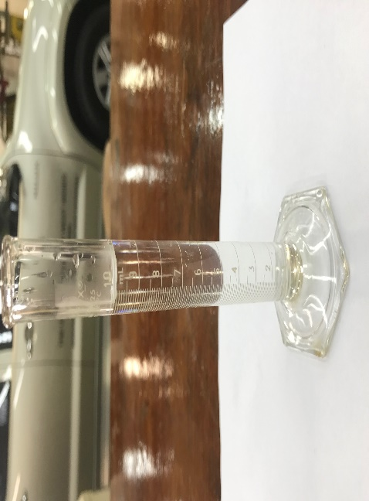

Biography
Dr. Adeyanju Anthony A. obtained his Ph.D. in Mechanical Engineering at the University of the West Indies, Trinidad.
He received the UWI-NGC 2014 Research Awards as the Most Outstanding Graduate Researcher 2011/2012.
He has industrial experience at the Nigerian National Petroleum Corporation, Concord Airline and Gas Airline in Nigeria. He is a registered engineer with the Council of Regulation of Engineering in Nigeria (COREN) and a member of Nigerian Society of Engineers (NSE). His research interests is in area of Thermofluid/energy. He is currently lecturing in the Mechanical Engineering Department at the University of the West Indies, Trinidad.

Email:anthonyademolaadeyanju@yahoo.co.uk; anthony.adeyanju@sta.uwi.edu

Presenting author details
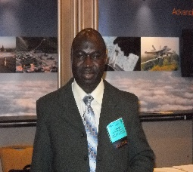

Full Name: Dr. Adeyanju Anthony Ademola
Contact number: +1 868-662-2002 Ext 83192
Twitter account:
LinkedIn account:
Session name/ number:
Category: (Oral presentation)
Passport Number:



