

Abstract Template

Title: Remote micro-grids: prospects and challenges

HAKIM NESREDDINE1, JACQUES BROCHU2, LOUIS DELORME2

1Hydro-Quebec, LTE Energy Technology Laboratory, Shawinigan, Canada
2Hydro-Quebec, IREQ research institute, Varennes, Canada

- Abstract Body (up to 250 words)
Despite efforts made in recent years toward cleaner energy production, most of remote communities and mining companies rely heavily on diesel-fuelled generators for electricity generation. The volatility of diesel cost and likely to increase combined with high costs of fuel transportation and the willingness for greenhouse gas (GHG) reduction are providing opportunities to include or increase renewable power sources in the energy mix.
The speech will provide an overview of the global remote micro-grid market and forecasts. A strategic profiling of key players and a comprehensive analysis of their market position in terms of ranking and core competencies will be presented. An emphasis is put on the techno-economic feasibility of energy service contracting by integrating high shares of renewable energy sources namely solar and wind combined with battery storage for mining industry.
Results show that mining industry is keen to outsource energy generation through energy service contracting since this business model allows the end-user to avoid investment costs, reduce operating costs, lower GHG emissions, transfer risk and focus on core business of ore extraction and processing.

Image:

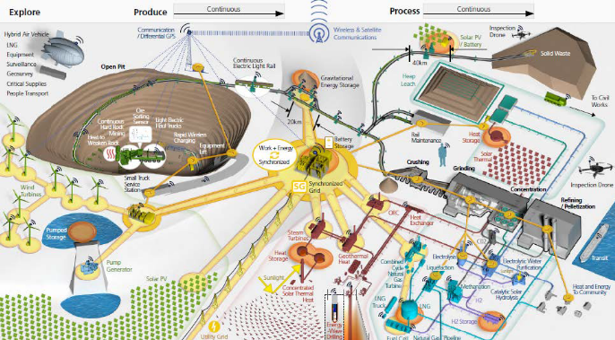

Biography (Up to 100 words)
Dr. Hakim Nesreddine is a senior project leader at Hydro-Quebec research institute. With his dual background in engineering and business administration, he leads multidisciplinary research teams which pioneered the development of cutting edge technologies in distributed generation, energy conversion and advanced refrigeration. He has disseminated his R&D findings in over 30 seminars delivered internationally to industry, corporations and research institutes. He is also an adjunct professor at the University of Sherbrooke and has advised 12 PhD/3M.Sc students and co-authored more than 90 peer-reviewed scientific papers and technical reports.
Dr. Nesreddine sits on the steering Committees of Canada Green Building Council and NSERC Chair on energy efficiency in industry. In addition, he serves on technical committees of the Canadian Standard Association (CSA) and the Centre for Energy Advancement through Technological Innovation (CEATI).

Presenting author details

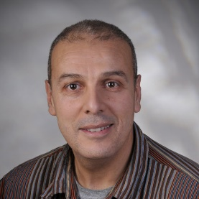
Full Name: Hakim Nesreddine
Contact number: (+1) 819-539-1400 ext. 1414
Twitter account: N/A
Linked In account: N/A
Session name/ number: N/A
Category: Keynote talk
Passport Number:

Source: Energy&Mines, Toronto, 2016


Source: www.microgridknowledge.com

