

Abstract

Title: Thermal performance improvement of flat plate solar air heater using V-shaped fins: A CFD study

MANJUNATH MS

1Department of Mechanical and Manufacturing Engineering, Manipal Institute of Technology, Manipal Academy of Higher Education, Manipal 576102, Karnataka, India,

- Abstract
Solar air heaters find wide applications in space heating as well as drying of agricultural products. The solar heat energy collection device used in air heaters are typically flat plate collectors which are characterized by poor thermal performance. In order to make use of the advantage of simple operational and constructional design aspects of flat plate collectors, it is essential to improve its heat transfer capability. In this regard, the influence of novel V-shaped fins is investigated in the present study using Computational Fluid Dynamics (CFD) methodology. The solar air heater duct consists of square duct of 50 mm sides and a length of 1200 mm. The fins are arranged on the absorber plate such that the lateral pitch and longitudinal pitch are fixed at 25 mm and 20 mm respectively. The CFD simulation is carried out for varying flow Reynolds number of 6000 to 17000 and a fixed solar heat flux value of 1000 W/m². The simulation study is carried out using ANSYS Fluent 18.0 software tool. The simulation results have been validated against the theoretical correlations which show a good agreement with an average deviation of ±5.9% for Nusselt number and ±3.2% for friction factor. The CFD results reveal that the V-shaped ribs not only augment the surface area for heat transfer, but also create intense flow disturbances thereby causing rigorous fluid mixing which enhance heat transfer to air stream. The increase in Nusselt number is found to be about 1.67 times higher for V-shaped fins as compared to smooth duct while the thermal enhancement factor is found to be between 1.24 and 1.55 indicating its worthiness as heat transfer enhancement device.

Air flow structure around the fins:

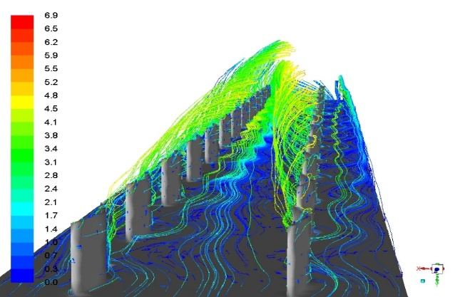
Turbulent mixing

Biography
Manjunath M.S has completed his PhD at the age of 35 years from Manipal University, Manipal, India in the area of Solar thermal energy. He is a faculty of Mechanical Engineering in the Department of Mechanical and Manufacturing Engineering, Manipal, an ‘Institute of Eminence’ as recognized by the Government of India. He has published about 10 papers in reputed journals in the area of solar energy. He has about 12 years of teaching experience and about 2 years of industry experience.

Presenting author details



Full Name: Manjunath M S
Contact number: +919483426391
Twitter account: @manjuna61689581
Linked In account: www.linkedin.com/in/manjunath7881

Session name/ number: Solar

Category: Oral presentation

Passport Number: R8551622

Figure: Intense flow disturbances caused by V-shaped fins.



