

Abstract Template

Title: Advanced Testing Capabilities for Smooth Integration of Renewable Energy Technologies to Power Systems

Taha Selim Ustun1

1Fukushima Renewable Energy Institute, Fukushima, Japan

- Abstract Body (up to 250 words)
Wide-scale deployment of Smart Inverters (SIs) can only happen if their impacts on power systems can be clearly understood. For this reason, thorough power flow and system stability studies are required. Traditional power system simulation software does not include proper models for SIs. Furthermore, dynamic behavior of SIs is not very well known to develop such models. Consequently, hardware in the loop tests with digital real-time simulators seem to be the best option, due to their high fidelity. That being said, interface between the simulated and real-world plays a very significant role. Since the real world is sampled and these samples are utilized to map reality inside digital real-time simulator, any mistake may render the test unstable. On the other hand, real-time simulation has very strong timing requirements and this becomes a deciding factor on how much detail can be modeled. Since the bridge inverters have several components that operate in time steps that are much smaller than conventional power systems, digital real-time simulators have very limited capacity. Using simplified inverter models has been investigated in the past and shown to be acceptable in steady-state situations. This paper investigates use of such models for protection studies in low-voltage networks

Image:
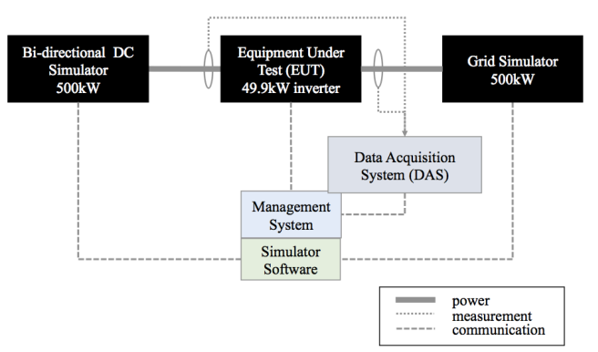

Biography (Up to 100 words)
Taha Selim USTUN received his Ph.D. degree in electrical engineering from Victoria University, Melbourne, VIC, Australia. Currently, he is a researcher at Fukushima Renewable Energy Institute, AIST (FREA) and leads Smart Grid Cybersecurity Lab. Prior to that he was an Assistant Professor of Electrical Engineering with the School of Electrical and Computer Engineering, Carnegie Mellon University, Pittsburgh, PA, USA. His research interests include power systems protection, communication in power networks, distributed generation, microgrids, electric vehicle integration and cybersecurity in smartgrids. Dr. Ustun is an Associate Editor of the IEEE ACCESS and Guest Editor of the IEEE TRANSACTIONS ON INDUSTRIAL INFORMATICS, Energies, Electronics and Information Journals. He is a member of IEEE 2004, IEEE 2800 Working Groups and IEC Renewable Energy Management Working Group 8. He has edited several books and special issues with international publishing houses. He is a reviewer in reputable journals and has taken active roles in organizing international conferences and chairing sessions. He has been invited to run specialist courses in Africa, India and China. He delivered talks for Qatar Foundation, World Energy Council, Waterloo Global Science Initiative and European Union Energy Initiative (EUEI).

Presenting author details

Full Name: Taha Selim Ustun
Contact number: +818047413532
Category: (Oral presentation/ oster presentation) Oral



