

«Energy cannot be created or destroyed, it can only be changed from one form to another.

Albert Einstein

The Challenge
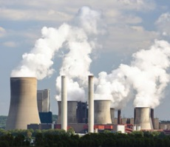  Air pollution | 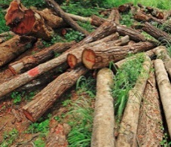  Deforestation
  Global warming | 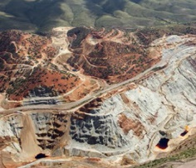  Fossil fuels are non-renewable

Our company developed UBA Plant and Technology which enables the highest potential in renewable
Bio-fuel industry and provides independence from fossil fuels.

Burning fossil fuels emits air pollutants which are harmful to both the environment and public health.

Accumulation of carbon dioxide in the atmosphere is one of the main reasons of global warning. In
addition to that, fossil fuels are non-renewable resources because they take millions of years to form and the
known viable reserves are being used much faster than new ones are being made. As well as wood pellet
industry causes deforestation, and damaging forests reduce their ability to store the carbon.

And even if new trees are planted promptly to replace old ones, they will take 15-20 years to grow
Sufficiently to take up all the CO2 emitted by burning the old trees.

The desire to produce energy on a large scale can lead to deforestation that would destroy the homes of
Large number of plants and animals.

UBA Pellet  With our UBA plant we are offering a carbon neutral source of renewable energy and also a solution to avoid deforestation, and all the other issues caused by it.  UBA biomass will be converted into pellet-fuels, which are absolutely compatible with wooden pellets with their energy density as well as more cost-efficient than wood pellets. This technology is ready to be implemented globally to reduce and replace the coal use. | UBA PLANT  During the last 8 years our team of scientists has been developing a plant, which we believe will become the future of bioenergy and allow to create a renewable source of energy without cutting a single tree.  Our UBA plant is a low-cost and low-maintenance energy crop. It is an annual herbaceous plant that grows between 15 to 27 feet tall, with a stem diameter up to 20 inches in 7 to 9 months.

 | 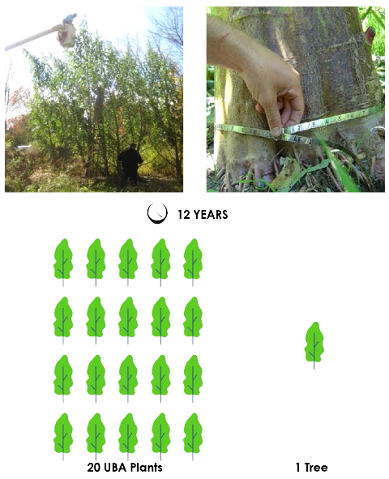
  UBA PELLET  PARAMETERS | UNIT | STANDARD | LIMIT
  Diameter  Length  Volatile Matter  Water Content  Bulk (Apparent) density  NET Calorific value  ASH Content  Deformation Temperature | MM  MM  %DM  KG/M3  GJ/TON AR  %DM  OC | CEN/TS 14961  CEN/TS 14961  CEN/TS 15146  CEN/TS 14774  CEN/TS 15103  CEN/TS 14918  CEN/TS 14775  CEN/TS 15370 | 4-10  10-40 MM  >65%  <10%  >600  >16  <1,5%  >1200 OC
  CL  S  N  F  P | PPM  % DM  % DM  PPM  PPM | CEN/TS 15289  CEN/TS 15289  CEN/TS 15104  CEN/TS 15289  CEN/TS 15290 | 500  <0,2%  <0,5%  <70  300
  Heavy Metals  AS  CD+TL  CR  CU  HG  PB  ZN | SUM heavy Metals  AS+CO+CR+CU+  MN+NI+PB+SB+V  MG/KG DM  MG/KG DM  MG/KG DM  MG/KG DM  MG/KG DM  MG/KG DM | CEN/TS 15297  CEN/TS 15297  CEN/TS 15297  CEN/TS 15297  CEN/TS 15297  CEN/TS 15297  CEN/TS 15297  CEN/TS 15297 | < 800  <2  <1  <15  <20  <0,1  <20  <20
  Halogenated Organic  Comp. Benzo-A-Pyrene C6HCI50  Durability  Particle size distribution  % <4,0 MM  % <3,0 MM  % <2,0 MM  % <1,5 MM  % <1,0 MM | MG/KG DM  MG/KG DM | GCMS  ECD  CEN/TS 15210  CEN/TS 15149 | <0,5  <3  94%-98%  MINIMUM  100%  99%  95%  75%  50%

UBA Econometrics  With the help of National Economic Research Associates (NERA) we created the econometrics and conducted research and analysis of the economic feasibility of our project.  Under the assumptions of a scale of 6000 acres we estimated the potential growth of our revenues from conservatively projected $ 32 million in 2020 to $ 297 million in 2023. | Same energy different impact on the inviroment  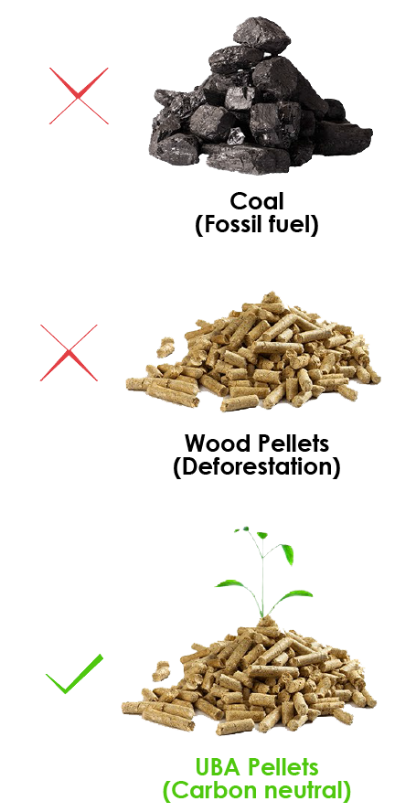
  Revenue From Sales
  2020 | 2021 | 2022 | 2022
  32,053,944 | 178,500,000 | 237,000,000 | 237,000,000
  178,500,000 | 237,000,000 | 297,000,000 | 297,000,000
  237,000,000 | 297,000,000 | 355,500,000 | 355,500,000
  297,000,000 | 355,500,000 | 415,500,000 | 415,500,000
  355,500,000 | 415,500,000 | 457,050,000 | 457,050,000
  415,500,000 | 457,050,000 | 502,755,000 | 502,755,000
  252,592,324 | 323,425,000 | 377,467,500 | 430,139,250
  Average yield
  • 6000 Acres planted ares w/12in spacing & 4lb dry  Matter yields (resulting 87 ton used conservative  Assumption 46.15 Ton) $115,76/Ton Pellet | • 6000 Acres planted ares w/12in spacing & 10lb dry  Matter yields resulting 158 ton $250/Ton Pellet
  • 6000 Acres planted ares w/12in spacing & 6lb dry  Matter yields resulting 117 ton $250/Ton Pellet | • 6000 Acres planted ares w/12in spacing & 12lb dry  Matter yields resulting 237 ton $250/Ton Pellet
  • 6000 Acres planted ares w/12in spacing & 8lb dry  Matter yields resulting 158 ton $250/Ton Pellet | • 6000 Acres planted ares w/12in spacing & 14lb dry  Matter yields resulting 277 ton $250/Ton Pellet

UBA Platform  To implement our plant and technology globally we eill be utilizing distributed ledger solutions. The blockchain is a distributed, digital data ledger that enables the storage of digital transaction in a secure and highly transparent manner.  Adoption of blockchain in energy sector has the potential to empower the and user with better visibility over the transaction and help them understand the revenue generation model.  We will provide an exchange platform to its users, (which are stake holders, buyers, farmers and traders) to use implemented UBA technology in growing, processing, trading as well as investing in carbon neutral renewable energy products. | UBA Token  The UBA Token will represent the consolidated worth of the intrinsic and incremental value of its owned land, green certificates, and the gross product. This will force the market continuously to reevaluate its value based on increasing number of its users and volume of the product.  Our platform will make the electric grid smarter and greener while providing transparency with smart contracts between process contributors and with other innovative tools.

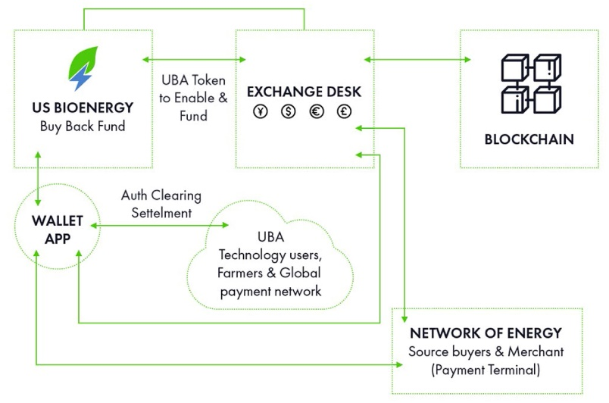 | 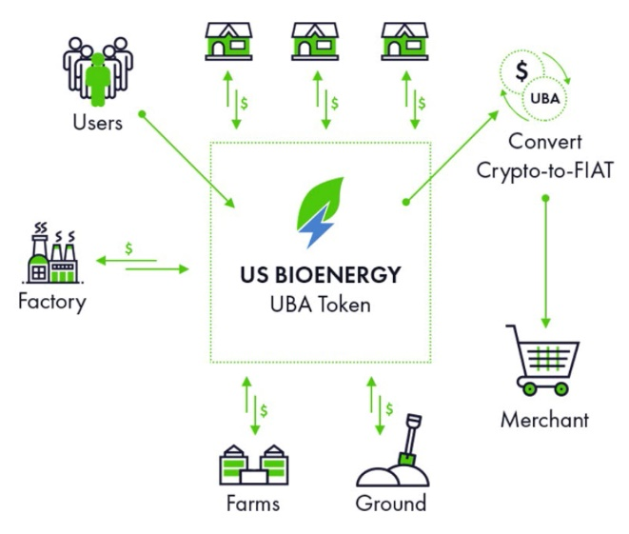

UBA Operational Program

Consolidation ot the whitepaper content  —> | Cloning nursery and the laboratory establishment  —> | UBA digital token and the blockchain technology solution  —> | Purchase of 6000 acres of agricultural land  —> | The construction  of Pelletizing factory  —>

 | Kari Kazumian is the chief executive officer of US Bioenergy Inc, a scientific research company focusing on development of environmentally friendly bio-energy as well as the implementation of the product and the technology globally, using distributed ledger solutions. She is passionate in an effort to enact change to preserve and protect our environment and she has effectively contributed to the company’s mission.  She is a graduate from the ASU from which she has a MA Degree in Psychology. She has completed number of marketing and management courses.  She has an extensive and successful experience in managing and operating various industrial projects where she has demonstrated leadership and exceptional judgment. She is also on the board of directors at Pharmix USA a revolutionary pharmaceutical facility for sterile injectable medications based in Miami, FL.

 usbioenergy.org | We believe that the future is  Green and decentralized

