Application of laser-induced breakdown spectroscopy (LIBS) on oilfield scales- a comparative study
G. Bassioni
Faculty of Engineering, Ain Shams University, Cairo, Egypt
M. A. Harith, A. H. Galmed
National Institute of Laser Enhanced Science, Cairo, University, Giza, Egypt

Abstract
In oil and gas ﬁelds, scales are a conglomeration of different compounds of inorganic and organic nature. Scales, if not handled properly, may result in signiﬁcant production losses. It is necessary to continuously update scale-management strategies for the protection and maintenance of the system to extend the ﬁeld’s lifetime. During oilﬁeld scale cleanup, accumulated naturally occurring radioactive materials (NORMs) at concentrations greater than the permissible health levels can be retrieved. Accumulated radioactive materials concentrate in tubing and surface equipment, and workers at equipment-cleaning facilities and NORMs disposal facilities are the population most at risk for exposure to NORM radiation. Results of proper NORM assessment can be used to assess the respective hazard on workers in the ﬁeld and represent a basis for revisiting current engineering practices [1]. Generally, knowledge of trace metals in organic and inorganic scales could play a significant role in providing useful information on mechanistic and migratory features [2-4]. These metals originate directly from interaction of oils and formation water with source-rock, mineral matter, and production water. Suitable samples were subjected to high performance laser depth profiling and metals found were recorded [5]. This study shows in a systematic way the use of LIBS technique to confirm ICP-MS findings as well as to find correlations between radioactivity, deposition tendency and the elements distribution in the samples.

Image

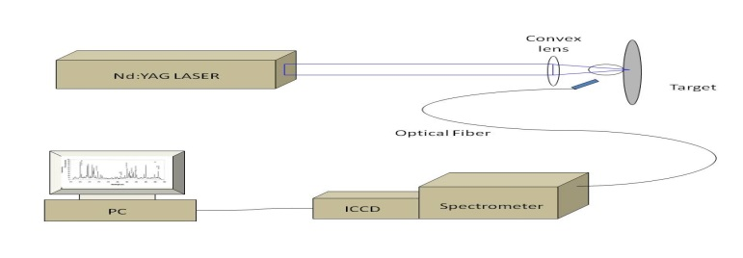
Recent Publications
- Ghada Bassioni, Fareed Abdulla, Zeinab Morsy, Nabil El-Faramawy (2012) Evaluation of Naturally Occurring Radioactive Materials (NORM) in Inorganic and Organic Oilfield Scales from the Middle East, Archives of Environmental Contamination and Toxicology, Vol.62 (3), pp.361-368.
- Ghada Bassioni (2010) Mechanistic aspects on the influence of inorganic anion adsorption on oilfield scale inhibition by citrate, Journal of Petroleum Science and Engineering, vol. 70, pp. 298-300.
- Syed Taha Taqvi, Ali Almansoori, Ghada Bassioni (2014) Modeling the Impact of Wettability Alterations on Calcium Carbonate System for Crude Oil and asphaltenic solutions, Industrial and Engineering Chemistry Research, Vol. 53, pp. 4773-4777.
- Syed Taha Taqvi, Ali Almansoori, Ghada Bassioni (2016) Understanding the Role of Asphaltene in Wettability Alteration using Zeta Potential Measurements, Energy and Fuels, Vol. 30 (3), pp. 1927-1932.
- Avin Pillay, Ghada Bassioni, Sasi Stephen, Fritz Kühn (2011) Depth profiling (ICP-MS) study of trace metal 'grains' in solid asphaltenes, Journal of the American Society for Mass Spectrometry, Vol. 22 (8), pp. 1403-1408.

Biographies

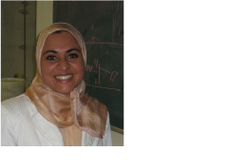
Ghada Bassioni, Ph.D. (Dr. rer. nat.), 2004, Technical University Munich, Germany.
She is a Professor and the Head of the Chemistry Division at the Faculty of Engineering, Ain Shams University in Cairo and is a member of the Egyptian National Committee for Pure and Applied Chemistry. She is an international project officer at the Science and Technology Development Fund (STDF), Egyptian Ministry of Scientific Research and has been a member of the Global Young Academy from 2013-2018. She has over 60 scientific publications in peer-reviewed journals and conference proceedings and has been recognized with several national (like the Egyptian State Incentive Award in Chemistry, 2013), regional (like the LEWA Leadership Excellence for Women award, 2013) and international awards (like the Young Scientist Award at the World Economic Forum in Dalian, 2013) and was selected as an academic visitor and panelist at the Nobel Laureates meetings in Lindau, Germany, in 2012 and 2014, respectively. In 2016, she has been awarded the Next Einstein and the Fulbright fellowships as well as the L.A.B. fellowship of three organizations: Nobel Laureate Meetings in Lindau, the European Forum in Alpbach and the Falling Walls in Berlin.
Email: ghada_bassioni@eng.asu.edu.eg

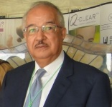
Mohamed Abdel Harith is a Professor of Laser Physics at the National Institute of Laser Enhanced Science (NILES). He obtained his degree of Ph.D. in experimental physics from Dresden Technical University in Germany. He founded a scientific school in laser spectroscopy at NILES where 32 students obtained their master degrees and 25 students have had their doctorate degrees. He served as the head of department Egyptian Society of Optical Sciences and Applications (ESOSA).and then the institute's vice Dean. From 2003 to 2005 he was the Dean of NILES. He has more than 128 publications with more than 1500 citations and h-index 24. Member of the European Society of Physics EPS and senior member of the Optical Society (OSA). Chairman of the Board of Directors of the Awarded the University of Cairo award of Appreciation in 2009 and the Cairo University award of Excellence for the year 2016.
Email: mharithm@niles.edu.eg

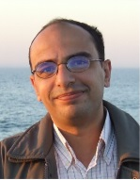
Ahmed Hassen Galmed is a lecturer of laser spectroscopy / laser physics in the department of laser applications in meterology, photochemistry and Agriculture (LAMPA) National Institute of Laser Enhanced Sciences (NILES), Cairo University. Worked as a Post doctor fellow in iThemba LABS, South Africa in the period between August 2016 and December 2018.
Dr. Galmed got his Bsc degree in Physics & Chemistry, Faculty of Science, Cairo University (1999) then his MSc (2006) and PhD (2011) degrees from National Institute of Laser Enhanced Sciences (NILES), Cairo University. The research field of Dr. Galmed is focused on the applications of Laser Induced Breakdown Spectroscopy (LIBS), Laser Induced Fluorescence (LIF) including industrial, medical and environmental applications. He published a number of international publications as well as supervised some MSc and PhD thesis.

Email: ahmedgalmed@niles.edu.eg

Notes/Comments:

