Investigation and evaluation of aerodynamic efficiency improvement measures for vertical axis small wind turbines
Daniel Lehser-Pfeffermann, Alex Piethe, Frank Ulrich Rückert, University of applied Sciences Saarbrücken, Germany
Franz Joos, Professor, Helmut-Schmidt-University Hamburg, Germany

Abstract
Power generation using wind turbines is an essential element of regenerative energy supply. Due to geographical and legal restrictions, multi-megawatt wind turbines are only installed at a considerable distance from consumers. In order to reduce grid losses, small wind turbines are used for local power generation. However, in suburban areas, increased turbulence in the wind conditions must be taken into account due to the development of small wind turbines. Since vertical axis wind turbines (VAWT) operate more independently of the wind direction, they are better suited for such applications despite lower overall power efficiency.
In order to increase the efficiency of VAWTs, various active and passive methods are investigated within the scope of this work. In particular, these are applications for vertex generation, surface layer suction and flexible trailing edges. The influence of the applications on the lift and drag coefficients in comparison to the original NACA 0021 profile is shown by simulative investigations. The flow around the profile is calculated and the resulting lift forces are plotted depending on the angle of attack. To validate the simulation, experimental investigations of the profile applications are carried out in a small wind tunnel. For manufacturing of the profile prototypes, an additive manufacturing process is used.
Finally, the simulation and test results are compared. In addition to the lift to drag ratio, an economic implementation is further evaluation criterion for the possible use on a VAWT rotor.

Image
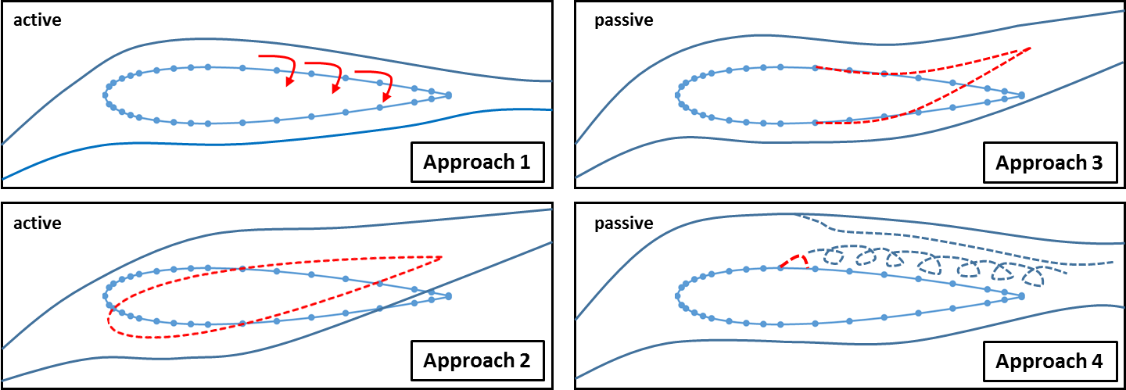
Figure 1: Different approaches of passive and active systems for an aerodynamic efficiency upgrade
Recent Publications
- Lehser-Pfeffermann, D., Häfele, T., Rückert, F., Griebsch, J., Müller, T., Joos, F. (2018) Location-Optimized Aerodynamic Rotor Design of Small Wind Turbines and Lightweight Implementation Using Additive Hybrid Material. SYMKOM 2018 IMP², Poland
- Ruffino, G., Lehser-Pfeffermann, D., Rückert, F., Müller, T., Joos, F. (2018) Numerical Simulation and Measurement for location optimization of a Vertical Axis Wind Turbine (VAWT). TURBWIND 2018, Italy
- Lehser-Pfeffermann, D., Theis, D., Rückert, F., Müller, T., Joos, F., (2018) Installation and Design of a New Wind Tunnel for Measurement of Vertical Axis Wind Turbines (VAWT). Green Energy 2018 London.
- Carbó Molina, A., Van de Maele, S., Bartoli, G., De Troyer, T., Runacres, M., (2018) Experimental characterization of VAWT airfoils for urban environments. TURBWIND 2018, Italy
- MacPhee, D., Beyene, A. (2018) Performance analysis of a small wind turbine equipped with flexible blades. Renewable Energy 132 497-508.

Biography
Daniel Lehser-Pfeffermann has studied mechatronics and sensor technology and works since 2014 as a research assistant in the lab of wind energy technologies on the university of applied sciences Saarbrücken. Actually, he worked in the fields of simulation (structural analysis, multi body simulation, computational fluid dynamics) additive manufacturing and experimental investigation. In his PhD-Project, he focused on the development and efficiency upgrade of vertical axis small wind turbines for suburban areas.
Email: daniel.pfeffermann@htwsaar.de
Notes/Comments

