Development of Tubular Type Direct Carbon Fuel Cells
Akifumi Ido, Central Research Institute of Electric Power Industry, Japan
Makoto Kawase, Central Research Institute of Electric Power Industry, Japan

Abstract
Direct carbon fuel cells (DCFC) are fuel cells utilizing solid carbon as fuel. The total reaction is expressed by following equation.
C(s) + O₂(g) = CO₂(g) (1)
Coal, biomass and waste can be used as fuel for DCFC. DCFC is expected to have high electric power generation efficiency and be a compact device. Easy storage and transportation of fuel is possible due to utilizing solid fuel. One of the big problem for DCFC has been how to continuously supply solid carbon to the electrode surface. To solve this problem, we proposed a novel DCFC system using tubular type cells. This study investigated basic characteristics of tubular type DCFC. We already developed tubular type molten carbonate fuel cells (TMCFC), and it was applied for DCFC cells in this study. Each electrode materials were formed by slurry coating method. Cathode was NiO-3%MgO, electrolyte matrix was LiAlO₂, anode was Ni-2%AlCr (+10%Al₂O₃) and electrolyte was 60%Li₂CO₃-40%Na₂CO₃ molten salt. A tubular cell was inserted into the mixture of activated carbon and molten carbonate (carbon:carbonate = 8:2 wt%). A continuous power generation test and I-V measurement were conducted. Continuous power generation was achieved for 100 mA cm⁻² for 24 hours at 800°C. The anode outlet gas composition was measured during the test. CO was 11.2% and CO₂ was 1.2%. Most of CO₂ generated by anode reaction was presumed to react with carbon and changed to CO by Boudouard reaction. The result of I-V measurement at 700-850 °C showed that cell performance of DCFC is better at higher temperature. This study found that tubular DCFC is able to generate high electric power and is useful for effective utilization of carbon resources.

Image
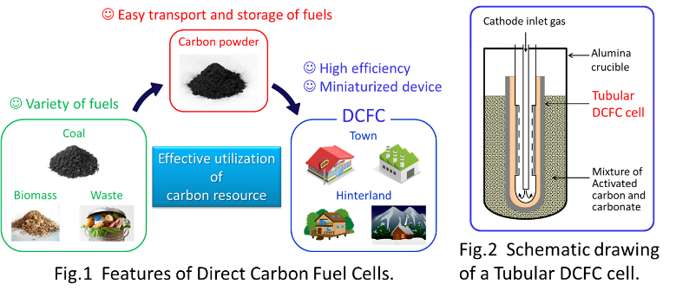
Recent Publications
- M. Kawase (2015) Manufacturing method for tubular molten carbonate fuel cells and basic performance. Jounal of Power Sources 285:260-265.
- N. J. Cherepy, R. Krueger, K. J. Fiet, A. F. Jankowski and J. F. Cooper (2005) Direct Conversion of Carbon Fuels in a Molten Carbonate Fuel Cell. Journal of The Electrochemical Society 152(1):80-87.
- S. Giddy, A. Kulkarni, C. Munnings and S.P.S. Badwal (2015) Composite anodes for improved performance of a direct carbon fuel cell. Journal of Power Sources 284:122-129.
- S. Li, W. Pan, S. Wang, X. Meng, C. Jiang and J.T.S. Irvine (2017) Electrochemical performance of different carbon fuels on a hybrid direct carbon fuel cell. International Journal of Hydrogen Energy 42:16279-16287.
- L. Deleebeeck, V. G. D. Ippolito, R. Campana, K. K. Hansen and P. Holtappels (2017) Direct Coal Oxidation in Modified Solid Oxide Fuel Cells. Journal of The Electrochemical Society 164(4):333-337.

 Biography
Akifumi Ido has expertise in electrochemistry and molten salt chemistry. He got his master’s degree in energy science from Kyoto university in Japan. After that he started his working in Central Research Institute of Electric Power (CRIEPI) from 2017. He currently engages in researches about advanced thermal power generation and fuel cells.
Email: iakifumi@criepi.denken.or.jp

Notes/Comments:

