Flame propagation of pulverised biofuels of varying size distribution fractions
Muhammad Azam Saeed, PhD, Department of Chemical and Polymer Engineering, University of Engineering and Technology, Lahore, Pakistan
Gordon E. Andrews, PhD, Energy Research Institute, School of Chemical and Process Engineering, University of Leeds, LS2 9JT, Leeds, UK
Herodotos N. Phylaktou, PhD, Energy Research Institute, School of Chemical and Process Engineering, University of Leeds, LS2 9JT, Leeds, UK

Abstract (300 word limit)
Solid biofuel is one of the most viable options to substitute coal in the pulverised coal power plants for renewable environment. Their milling to acquire same pulverisation is not very easy for these power stations however; they can be employed in coarser form due to their higher reactivity than coals. In this work, the flame propagation of fine and coarse biofuels was studied using modified Hartmann and 1 m³ explosion vessel. The actual combustible mass was converted to equivalence ratio for identifying the lean and rich region relative to stoichiometric base point. Results revealed that the propagation of the flame for biomass samples was affecting by the key parameters of chemical characterisation and particle size distribution. Biofuels with high volatiles and low ash were more reactive with fast rate of their flame spread. Fine size distribution of biomass released its volatiles more quickly due to more exposed surface area. High speed photography with 5000 frames rate were used to study the mechanism of flame propagation of different sized biomass particle. For fine sized bagasse particles of size smaller than 63 micron, flame propagated in 322mm long Hartman dust explosion tube in 180.4 ms whereas for coarse size bagasse particles, it took 1273 ms. Flame propagation for fine mixture was more luminous and uniform as compared to coarse fraction. Also there was less delay in the building of uniform flame with more mass burning as compared to coarse fractions with more unburnt residue mass. This work aims to study the biofuels flame propagation for lean and rich concentration in comparison to coal and effect of particle size distribution that have scant data in the literature.

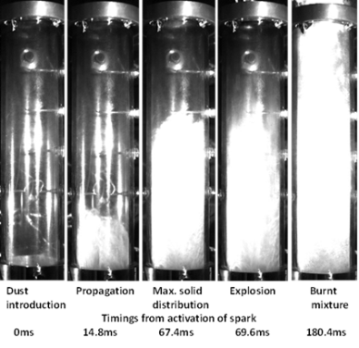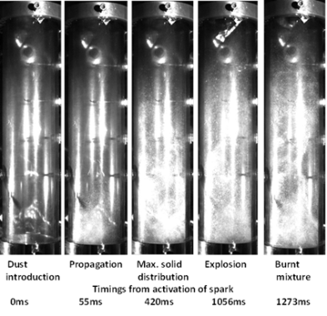
a
b

Figure 1: Flame propagation of biofuels a) fine sized particles b) coarse sized particles
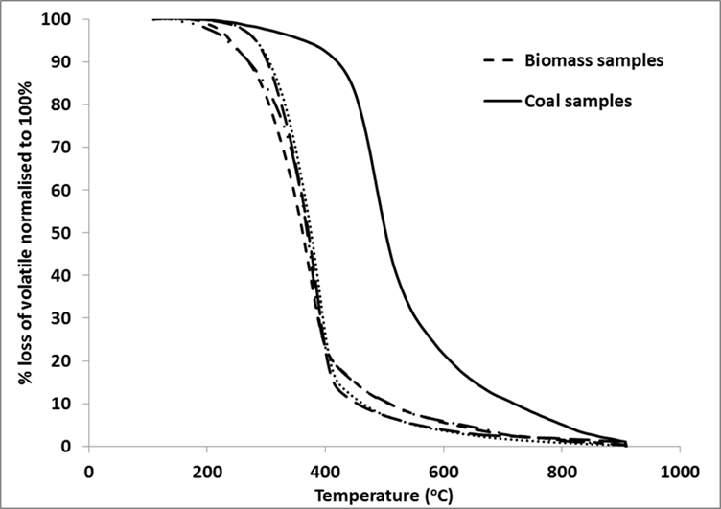

Figure 2: Volatile release rate of biofuels in comparison to Coal
Recent Publications (minimum 5)
- FERNANDEZ-ANEZ N., SLATTER D.J.F., M., SAEED, M.A., PHYLAKTOU, H. N., ANDREWS, G. E. & GARCIA-TORRENT J. 2018. ANDRESEN, J.M. 2018. Ignition sensitivity of solid fuel mixtures. Fuel, 223,451-461
- FAROOQ, M., ALMUSTAPHA, M.N., IMRAN, M., SAEED, M.A. & ANDRESEN, J.M. 2018. In-situ regeneration of activated carbon with electric potential swing desorption (EPSD) for the H2S removal from biogas. Bioresource Technology Journal, 249,125-131
- SAEED, M. A., ANDREWS, G. E., PHYLAKTOU, H. N. & GIBBS, B. M. 2017. Flame speed and Kst reactivity data for pulverised corn cobs and peanut shells. Journal of Loss Prevention in the Process Industries. Online
- SAEED, M. A., ANEZ, N. F., ANDREWS, G. E., PHYLAKTOU, H. N. & GIBBS, B. M. 2017. Steam exploded pine wood burning properties with particle size dependence. Fuel, 194, 527-532. SAEED, M. A., ANDREWS, G. E., PHYLAKTOU, H. N. & GIBBS, B. M. 2016.
- Global kinetics of the rate of volatile release from biomasses in comparison to coal. Fuel, 181, 347-357.
- SAEED, M. A., ANDREWS, G. E., PHYLAKTOU, H. N. & GIBBS, B. M. 2016. Raw and steam exploded pine wood: Possible enhanced reactivity with gasification hydrogen. International Journal of Hydrogen Energy, 41, 16566-16576.
- SAEED, M. A., DAVID.J, S., ANDREWS, G. E., PHYLAKTOU, H. N. & GIBBS, B. M. 2016. Combustion of Pulverized Biomass Crop Residues and Their Explosion Characteristics. Combustion Science and Technology, 188, 2200-2216.
- SAEED, M. A., ANDREWS, G. E., PHYLAKTOU, H. N. & GIBBS, B. M. 2016. The burning velocity of pulverised biomass: The influence of particle size Chemical Engineering 53, 31-36.
- SAEED, M. A., MEDINA, C. H., ANDREWS, G. E., PHYLAKTOU, H. N., SLATTER, D. & GIBBS, B. M. 2014. Agricultural waste pulverised biomass: MEC and flame speeds. Journal of Loss Prevention in the Process Industries, 36, 308-317.

Biography (150 word limit)
Dr. Muhammad Azam Saeed has his expertise in biofuels and bioenergy. His research work is based on efficient utilization of biofuels with minimum fire/ explosibility risks. He worked on the kinetics for the volatile release rate and developed ‘Series reaction model’ and ‘Competitive reaction model’. In his research work, he tested raw biomass crop residues and wood samples along-with the thermal treated biomass samples. Thermal treated (torrefied and steam exploded) biomass was found to have more energy per unit volume with less milling energy requirements due to high brittleness and more porous structure. He compared the results of flame propagation of biofuels in comparison to coal. His main findings are that biofuels can be a good substitute of coal in the power generation plants for green power generation; however they are more reactive and pose more fire/explosibility hazards that need to be evaluated before its application.
Email: azamsaeed86@hotmail.com

Notes/Comments:

