Strong-acid compatible, earth-abundant-element, molecular water oxidation catalysts for solar fuel production
Meilin Tao, Quishi Yin, Sarah M. Lauinger, Yurii V. Geletii,
and Craig L. Hill, PhD, AAAS, VICS, MAE, FRSC, Department of Chemistry, Emory University, Atlanta, GA 30322

Abstract (300 word limit)
Deeper insights and commensurely better versions of the three interconnected functional units in solar fuel generation systems are needed: water oxidaton catalysts (WOCs), H₂O and CO₂ reduction catalysts and light-absorbing-charge-separating structures. Transition-metal-substituted polyoxometalates (POMs) have been investigated by many groups as WOCs because they combine the advantages of molecular (homogeneous) catalysts (their properties can be studied in depth experimentally and computationally), with the advantages of non-molecular (heterogeneous) catalysts (carbon-free and very robust). Many groups have studied and developed POM WOCs that contain only earth-abundant elements since our first report.¹⁻³ A grand challenge in water oxidation and solar fuel production is the development of earth-abundant-element, effective WOCs that also function in strong acid. We will report new earth-abundant-element POMs that are both very good in strong base and, more importantly, in strong acid. Five different forms of a POM containing 9 cobalt centers with the polyanion formula [Co₉(OH)(H₂O)₆(HPO₄)₂(PW₉O₃₄)₃]¹⁶⁻ have been prepared and structurally characterized (XRD, NMR and other methods). Figure 1 shows the X-ray crystal structure of the (Cs⁺)₉ salt. Despite different unit cells, all give derivatives catalyze water oxidation in strong acid but at different rates, with the Y³⁺ salt being the most effective. Despite different reactivities and crystal structures, the tafel slopes for the 4 insoluble derivatives are the same indicating that all oxidize water by a similar or identical mechanism.
Good methods for immobilization of homogeneous catalysts on photoelectrodes is also a central issue in solar fuel generation. We will discuss the preparation and characterization of POM-WOC-SC (SC = semiconductor = TiO₂ or Fe₂O₃) photocatalytic water oxidizing electrodes. ³⁻⁵ We recently demonstrated that POM-WOC-SC systems can be stabilized by appropriate layers (depths) of Al₂O₃ deposited by atomic layer deposition (ALD; see Figure 1).⁵

Image
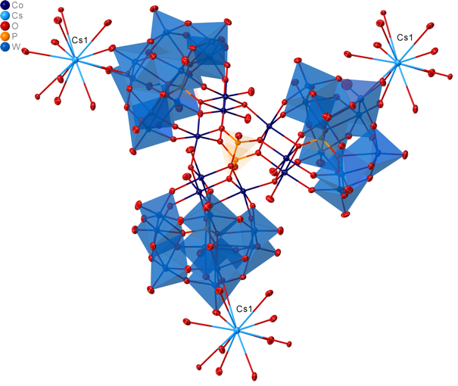
Figure 1: X-ray structure of a fast, all-earth-abundant-element-containing molecular WOC that functions in acid: Cs₉[Co₉(OH)(H₂O)₆(HPO₄)₂ (PW₉O₃₄)₃]^{n-}

Recent Publications (minimum 5)
- Yin, Q, Tan, J M, Besson, C, Geletii, Y V, Musaev, D G, Kuznetsov, A E, Luo, Z, Hardcastle, A I, Hill C L (2009) A Fast Soluble Carbon-Free Molecular Water Oxidation Catalyst Based on Abundant Metals. Science 328:342-345.
- Lv, H, Song, J, GeletiiYV, VickersJW, SumlinerJM, MusaevDG, KögerlerP, Zhuk, P, Bacsa, J, Zhu, G, HillCL. (2014) An Exceptionally Fast Homogeneous Carbon-Free Cobalt-Based-Water Oxidation Catalyst. J. Am. Chem. Soc. 136:9268-9271.
- LauingerSM, Yin Q, GeletiiYV, HillCL. (2017) Polyoxometalate Catalysts in Solar Fuel Production. Advances in Inorganic Chemistry 69:Chapter 5.
- Fielden, J, SumlinerJM, Han, N, Geletii, YV, Xiang, X, Musaev, DG, Lian, T, Hill, C. L. (2015) Water Splitting with Polyoxometalate-Treated Photoanodes: Enhancing Performance through Sensitizer Design. Chem. Sci. 6:5531–5543

- Lauinger, S. M. et al. (2017) ACS Applied Materials & Interfaces 9: 35048-35056.

Biography (150 word limit)
Craig L. Hill (PhD, MIT, NSF postdoc, Stanford) is the Goodrich C. White Professor of Science at Emory University. His group conducts research on solar fuels and other aspects of green energy, multifunctional nanomaterials and new types of anticancer therapeutics. He and his ~130 co-workers over the last 3 decades have published ~420 papers that have been cited 28,600 times for an H index of 85 (Google Scholar). CLH is a Fellow of the AAAS, the Academia Europaea, the Victorian Institute of Chemical Sciences and the Royal Society of Chemistry. He has edited multple journals, served or chaired many national and international research panels and chaired or organized 7 international scientific conferences.
Email: chill@emory.edu

