A Case Study on Nest’s “Smart Home Energy” Business Model:
x

Based on Strategic Choices for Connected Product

Song, Minzheong
Hansei University
mzsong@hansei.ac.kr

Abstract
The purpose of this study is to develop…

Keywords: Nest Labs, smart energy, smart home, business model

INTRODUCTION

Development of Information and Communication Technology (hereafter ICT) requires industrial structure change due to expansion of distributed resources and emergence of new players. In energy sector, conventional power industry is vertically separated from power generation and transmission to distribution and sales. But, after “Behind the Meter” market emerges, a circulating power distribution structure has been created. Even non-energy companies such as ICT, insurance, and finance started to use ICT infrastructure to enter the electric power industry for creating new business model and expanding new businesses like electric car and smart home. Moreover, the emergence of energy prosumers utilizing distributed power generation and the establishment of demand resource markets blur the boundary between energy suppliers and consumers.
The home is a complex and technically challenging place to live. So, smart home service providers are increasing their service delivery and technical support capabilities within the home. The research company, OVUM regularly reports dynamic assessment of the most relevant service providers within the smart home market at a global level. As of June 2017, 167 broadband operators, 69 utility suppliers, and 68 insurance companies have been searched and the analysis includes a proactivity index measuring proactive-ness of each company in the smart home market. There are 7 categories in this: Security & monitoring, safety, energy, lighting, automation, care/assisted living and advanced technical support. Among them, this study focuses on the smart home energy (hereafter SHE), centralized systems of heating, ventilation, and air conditioning controlling household temperature while providing comfort, convenience, and energy efficiency. These have ability to learn the movements of the occupants of the household and set the temperature accordingly. Example devices include smart thermostats, ceiling fans, ACs, humidity sensors and power outlets [1].
The most representative use case is Nest Labs, a smart home specialist. It has been acquired about US$3.2 billion in 2014. Nest thermostat controls temperature of the house by itself and reduce energy usage. Based on machine learning, Internet of thing (hereafter IoT), this device can learn various patterns of users and remote control is possible by using apps and real-time energy usage information. Google took a step into home area with the acquisition of Nest Labs (hereafter Nest). Before the merger, Nest was only a smart home device manufacturer with a technology platform based on connected product.
One year after merger, in 2015, Google restructured the corporate governance and created Alphabet as a holding company. Nest has been separated from Google in this process and a separate division under the same corporate umbrella, even if Google is trying to gain ground in the smart home through Google’s own GoogleHome and OnHub, a WiFi router with embedded functionality that improves the connectivity of all devices at home and acts as control hub for connected devices. Three years later, early in 2018, Alphabet is merging its Google and Nest divisions together. The firm efforts to build hardware and software to create a more thoughtful home. Google is bringing gadget maker Nest back under its control as the search giant battles rivals Amazon and Apple in the rapidly expanding SHM. Making it easier to add Google’s artificial intelligence (AI) technology and Assistant, a digital helper that competes against Amazon’s Alexa and Apple’s Siri, into new Nest products.
With ubiquitous connectivity, it is possible to make all types of products connected. This study aims to investigate Nest’s business strategy, because Nest products have synergy with Google’s AI and vice versa. It makes sense to be developing them together. Nest has several direct and indirect distribution channels and its ecosystem is the most effective because it promotes the adoption of smart home technologies through diverse market mechanisms, such as product incentives and rewards programs. Google is more of a software and cloud platform and it is expected, Nest can develop a distinctive business strategy approach for future energy solution.

THEORETICAL BACKGROUND

1. Previous Studies about “Smart Home Energy”
Google Scholar and Taylor & Frances Online have been searched in search names “smart home” or “smart energy”. The first academic article is a case study in 2013. Xiao and Boutaba explain the key design requirements for the smart home system have been explained and it shows how convergence system design is a capable methodology for enabling an integrated and multi-faceted home management system encompassing energy management, home appliance control, environment management, u-health, and living support functionalities under a single unified design [2].
In 2014, Rodríguez-Molina et al. [3] insist, smart grid combines efficient energy consumption with avant-garde technologies related to renewable energies and it can provide several beneficial utilities like power monitoring and data provision. The smart grid users can be the most important value creators and a decisive agent of change in terms of electricity usage. They deal with emerging business models for smart grid prosumers, their strengths and weaknesses.
In 2016, Lobaccaro et al. reviewed smart home and smart grids technology together. There are numerous technologies and applications that can be installed in smart homes enabling communication between home appliances and users, and enhancing home appliances’ automation, monitoring and remote-control capabilities. They introduce concept of smart home and the advent of the smart grid and investigate technologies for smart homes. The technologies of the systems are presented and advantages and disadvantages of each technology are explained [4].

3. Ten Strategic Questions for Management of Connected Product
With the Internet of Things (IoT) booming up in 2015, Harvard Business School professor, Michael Porter described how IoT transforms the competitive landscape [5]. Companies increasingly compete by producing connected devices that are part of software-enabled platforms. This transformation includes which capabilities are most important, what talent is most essential, what functionality is most critical to customers, how best to differentiate, which business models to pursue. This IT is complicated and forces companies to make difficult decisions. To assist leaders in thinking through these choices, Porter and Heppelmann have created 10 strategic choices and four capabilities. There are four capabilities to pursue. With monitoring there is visibility about where a product is, what it is doing, what environment the product is being used in, and the condition of the product. By monitoring a product, it is possible to set acceptable ranges and trigger alerts and alarms. With control, it is possible to embed software that enables bidirectional control over a product, controlling the product from a phone or tablet. With optimization, it is possible to add algorithms to optimize its operation and performance. This can include predictive maintenance to intervene before something bad happens. Lastly, with autonomy, it is possible to create products that act on their own.

Figure 1. Ten strategic choices [5]
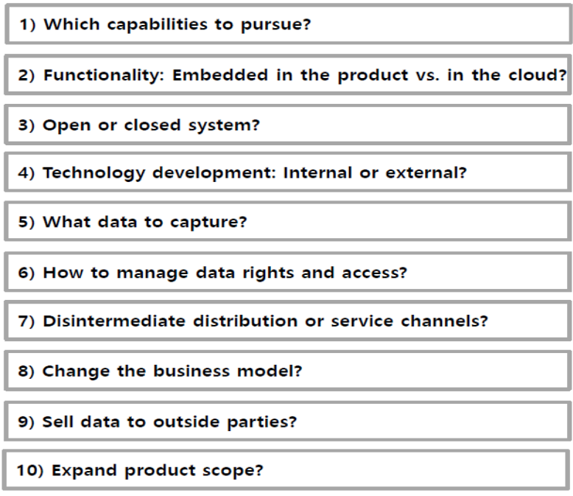

The connected product requires a platform and it enables a product to connect with other products (via a wire, wireless, WiFi, Bluetooth, or cellular). It requires building a cloud to which the product connects and creates a database to aggregate data from multiple products as well as from internal business systems and external sources. Analytics are needed to analyze and derive value from the massive amounts of data. Then, it further needs to be an application platform and various business applications. All these technologies are connected in a secure way, which makes cybersecurity critically important and exponentially more complex.
Unlike the previous silo system of IT which helped firm’s productivity, the IoT affects companies’ strategies to open or not and how companies differentiate themselves, create value, and compete, and change the structure of industries. Connected products blur the boundaries within an industry and shift bargaining power and change the basic principles of product design. So, products need to be designed to be part of systems. Then, they can be continuously upgraded, with product usage data enabling rapid redesign. They can be customized and designed for security. The real transformation is when connected products are brought together into a connected “product system” where the connected technology platform is integrated with other equipment to optimize the entire operation. That means, one equipment system can be connected to other systems, creating a system of systems. This represents a fundamental change in a company’s business model from making and selling a product to making entire product systems or platforms. Companies should decide if they want to be the system integrator that provides the entire platform or one discrete product on a larger platform.
Porter and Heppelmann insist that winners make the right choices among 10 strategic questions and get the basics right. Companies need different types of talent than in the past. The process of developing new products must be handled differently from when the products being developed were merely physical, mechanical products. They also emphasized, technology makes an amazing array of functionality possible, but winners focus on functionality that provides value that customers are willing to pay for. Ultimately, the biggest factor that distinguish winners and losers is the choice of what business a company is in. The emergence of connected products with embedded technologies is likely to drive consolidation among companies with complementary product portfolios, also resulting in new players with new products and business models. It is important not to view this new IT as incremental in nature. These technologies are transformational, with major implications for companies’ strategies, for how companies compete, and for which companies will win and lose.

RESEARCH DESIGN

1. Research question
In the platform businesses, the boundaries between suppliers, customers and competitors can shift rapidly. The participants such as consumers, producers, and providers (service or device) create value for a business and their boundaries are blurring. Some producers turn on the platform and compete directly with it. Zynga is an example. It began as a games developer and producer on Facebook platform, but sought to migrate players onto its own service platform. Amazon and Samsung, providers of devices for the Android platform provided by Google try to create their own versions of the operating system and take consumers with them.
A platform provides the infrastructure and rules for a marketplace that brings together producers and consumers. The players in the business ecosystem fill four roles such as producer, provider (service or device), and consumers, but may shift rapidly from one role to another. Understanding the relationships both within and outside the business ecosystem is central to platform strategy. [6]. Based on the 10 strategic questions for creating business models of the connected product, this paper categorized these 10 questions again into 4 groups based on the four components of business model by Christensen, Bartmen, and van Bever [7], because platform industry requires new business models different from the traditional ones of the previous pipeline industry. Christensen, the initiator of disruptive innovation described four components as follows:
- The value proposition: A product that helps customers do more effectively, conveniently and affordably a job they have been trying to do.
- Processes: Ways of working together to address recurrent tasks in a consistent way: Traning, development, manufacturing, budgeting, planning, etc.
- Resources: People, technology, products, facilities, equipment, brands, and cash that are required to deliver the value proposition to the targeted customers.
- Profit formula: Assets and fixed cost structure, and the margins and velocity required to cover them.
Based on the four components of business model in 2016, adjusted strategy framework of connected product is as follows: Product capabilities and functionality are related to the value proposition. The platform access (whom to let onto the platform) and governance (what consumers, producers, providers, and competitors are allowed to do there) means ecosystem planning and development and it is related to the processes. Platforms consist of rules and architecture. Their owners need to decide how open both should be. An open architecture allows players to access platform resources, such as app developer tools, and create new sources of value. Open governance allows players other than the owner to shape the rules of trade and reward sharing on the platform. Data is key resource and distribution method is related to the profit formula.

Figure 2. Research Framework for creating SHE business models
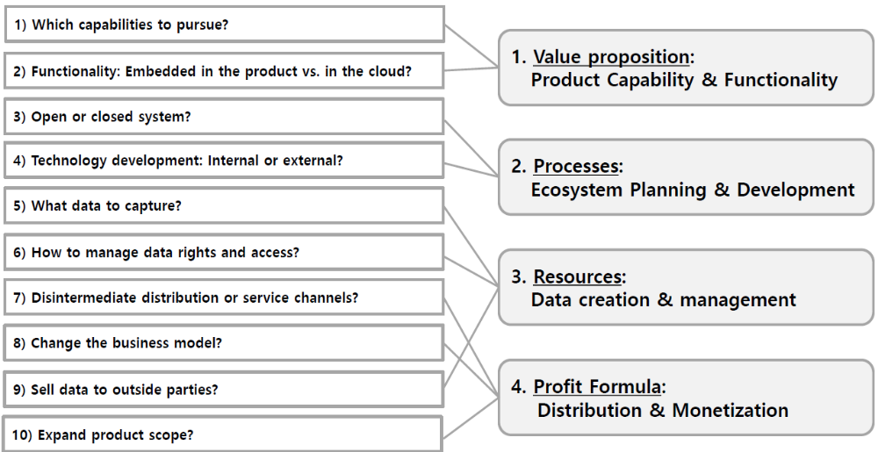

The research questions regarding Nest are as follows:
Question 1. What is the value proposition of Nest in terms of product capability and functionality?
Question 2. How are the processes of Nest in terms of ecosystem planning and development?
Question 3. How is the data resource of Nest created and managed?
Question 4. What is the distribution and monetization method in terms of profit formula?

2. Methodology
This study covers a global company. Therefore, the analysis is along with extensive tracking of ICT and financial data released by secondary source such as global research company, OVUM analysis reports & trackers and domestic company such as fnguide.com during 2014~2017, because the year 2014 is considered Google’s acquisition year of Nest. In addition, the information released by newspaper and press release was thoroughly examined and academic journals, periodicals, and financial report from stock market were investigated. In addition, publicly available information from company websites, together with press releases, announcements, and company reports are searched.

RESULTS AND DISCUSSION

1. Value proposition: Product Capabilities and Functionality [8]
Nest has four connected products [8]: Nest Thermostat is programmable, self-learning Wi-Fi-enabled and has auto-schedule, auto-away, remote-control, and sensors for temperature, humidity, near and far-afield activity, and ambient light allowing home support compatible with 24V heating and cooling systems including gas, electric, forced air, heat pump, radiant, oil, hot water, solar, and geothermal. Nest Protect is Wi-Fi-enabled smoke and carbon monoxide detector with functions of voice alarms with custom location, phone alerts, split-spectrum sensor for fast- or slow-burning fires, humidity sensor, occupancy and ambient light sensor, safety check-up, and app silencer and battery charge is possible. It experienced temporary recall in April 2014 and Nest announced the permanent disablement of Revolv. The corporate decision to abandon this project brought further volatility to Nest’s smart home strategy, undermining its position as an innovative company. Nest Cam Indoor’s functions are 24/7 live streaming, night vision, sound and motion alerts, two-way talk. The last, Nest Cam Outdoor is Weatherproof Wi-Fi HD security camera and its functions are same as Indoor.
In terms of monitoring, Nest’s products track a home’s temperature and the presence of smoke. They track when people wake up, leave and return home as well. In terms of control, by incorporating hardware and software and using sensors and algorithms to learn behavior, they are controlled remotely with a smartphone application. The optimization includes predictive maintenance to intervene before something bad happens. Nest products know everything they can about customer at home. The more they’re tied into users’ everyday lives, the more they can deliver optimized products and services. Ultimately Nest products can be in autonomy to create capabilities that act on their own.
In terms of functionality, Nest’s cloud cloud-computing function to offer a seamless integration of devices, platforms, and services is a key part of its smart home strategy. All of Nest’s products are designed to act as hubs in and of themselves with the hope that third-party developers would use them as a foundation from which to build more smart devices, platforms, and services. Nest Weave, a protocol providing direct device-to-device communications across networks and allows numerous devices to interoperate seamlessly. With it, Nest has made it possible for any smart solution to connect with Nest, encouraging at the same time the creation of new automated experiences at home. All Nest products were designed to work together, acting as hubs in and of themselves. For example, if there is a carbon monoxide leak, Nest Protect can send a command to the Nest Thermostat to turn off the heat. The Nest app controls them from one single place. Nest improved this functionality that further automates integration.

2. Processes: Ecosystem planning and development [8]
The Nest’s device has been developed as a connected product and need to be a technology platform for third parties. Based on this product interoperability, “Works with Nest” is offered to support numerous partners and third-party developers. Nest products can interact with other smart home devices, platforms, and services. Suppliers in “Works with Nest” can develop new solution to compete each other. Nest created a lucrative ecosystem of partners and third-party developers that generates benefits for all participants and this ecosystem generates virtuous cycles of sales for Nest and its partners, as well as significant benefits for its customers. New participants can join the ecosystem on a regular basis, bringing enhanced interoperability between Nest products and their connected devices, platforms, and services.
In Nest’s “Works with Nest” development community, Thread is a first wireless low-power network protocol created to connect and control devices in the smart home and it is compatible with ZigBee. Nest Labs had a key role in the development of Thread together with other companies such as ARM, Qualcomm, Samsung, and Yale Security. Then, in 2014, Nest introduced open APIs to connect its smart devices to the wider IoT. The program provides the necessary tools to connect Nest products with other devices, such as lights and appliances. In 2015, Nest launched Nest Weave protocol which runs on IPv6 over Thread and Wi-Fi and provides direct device-to-device communications across home networks allowing devices to talk directly to each other and to Nest products. In 2016, Nest released OpenThread, an open source implementation of the Thread networking protocol and initial version of OpenThread has been distributed by Nest on GitHub.
By opening its technology platform to third-party developers and partners, Nest has made it possible for any smart solution to connect with Nest, encouraging the creation of new automated experiences at home. One of the important milestones of “Works with Nest” program is the wider availability of Nest Weave which allows devices to talk directly to each other, meaning low latency when compared to Wi-Fi and Bluetooth. The protocol can run on a single battery for many years due to its compact size.
Nest Weave can deliver reliable messages across multiple self-healing mesh networks. If one device crashes or the Wi-Fi goes down, the other devices will not cease to work. When running over Thread network protocol, each powered device can act as a wireless extender, expanding the reach of Wi-Fi throughout the home. Nest Weave has a dedicated layer of security that runs on top of the network layer and it provides specific encryption keys for each application, so that hackers cannot compromise one device by gaining access to another. These benefits help smart home devices interact more easily with each other, bringing renewed business opportunities for third-party smart home manufacturers keen on increasing current adoption levels. Thread is the key networking standard and the OpenThread shows how committed Nest is to the developer community.
For using external technology, Nest also promotes the adoption of smart home technology through incentive programs for external technologies. Nest’s service strategy is based on a seamless end-to-end experience and its philosophy is set on the premise that all products were designed to work together and interoperate with other smart solutions through internal mechanisms or with the help of external web services such as IFTTT (If This, Then That).
Nest provides rich product functionality and interoperability with third-party solutions to enable a seamless end-user experience that keeps customers continuously engaged. With IFTTT, Nest can customize the smart home experience. All Nest products work with IFTTT and by making them IFTTT-enabled, Nest can give their consumers the possibility to create their own commands to automate different tasks and smart devices at home. This means that the integration of IFTTT into every single device is encouraging users to customize their own smart home experiences.
Nest works with different smart devices such as lights, door locks, speakers, fitness bands, and cars and expands the list of smart solutions it works with on a regular basis, including other types of solutions such as smart platforms and apps. All Nest products work with IFTTT. By providing the opportunity to integrate with other smart home devices, Nest creates a comprehensive ecosystem serving as the foundation for the Nest smart home to continue evolving. Nest products also act as hubs in and of themselves without the need to depend on an external controller bridge to interoperate with each other and with many third-party devices sharing the same characteristic. In terms of partnership with energy providers, Nest provides a seamless device interaction and an enhanced experience for the customer.

3. Resources: Data creation and management [8] [9]
For data management, artificial intelligence (AI) solution, Google Assistant is a key for the whole smart home service including Nest. It understands multiple contexts throughout the conversation. Collected data enables a natural dialog with the personal assistant and enhances the overall user experience. For energy and insurance data utilization, Nest developed various programs with its partners to provide important savings on energy bills and insurance premiums. It means that the SME is not only delivering home monitoring and control, but also tangible financial gains for smart home customers. The issue is data privacy because Nest share a certain amount of data gathered by its devices. Nest advocates transparency and insists not to share sensitive customer data when customers join specific rewards programs.
Adding value through sharing device data, the customer experience has been improved and Nest is offering benefits in the shape of savings, safety, and comfort. The program sharing consumer insights with partners is a good way and it allows some partners to take advantage of Nest’s customer insights by gaining access to data that enables them to improve their decision-making processes and business performance. Nest started to sign partnership agreements with different types of industries such as consumer hardware, energy, telco/security, insurance, home services, and hospitality. For each type of partner, Nest has developed a partnership program considering their specific needs. Nest designed a program for its energy partners that helps to reduce the load on the electrical grid during times of high demand of energy.
Nest expands the list of energy partners at a global level and the program has the best reception in the US to alleviate current energy shortages. Some energy companies offer a thermostat at no cost when the customer signs up with them. Other only provide discounts. The energy providers offer 3 options: self-installed, contractor-installed, and utility-installed. For the latter, some providers arrange for a certified home service professional to perform the installation for free. Other companies provide the service at an additional cost. Some energy companies give instant money rebates after program enrolment to lower energy demand during peak load times. There are two options: Winter and Summer Rush Hour Rewards are separate programs. Some energy companies offer both, while others may offer only one. With Seasonal Savings Program, the thermostat can provide savings by making small adjustments to the temperatures in the user’s schedule as the weather changes. This program can provide savings of 5-10% on heating and air conditioning. Time of Use (TOU) plans set different energy prices during the day. Nest automatically reduces heating or cooling use when electricity costs are higher. The energy partner shares the electricity rate plan with Nest.

Table 1. Nest with energy partners (2016) [8]
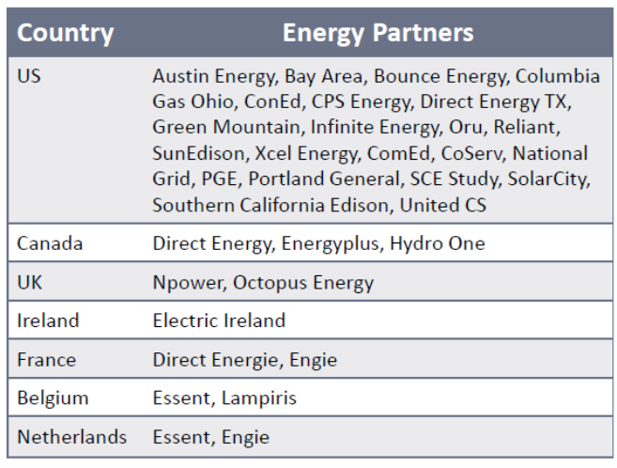

Consumers, Nest, and energy providers offering important savings for its customers have their benefits: For energy providers, the different programs help reduce the load on the electrical grid during times of high demand for energy and the utilities can gain access to usage data which allows them to improve their business performance and the efficiency of their investments. For Nest, it has created a significant revenue stream by taking advantage of its customer insight around usage. Considering that product life expectancy can surpass a decade, revenue from utilities is likely to be greater than the direct revenue from thermostat sales. Consumers also have an easy way to make important savings in energy consumption per day and season.
For insurance companies, Nest rewards customers by offering reduced pricing on their home insurance policy when they deploy a Nest Protect smoke alarm. It is mentioned above. Important is that Nest’s capacity to accommodate the needs of each type of partner is crucial for offering concrete benefits for partners and their customers. Insurance partners subsidize the total device cost of Nest Protect by promotion which is only valid for the battery model to avoid additional installation costs. The “Nest Safety Rewards Program” rewards “responsible” customers by reducing the price of their home insurance policy (up to 5% off their insurance premiums). Nest sends monthly summarized data to insurance partners to report the service status of batteries, sensors, and Wi-Fi connectivity. There is no sensitive data shared with partners, guaranteeing data privacy. Nest developed a way to monetize customer data and emphasizes how the consumer benefit from sharing data with their insurance provider. Even if 5% is not a significant discount on insurance premiums, the use of economic incentives has the potential to make smart home energy consumers more responsible about preventing hazards by using smart technology at home.
Nest Safety Rewards Program started from June 2015. First company was Liberty Mutual which has its own “Smart Home Verified Discount Program” and it offers additional discounts for smartphone-enabled water and theft protection technologies. By switching to Liberty Mutual home insurance, the policyholder receives a $99 Nest Protect at no cost and 5% discount on the home, condo, or renters’ policy. Additionally, the insurer offers 20% off the fire portion and a 10% discount when auto insurance is added. As of 2017, the offer is available in more than 20 states across the US if customers join the Nest Safety Rewards program. Through monthly reports, this program allows Liberty Mutual to verify if the devices are working correctly [9].
American Family has also offered a $99 Nest Protect at no cost and 5% discount on the home policy from June 2015. This company had its own home automation technology platform, Revolv and it was later sold to Nest in November 2013. American Family offers better rates for homeowners equipped with qualifying devices including water/moisture detection systems, video doorbell, burglar alarms, and automatic sprinkler systems. It offers a $99 Nest Protect (battery version) at no cost and a 5% discount on the home policy. The policyholder needs to join the Nest Safety Rewards program to receive the monthly discount and share certain types of data with American Family on monthly basis. Nest sends monthly summarized data to the insurance partners to report on the service status of the batteries, sensors, and Wi-Fi connectivity. There is no shipping, service, or monthly fees associated with this program [9]. AXA offered more than 1,000 Nest Protect alarms to its customers as part of a broader initiative to increase awareness and adoption of fire safety products among the Belgian population only from February 2015 to March 2016 [9].
Nest created an ecosystem of partners and developers that promotes the integration of devices, platforms, and services at a functional level. For this program to work, Nest must bring on board various partners with different business objectives and go-to-market strategies. As mentioned above, energy providers want to reduce the load on the electrical grid by using smart thermostats, while insurance companies want to reduce risks by using smoke detectors (and other such devices). Nest’s capacity to accommodate different needs and deliver tangible benefits for consumers is key for the expansion of partners and the data has an important role.

4. Profit formula: Distribution and monetization [8] [10]
As of 2017, Nest’s solutions are only available in 11 countries, in North America and Europe, and majority of partners capable of providing support services are based in the US. Nest needs more partners and learns the lessons from the temporary recall of Nest Protect due to a product flaw [10]. Nest created only the product and developed technology platform combining hardware revenue with revenue from the monetization of data as mentioned above. Nest needs to have global expansion for monetization. Nest develops the service channel for the diverse distribution. There are two routes: Direct and indirect. For direct distribution, Nest uses its own store including Google’s store. It created a sales portal offering Nest products, Nest Pro installation services, and selected products from “Works with Nest” partners. Nest Store gives customers access to multiple smart home solutions in one place. This strategy enables the customer to create a Nest home, allowing Nest to not only materialize its smart home vision, but also demonstrate its commitment towards its partners. Since the acquisition of Nest, Google’s online store offers Nest products together with other Google devices such as smartphones, tablets, and Chromebooks including Google Home which is a voice-activated smart device that provides home assistance and entertainment, among other tasks. After reunion between Google and Nest in February 2018, there is a promotion which can help Nest buyer save energy bill each month and get a free Google Home Mini.
For indirect sales, Nest offers a variety of sales channels expanding on a regular basis through new partnership agreements. Nest products are available on online, e-commerce sites like eBay and available from retail stores such as Best Buy, Target, Staples, Walmart, Home Depot, Lowe’s, John Lewis, and Maplin. The company provides Nest displays for the stores to showcase the products. All Nest certified installers also can resell Nest products together with installation services. They can purchase the Nest products at a local Nest distributor or ‘Nest Pro’ store. As mentioned above, especially energy providers resell Nest thermostats at discounted prices as part of fixed-term bundles that can include installation services at no extra charge or at an additional fixed or variable price depending on the type of installation. Some telecoms service providers like Verizon Wireless in the US resell Nest products, but it is not an integration in terms of functionality. Frontier Communications in the US resells Nest products at discounted prices when customers switch to Frontier High-Speed Internet and offers installation services for an additional cost.
Nest also needs to think about further monetization and to have more partnerships with other business platforms not only for distribution channels such as telecom’s home service, but also for new business models. An example of business partnership with other business platforms is a partnership agreement with AirBnB. Nest and AirBnB signed a sales agreement to provide free Nest thermostats to selected AirBnB hosts in the US from 2014. Its primary purpose is to expand the distribution channel. But AirBnB can also make its own home-rental service more environmentally friendly and in terms of SHE, hosts can save energy while increasing Nest brand’s visibility. As part of the deal, AirBnB hosts using Nest can have free access to MyEnergy, a platform tracking energy consumption and helping consumers be more aware and energy-efficient at home. In addition, in November 2015, AirBnB introduced a new product suite with several tools and services for hosts. One of them is “Host Assist,” which allows an easy key exchange and keyless entry to a property and it connects AirBnB accounts with several partner products including Yale Locks and its new “Works with Nest Linus lock”. It allows hosts to create guest passcodes through the Nest application based on specific check-in and check-out dates. It also provides notifications about guests’ arrival. Additionally, the smart lock shows a caution symbol when there is CO in the property thanks to its integration into Nest Protect.

CONCLUSION

The key activities based on strategy framework can be summarized as figure 3. Nest’s capacity and functionality is to offer a seamless integration of devices, platforms, and services and the “Works with Nest” offers an ecosystem that can fulfil the needs of different partners. For utilizing and monetizing customers’ usage data, Nest provides a seamless end-to-end customer experience supported by product incentives. Nest also introduces the Nest Developer Program and Nest APIs to connect its smart devices to the wider IoT. Nest is open to external technology, IFTTT. “If This, Then That,” free service allows users to design their own conditional commands known as “recipes” to create solutions integrating devices and applications.

Figure 3 Key summary of the result
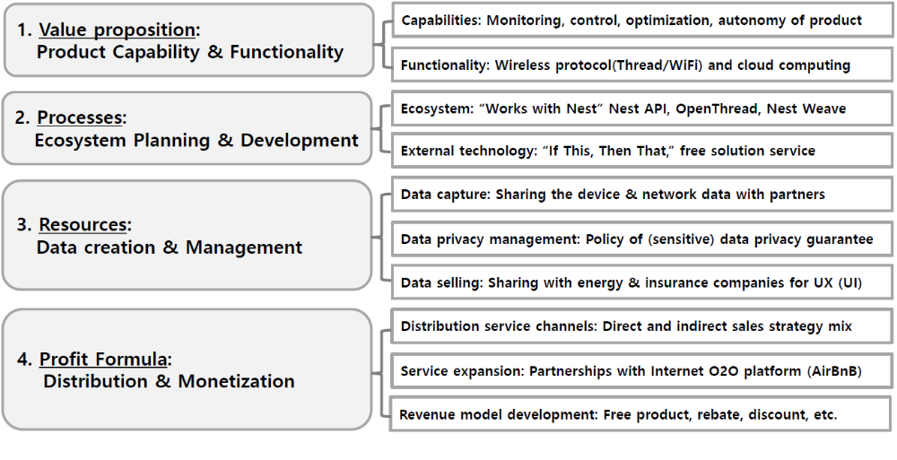
Based on the capabilities and functionalities, Nest builds Nest home. In terms of product interoperability, all Nest products were designed to work together, acting as hubs in and of themselves. For example, if there is a carbon monoxide leak, the Nest Protect can send a command to the Nest Thermostat to turn off the heat. The Nest app controls them from one single place. In terms of enhanced functionality, Nest introduced new product functionality that further automates integration. For example, Nest Family Accounts allow up to 10 people to control the Nest products in a home from their own Nest Accounts. Nest Home/Away Assist uses GPS location, learning algorithms, and activity sensors built into Nest products to determine if anyone is home. After these activity, Nest made an ecosystem, “Works with Nest program.” Thanks to the support of numerous partners and third-party developers, all Nest products can interact with other smart home devices, platforms, and services. Nest has created an open ecosystem of partners and developers that promotes the integration of devices, platforms, and services at a functional level. In terms of creating SHE ecosystem, Nest has partnered with 32 energy providers as of 2017. These partners provide energy from renewable and non-renewable energy sources. In terms of data management for SME, Nest found a way to monetize customer data, emphasizing how the consumer can benefit from sharing information with their energy and insurance provider. Even if 5% is not a significant discount on insurance premiums, the use of economic incentives has the potential to make consumers more responsible about preventing hazards by using SHE technology at home. Nest has created a sales channels in direct and indirect route. Very interesting is that as part of the deal, AirBnB hosts who use Nest can have free access to MyEnergy, a platform tracking energy consumption and helping consumers become more energy-efficient at home.
In conclusion, by opening its smart home platform to third-party developers and partners, Nest has made it possible for any smart solution to connect with Nest, encouraging at the same time the creation of new automated experiences at home. However, the results of this study are subject to some limitations to have a qualitative analysis and to analyse only one company based on the limited company reports and press releases, but this study offers significant basis where provides the strategic options for creating business model of connected product and shows a use cases to benchmark SHE business. Further study is suggested to compare ecosystem companies such as Google, Amazon, and Apple in competition along the four detailed business models and 10 strategic choices.

ACKNOWLEDGMENT
This work…

REFERENCES

- OVUM, Smart Home Service Provider Tracker: 1H17, July 2017.
- Xiao, J. and Raouf Boutaba, The Design and Implementation of an Energy-Smart Home in Korea, Journal of Computer Science and Engineering, Vol. 7, No. 3, September 2013, pp. 204-210.
- Rodríguez-Molina, J., Martínez-Núñez, M., Martínez, J.-F, and W. Pérez-Aguiar, Business Models in the Smart Grid: Challenges, Opportunities and Proposals for Prosumer Profitability, Energies, 2014, 7, 6142-6171
- Lobaccaro, G., Carlucci, S. and Erica Löfström, A Review of Systems and Technologies for Smart Homes and Smart Grids, Energies, 2016, 9, 348; doi:10.3390/en905034.
- Porter, M.E. and Heppelmann, J.E., “How Smart, Connected Products Are Transforming Competition,” Harvard Business Review, Nov. 2014
- Van Alstyne, M.W., Parker, G.G. and Sangeet Paul Choudary, “Pipelines, Platforms, and the New Rules of Strategy,” Harvard Business Reviews, April 2016
- Christensen, C.M, Bartman, T. and Derek van Bever, The Hard Truth About Business Model Innovation, MIT Sloan Management Review, Sep. 13, 2016.
- Zamoszczyk, M., Google Home Case Study, OVUM, December 2016
- Zamoszczyk, M., Smart Home: Insurance Industry Business Models, OVUM, January 2017
- Zamoszczyk, M., Google Assistant and Nest continue to fuel Alphabet’s strategy for the smart home, OVUM, Feb. 17, 2017.

