Recovery of rare earth elements and yttrium from U.S. domestic coals and coal by-products
Ronghong Lin, PhD, National Energy Technology Laboratory, USA
Yee Soong, PhD, National Energy Technology Laboratory, USA
Bret H. Howard, PhD, National Energy Technology Laboratory, USA
Elliot A. Roth, PhD, National Energy Technology Laboratory, USA; AECOM, USA
Evan J. Granite, PhD, National Energy Technology Laboratory, USA

Abstract

Rare earth elements and yttrium (REY) are of strategic importance because they find numerous applications in various sectors of the global economy such as clean energy production, health care, oil refining and electronics. As the U.S. is 100% dependent on REY imports, these elements are critical to our national security, energy independence, environmental future, and economic growth. The development of technologies and processes that could economically extract and recover REY from alternative domestic resources will help to maintain the nation’s economic growth and national security. To tackle these challenges, National Energy Technology Laboratory (NETL) has created a collaborative R&D program to develop technologies for the recovery of REY from U.S. domestic coals and coal by-products.

In this presentation, a brief introduction will first be given on the discovery of REY, global REY production, REY applications as well as current U.S. REY demand. The opportunities and challenges associated with the research initiative for the recovery of REY from U.S. domestic coals and coal by products will be discussed. Progress on sampling, sample characterization, physical separations and chemical treatment of coal and coal by-products for REY enrichment will be reported. Our results indicate that U.S. domestic coal is a promising, alternative source for beneficial recovery of REY to meet the U.S. REY demand for economic growth.
Image
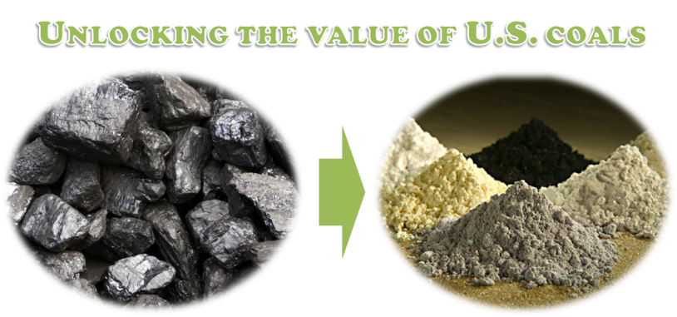
Recent Publications (minimum 5)
- Lin R, Howard B, Roth EA, Bank TL, Soong Y and Granite EJ (2017) Enrichment of Rare Earth Elements from Coal and Coal By-Products by Physical Separations, Fuel 200: 506-520.
- Lin R, Bank TL, Roth EA, Granite EJ and Soong Y (2017) Organic and Inorganic Associations of Rare Earth Elements in Central Appalachian Coal, International Journal of Coal Geology 179: 295-301.
- Lin R., Soong Y and Granite EJ (2018) Evaluation of Trace Elements in U.S. Coals Using the USGS COALQUAL Database Version 3.0. Part I: Rare Earth Elements and Yttrium (REY), International Journal of Coal Geology, In press.
- Lin R., Soong Y and Granite EJ (2018) Evaluation of Trace Elements in U.S. Coals Using the USGS COALQUAL Database Version 3.0. Part II: Non-REY Critical Elements, International Journal of Coal Geology, In press.
- Roth E, Macala M, Lin R, Bank T, Thompson R, Howard B, Soong Y and Granite E (2017) Distributions and Extraction of Rare Earth Elements from Coal and Coal By-Products, 2017 World of Coal Ash (WOCA) Conference, Lexington, Kentucky, May 9-11, 2017.

Biography
Dr. Ronghong Lin is currently an ORISE postdoctoral research associate at U.S. Department of Energy’s National Energy Technology Laboratory (NETL) in Pittsburgh, PA. He obtained his PhD degree in Chemical Engineering from Syracuse University, Syracuse, New York in 2011. Prior to joining NETL, he was a postdoctoral research associate at Syracuse University. His research interests include fuels and renewable energy, adsorption, supercritical fluid technology, and rare earth elements. He is currently working on recovery of rare earth elements, yttrium, and other valuable elements from coal and coal by-products.

Email: ronghong.lin@netl.doe.gov

Notes/Comments:

