Electrochemical Oxidation of Formic Acid with Pd/WC Electrodes Synthesized by Atomic Layer Deposition.
Uwitonze Nestorª, Wei Chenª and Yan-Xia Chen*
Hefei National Laboratory for Physical Sciences at Microscale, Department of Chemical Physics, University of Science and Technology of China, Hefei, 230026, China
Uwitonze@mail.ustc.edu.cn
Tel : +8615656576310
Table of contents 
1. Introduction
2. Materials and Methods
3. Results and Discussions
3. 1 Factors affecting formic acid oxidation on Pd/WC electrode
3.2 Testing the stability of Pd/WC electrode for direct formic acid fuel cell
3.3 Differential Electrochemical Mass Spectroscopy(DEMS) approach for formic acid oxidation on Pd/WC electrode
4. Conclusion
Acknowledgement
References

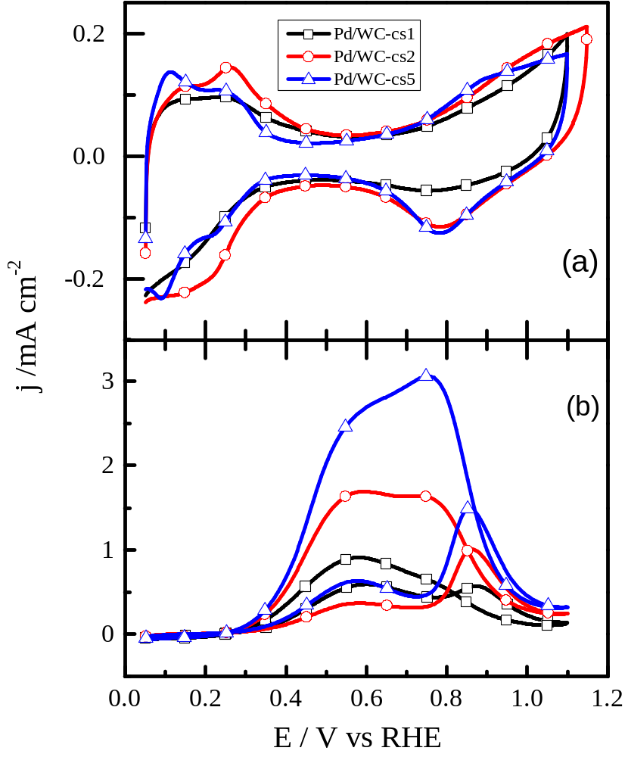

Figure. Cyclic voltammogram of Pd/WC in 0.1 M HClO₄, the scan rate is 100 mV/s. (Top figure). Cyclic voltammograms of 0.1M formic acid electrooxidation obtained in 0.1M HClO4 at the Pd/WC,the scan rate is 10 mV/s (Bottom figure)

Abstract

Palladium/Tungsten carbide (CS1), (CS3), and (CS5) electrodes have been synthesized by Atomic Layer Deposition technique (ALD). The obtained electrodes were used for electro-oxidation of formic acid. Electrochemical techniques such as Cyclic Voltammetry (CV) and Chrono-Amperometry(CA) were applied for electrocatalytic investigations and was found that Pd/WC(5C) was catalytically more active than Pd/WC(CS1) and Pd/WC(CS3).The effect of some experimental factors was studied and optimum conditions were suggested. The finding indicated that the synthesized electrodes have satisfactory stability and improved activity when cycling many cycles. To investigate the nature of intermediates formed for formic acid oxidation, Differential Electrochemical Mass Spectrometry (DEMS) machine has been used for both Cyclic Voltammetry and Potential step measurements. The production of CO₂ mass signal is an indication that the synthesized electrocatalyst is good for formic acid oxidation.
Keywords: Tungsten carbide, formic acid oxidation, DEMS, Atomic Layer Deposition.

References

1. Rhee, Y.-W., S.Y. Ha, and R.I. Masel, Crossover of formic acid through Nafion® membranes. Journal of Power Sources, 2003. 117(1): p. 35-38.
2. Yu, X. and P.G. Pickup, Recent advances in direct formic acid fuel cells (DFAFC). Journal of Power Sources, 2008. 182(1): p. 124-132.
3. Ha, S., et al., Direct formic acid fuel cells with 600 mA cm–2 at 0.4 V and 22° C. Fuel Cells, 2004. 4(4): p. 337-343.
4. Rice, C., et al., Catalysts for direct formic acid fuel cells. Journal of Power Sources, 2003. 115(2): p. 229-235.
5. Habibi, B. and S. Mohammadyari, Palladium nanoparticles/nanostructured carbon black composite on carbon–ceramic electrode as an electrocatalyst for formic acid fuel cells. Journal of the Taiwan Institute of Chemical Engineers, 2016. 58: p. 245-251.
6. Rice, C., et al., Direct formic acid fuel cells. Journal of Power Sources, 2002. 111(1): p. 83-89.
7. Zhu, Y., S.Y. Ha, and R.I. Masel, High power density direct formic acid fuel cells. Journal of Power Sources, 2004. 130(1): p. 8-14.
8. Lust, E., et al., Pt and Pt–Ru catalysts for polymer electrolyte fuel cells deposited onto carbide derived carbon supports. Electrochimica Acta, 2013. 101: p. 130-141.
9. Hu, C., et al., Preparation of high performance Pd catalysts supported on untreated multi-walled carbon nanotubes for formic acid oxidation. Electrochimica Acta, 2010. 55(20): p. 6036-6041.
11. Mostafa, E., Electrocatalysis and Kinetics of the Direct Alcohol Fuel Cells: DEMS and ac Voltammetry Studies, 2013, Bonn, Rheinische Friedrich-Wilhelms-Universität Bonn, Diss., 2013.
12. Borkowska, Z., A. Tymosiak-Zielinska, and G. Shul, Electrooxidation of methanol on polycrystalline and single crystal gold electrodes. Electrochimica Acta, 2004. 49(8): p. 1209-1220.
13. Chen, Y.-X., et al., Bridge-bonded formate: active intermediate or spectator species in formic acid oxidation on a Pt film electrode? Langmuir, 2006. 22(25): p. 10399-10408.
14. Chen, Y.X., et al., Kinetic Isotope Effects in Complex Reaction Networks: Formic Acid Electro‐Oxidation. ChemPhysChem, 2007. 8(3): p. 380-385.

