Potential yield of dedicated energy crops: results and outcomes of the Sun Grant Regional Feedstock Partnership
Vance N. Owens, PhD, South Dakota State University, USA

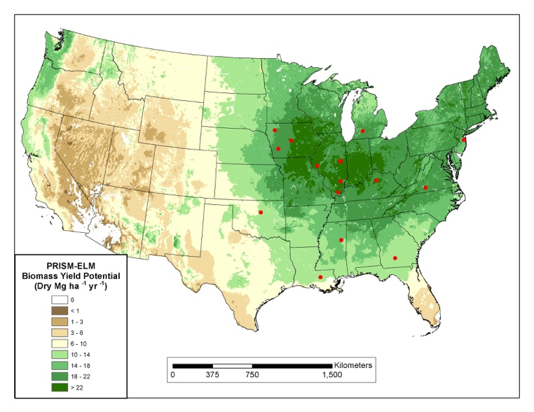
Abstract
Statement of the Problem: The Sun Grant Regional Feedstock Partnership commenced in 2007 with the goal of supporting the realization of the biomass potential envisioned in DOE’s 2005 Billion Ton Report. Concluding in 2016, the partnership sought to increase the knowledge of bioenergy through coordinated feedstock research across the lower 48 states and Hawaii with partners in academia, government, and private industry. Methodology & Theoretical Orientation: The core of the research includes over 130 field trials and regional resource assessment activities focused on agricultural residues and a suite of likely dedicated energy crops. In 2013 a series of meetings was held across the US with each of the crop teams and the resource assessment team, led by the Oregon State University and Oak Ridge National Laboratory, to review, standardize, and verify yield trial data and assimilate their outcomes into a national model of biomass yield suitability. The meetings provided a way to “ground truth” yield estimates in order to accurately capture interactions of climate and soils for dedicated energy crops, including switchgrass, energycane, biomass sorghum, CRP mixtures, Miscanthus x giganteus, hybrid poplar, and willow. Findings: From these sets of funded trials and historical data, yield was estimated across spatial gradients according to soil characteristics and climate history (see Figure 1 for Giant Miscanthus example). The resulting spatial grids provide critical information for policymakers and planners of the potential productivity of these pre-commercial crops. National yield estimates, as well as overall yield across the continental USA, demonstrated potential for these diverse feedstock resources. Conclusion & Significance: Production and management data, as well as biomass composition characteristics, provide empirical support of logistic design and feedstock supply systems. These data and maps are vital for policy makers, producers, end-users, and others in the bioeconomy.

Figure 1. Example yield potential map developed from the Regional Feedstock Partnership Field Trials. This map is for Giant Miscanthus; maps were also developed for upland and lowland switchgrass, energycane, mixed grasses, sorghum, willow, and poplar.
Recent Publications
- D.K. Lee, 55 other authors, and V. Owens. 2017. Biomass Production of Herbaceous Energy Crops in the United States: Field Trial Results and Yield Potential Maps from the Multiyear Regional Feedstock Partnership. GCB Bioenergy (Accepted).
- Liming Lai, Chang Oh Hong, Sandeep Kumar, Shannon L. Osborne, R. Michael Lehman and Vance N. Owens. 2017. Soil nitrogen dynamics in switchgrass seeded to a marginal cropland in South Dakota. GCB Bioenergy, doi:10.1111/gcbb.12475.
- John H. Fike, James W. Pease, Vance N. Owens, Rodney L. Farris, Julie L. Hansen, Emily A. Heaton, Chang O. Hong, Hilary S. Mayton, Robert B . Mitchell and Donald R. Viands. 2017. Switchgrass nitrogen response and estimated production costs on diverse sites. GCB Bioenergy (2017), doi: 10.1111/gcbb.12444.
- Arvid Boe, Paul J. Johnson, Vance Owens, DoKyoung Lee, Jia Guo, Jose L. Gonzalez- Hernandez. 2017. Genetics and Partitioning for Biomass of Prairie Cordgrass Compared to Switchgrass on Marginal Cropland. Bioenergy Research DOI 10.1007/s12155-017-9849-0.
- Ibrahim, M., Chang Oh. Hong, S. Singh, S. Kumar, S. Osborne, and V. Owens. 2017. Switchgrass biomass quality as affected by nitrogen rates, harvest time, and storage. Agron. J. 109:1–11, doi:10.2134/agronj2016.07.0380.
- Owens, V.N., D.R. Viands, H.S. Mayton, J.H. Fike, R. Farris, E. Heaton, D.I. Bransby, C.O. Hong. 2013. Nitrogen use in switchgrass grown for bioenergy across the USA. Biomass and Bioenergy http://dx.doi.org/10.1016/j.biombioe.2013.07.016.

Biography (150 word limit)
Vance Owens received BS, MS, and PhD degrees at Brigham Young University, Utah State University, and the University of Wisconsin-Madison, respectively. He is Director of the North Central Sun Grant Center and Professor of Plant Science at South Dakota State University. He has conducted research on production of bioenergy feedstock crops, specifically perennial species, for more than 20 years.
Email: vance.owens@sdstate.edu

Notes/Comments:

