Recent Developments in Wind Turbine Sensing for Structural Health Monitoring
Christopher Niezrecki, Ph.D., University of Massachusetts Lowell and WindSTAR Industry/University Cooperative Research Center, USA

Abstract
A significant amount of interest exists in performing wind turbine structural health monitoring, characterization, and evaluation. The presentation highlights some recent advances in optical sensing, acoustic methods, infrared, UAV sensing, and radar technologies that can be applied to characterize wind turbine structural health, structural dynamics, damage, and embedded defects. Non-contacting, full-field surface dynamic measurements are presented that leverage three-dimensional (3D) digital image correlation (DIC), point tracking (PT), and motion magnification methods. The approaches are able to obtain full-field geometry data, in three dimensions. Information about the change in geometry of an object over time can be found by comparing a sequence of images and virtual strain gages (or position sensors) can be applied over the entire visible surface of an object of interest. Non-contact structural dynamic information can be extracted. Results from structural interrogation of acoustic monitoring, infrared sensing, and radar sensing are also presented on a variety of test objects. Several examples of various sensing technologies are presented on wind turbine rotors and blades.

Image
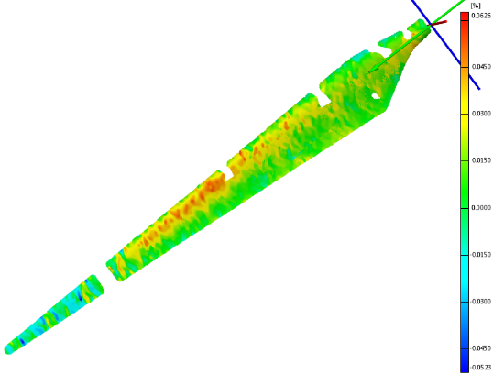
Figure 1. Full-field strain extracted from a 9 m wind turbine blade by using optical, non-contact sensing.
Recent Publications
- Poozesh, P., Baqersad, J., Niezrecki, C., Avitabile, P., Harvey, E., and Yarala, R., "Large-Area Photogrammetry Based Testing of Wind Turbine Blades," Journal of Mechanical Systems and Signal Processing, Vol. 86, Part B: P. 98-115, 2017, Doi.Org/10.1016/J.Ymssp.2016.07.021, 2016.
- Baqersad, J., Poozesh P., Niezrecki, C., and Avitabile, P., "Full-Field Optical Measurement Techniques in Structural Dynamics - A Review", Mechanical Systems and Signal Processing, Special Issue: Non-Contact Measurement, doi:10.1016/j.ymssp.2016.02.011, 2016.
- Baqersad, J., Niezrecki, C., and Avitabile, P., "A Non-Contacting Approach for Full-Field Strain Monitoring of Rotating Structures," J. of Vibration and Acoustics, Vol. 138, pp. 31008-31008-9, 2016.
- Baqersad, J., Niezrecki, C., Avitabile, P., “Full-Field Dynamic Strain Prediction on a Wind Turbine using Displacements of Optical Targets Measured by Stereophotogrammetry,” Mechanical Systems and Signal Processing, doi:10.1016/j.ymssp.2015.03.021, 2015.
- Niezrecki, C., Avitabile, P., Chen, J., Sherwood, J., Lundstrom, T., LeBlanc, B., Hughes, S., Desmond, M., Beattie, A., Rumsey, M., Klute, S. M., Pedrazzani, R., Werlink, R., and Newman, J., “Inspection and monitoring of wind turbine blade-embedded wave defects during fatigue testing,” Journal of Structural Health Monitoring, Vol. 13(6) pp. 629-643, 2014.
- LeBlanc, B., Niezrecki, C., Avitabile, P., Chen, J., Sherwood, J. “Damage Detection and Full Surface Characterization of a Wind Turbine Blade Using Three-Dimensional Digital Image Correlation,” Journal of Structural Health Monitoring, Volume 12 Issue 5-6, pp. 430 – 439, September 2013.

 Biography
Dr. Niezrecki is Professor and Chair of Mechanical Engineering at the University of Massachusetts Lowell, the Co-Director of the Structural Dynamics and Acoustics Systems Laboratory (http://sdasl.uml.edu/), the Director of the Center for Wind Energy at UML (www.uml.edu/windenergy), and also the Director of the National Science Foundation-Industry/University Cooperative Research Center for Wind Energy Science, Technology and Research (WindSTAR). He has been directly involved in structural dynamics, acoustics, smart structures and materials, and sensing research for over 23 years, with more than 100 publications. He has conducted over $11M USD of sponsored research through grants from numerous federal and state agencies as well as several companies. Email: Christopher_Niezrecki@uml.edu

Notes/Comments:

