Controlled Synthesis and Layer-Number-Dependent Catalytic Properties of Few-layered MoS₂/CdS van der Waals heterostructures for Efficient Photocatalytic H₂ Evolution
Shahid Iqbal
International Research Center for Renewable Energy, State Key Laboratory of Multiphase Flow in Power Engineering, Xi'an Jiaotong University, Shaanxi, 710049, China.
Abstract: In a typical photocatalytic reaction, efficient solar light harvesting and charge generation, as well as effective charge transport, are key factors that determine the efficiency of the photocatalytic system for H₂ production. Atomically layered heterostructures have attracted significant research interest due to their unique layer-dependent catalysis and electronic properties. Previous studies have reported that the catalytic properties of MoS₂ layered materials are highly dependent on the number of layers, and the difficulty of controlling the number of layers over a substrate has been a bottleneck for widespread use. Therefore, developing a simple, facile and environmentally friendly method to fabricate van der Waals heterostructures (vdWHs) with precisely controlled MoS₂ layers for achieving highly efficient H₂ generation is still a challenge. Here we report for the first time that the H₂ bubbles generated by photocatalytic water splitting are effective in the layer-by-layer exfoliation of MoS₂ nanocrystals (NCs) into few layers (Figure 1). The as obtained few layers can be in situ assembled with CdS nanosheets (NSs) into vdWHs of few-layered MoS₂/CdS NSs which, in turn, are effective in charge separation and transfer, leading to enhanced photocatalytic H₂ production activity. The few-layered MoS₂/CdS vdWHs exhibited a H₂ evolution rate of 140 mmol g_{(CdS)}⁻¹ h⁻¹ and achieved an apparent quantum yield of 66% at 420 nm. This study provides a new strategy for the design of noble-metal-free few-layered MoS₂/CdS vdWH systems for photocatalytic H₂ generation. We believe that this bubble exfoliation strategy can be extended to a range of other layered transition metal dichalcogenide compounds.
Key word: Hydrogen, Bubble exfoliation, Van der Waals heterostructures, MoS₂, Photocatalysis
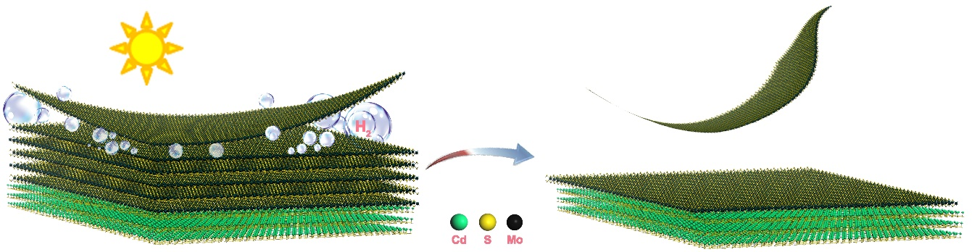
Figure 1: Figure demonstrating the fundamental question that we are tempting to solve experimentally: developing a simple, facile and environmentally friendly bubble exfoliation method to fabricate van der Waals heterostructures (vdWHs) with precisely controlled MoS₂ layers for achieving highly efficient H₂ generation.
References:
1. Chang, K.; Li, M.; Wang, T.; Ouyang, S.; Li, P.; Liu, L.; Ye, J., Drastic Layer-Number-Dependent Activity Enhancement in Photocatalytic H₂ Evolution over MoS₂/CdS (n ≥ 1) Under Visible Light. Advanced Energy Materials 2015, 5 (10).
2. Iqbal, S.; Pan, Z.; Zhou, K., Enhanced photocatalytic hydrogen evolution from in situ formation of few-layered MoS₂/CdS nanosheet-based van der Waals heterostructures. Nanoscale 2017, 9 (20), 6638-6642.

