Distributed Secondary Frequency and Voltage Control of Multiagent Based Autonomous Micro-grid with Enhanced Active and Reactive Power Sharing
Yahong Chen, Changhong Deng, School of Electrical Engineering, Wuhan University, Wuhan 430072, Hubei Province, China

Abstract
Primary frequency and voltage control of Micro grid (MG) generally adopt P-f and Q-U droop control methods to balance power supply and load demands. However, after reaching a new power balance status, MG frequency and voltage would deviate from rated value. Therefore secondary control is needed to restore them. Centralized secondary frequency and voltage restoration in MG have high computation and communication reliability requirements for central PC. This paper presents multi agent based autonomous MG. Secondary restoration function is realized in local agents in decentralized way. Consequently MG operation reliability is increased. Besides, affected by output and line impedance between distributed generations (DGs), terminal voltages of DGs are generally different. It’s difficult for DGs to share active and reactive power. In the proposed MG, active and reactive power between DGs can be shared through dynamically changing their droop curves in local agents. Thus power sharing capability for DGs is enhanced. Simulations results are provided to verify the feasibility of the proposed control strategy.

Image
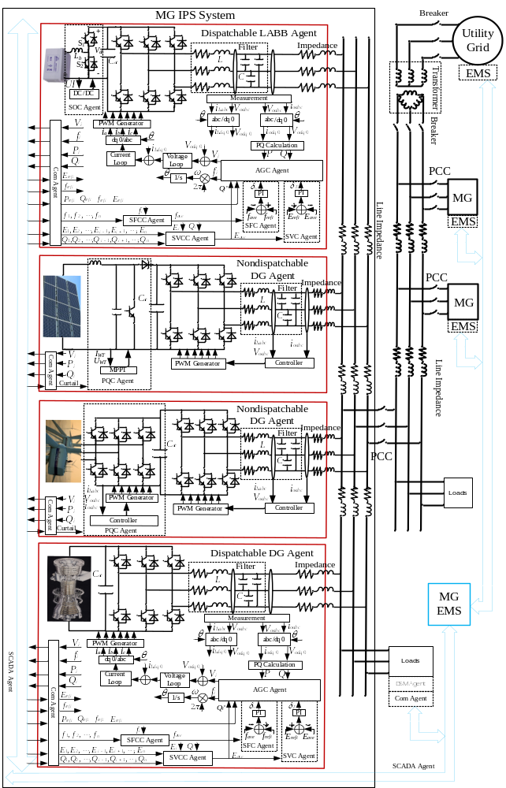
Figure 1. MG IPS system.
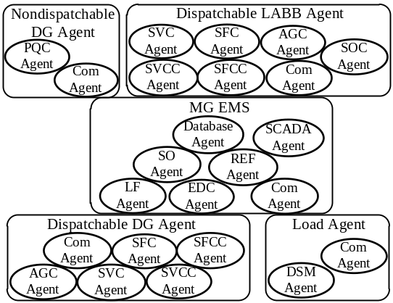
Figure 2. Structure of multi agent system.

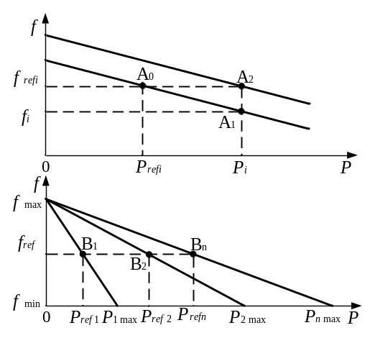
Figure 3. Droop control method. (a) P-f primary and secondary control. (b) Active power sharing.
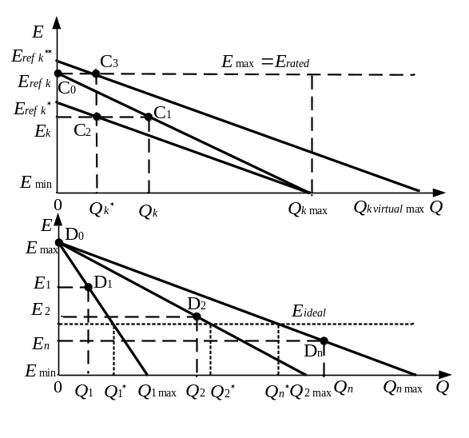
Figure 4. Droop control method.(a) Q-U primary and secondary control. (b) Reactive power sharing.
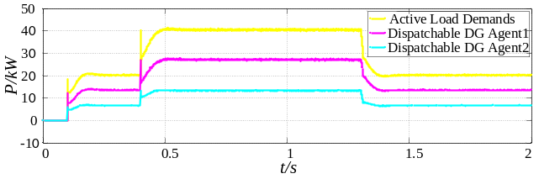
Figure 5. Output of dis-patchable DG agents when load change.
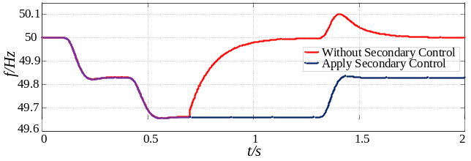
Figure 6. Frequency of dis-patchable DG agents.
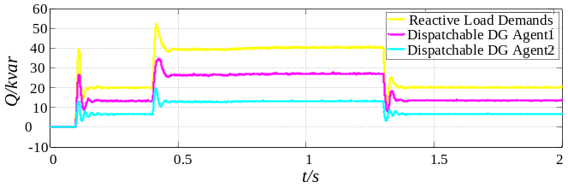
Figure 7. Output of dis-patchable DG agents when reactive load change.

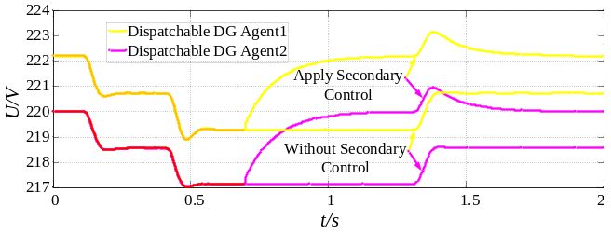
Figure 8. Voltage of dis-patchable DG agents.
Recent Publications
- Sullivan EV, Zahr NM (2008) Neuroinflammation as a neurotoxic mechanism in alcoholism: Commentary on “Increased MCP- 1 and microglia in various regions of human alcoholic brain”. Experimental neurology 213:10-17.
- Olivares D.E, Mehrizi-Sani A., “Trends in Microgrid Control,” IEEE Transactions on Smart Grid, vol.5, pp.1905-1919, July 2014.
- Guerrero J.M., Vasquez J.C, Teodorescu R., “Hierarchical control of droop-controlled DC and AC microgrids — a general approach towards standardization,” 35th Annual Conference of IEEE Industrial Electronics, vol.4, pp.4305-4310, Nov 2009.
- Shafiee Q, Stefanovic C, “Robust Networked Control Scheme for Distributed Secondary Control of Islanded Microgrids,” IEEE Transactions on Industrial Electronics, vol.61, pp.5363-5374, Oct 2014.
- Mao Meiqin, Dong Wei, Liuchen Chang, “Multi-agent based simulation for Microgrid energy management,” IEEE 8th International Conference on Power Electronics and ECCE Asia, vol.2, pp.1219-1223, June 2011.
- Mao Meiqin, Dong Wei, “Design of a novel simulation platform for the EMS-MG Based on MAS,” 2011 IEEE Energy Conversion Congress and Exposition (ECCE), vol.3, pp.2670-2675, Sept 2011.
- Bidram A, Davoudi A, Lewis F.L, “Secondary control of microgrids based on distributed cooperative control of multi-agent systems,” IET Generation, Transmission & Distribution, vol.7, pp.822-831, Aug 2013.
- Micallef A, Apap M, Staines C.S, “Secondary control for reactive power sharing and voltage amplitude restoration in droop-controlled islanded microgrids,” 3rd IEEE International Symposium on Power Electronics for Distributed Generation Systems, vol.1, pp.492-498, June 2012.
- Shafiee Q, Vasquez J.C, Guerrero J.M, “Distributed secondary control for islanded MicroGrids - A networked control systems approach,” 38th Annual Conference on IEEE Industrial Electronics, vol.5, pp.5637-5642, Oct 2012.
- Palma-Behnke R, Benavides C, Aranda E, “Energy management system for a renewable based microgrid with a demand side management mechanism,” 2011 IEEE Symposium on Computational Intelligence Applications In Smart Grid, vol.2, pp. 11-15, April 2011.
- Oyarzabal J, Jimeno J, Ruela J, “Agent based micro grid management system,” 2005 International Conference on Future Power Systems, vol.2, pp.6-18, Nov 2005.
- Meiqin Mao, Peng Jin, Hatziargyriou, “Multiagent-Based Hybrid Energy Management System for Microgrids,” IEEE Transactions on Sustainable Energy, vol.5, pp.938-946, July 2014.

Biography
Yahong Chen received his B.S. degree in Electrical Engineering and Automation from Guizhou University in 2013 and the M.S. degree in Electrical Engineering from Harbin Institute of Technology (HIT) Shenzhen Graduate School, Shenzhen, in 2016, respectively. He is currently working toward the Ph.D. degree at Wuhan University, Wuhan, China. His research interests are micro grids operation, energy management and power systems economic dispatch, sea water pumped storage system operation.

Changhong Deng was born on February, 1963. She is currently a Professor of the School of Electrical Engineering, Wuhan University, Wuhan, China. Her research interests include stability analysis and control of large power system, intelligent control of power grid, power system modelling, planning and digital simulation.
Email: yahongchen@foxmail.com

Notes/Comments:

