Aerodynamic analysis and experimental study on walker sail for Sail-assisted Ships
Yihuai Hu, Professor, Shanghai Maritime University, China
Huawu Zhang, Engineer, Shanghai Maritime University, China

Abstract
Wind sail has high efficiency for wind energy utilization on board ship, which has great significance on ship energy-saving and emission-reduction. A set of walker sail model was made and its aerodynamic characteristics were simulated with Fluent software. The influences of structural parameters of both diversion airfoil and rear airfoil on the walker sails’ aerodynamic characteristics are analyzed. These parameters includes diversion airfoil length, diversion airfoil deflective angle, rear airfoil chord length, rear airfoil thickness, rear airfoil deflective angle and rear airfoil offset clearance. It is discovered that the main function of diversion airfoil is to guide airflow and regulate the gap between main airfoil and rear airfoil, improving airflow condition, reducing flow separation on the surface of rear airfoil and in this way increasing the lift coefficient. The calculated results are ultimately verified by wind tunnel experiments. The diversion airfoil chord length should be as short as possible based on the requirements of its working functions and walker sail arrangement on board ship. If the deflective angle is too large and beyond the optimum range, the lift coefficient will be decreased. Longer diversion airfoil chord length and larger deflective angle could increase the resistance coefficient. The longer the displacement of rear airfoil is, the larger the lift coefficient will be. The displacement of rear airfoil has little influence on the drag coefficient. Finally, some important conclusions are drawn out, which lays the theoretical foundations for walker sail applications on board ship.

Image
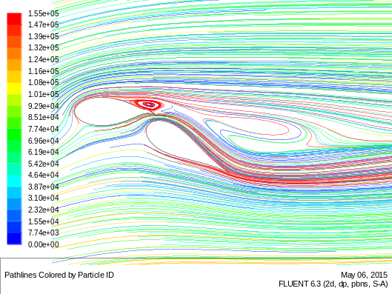
- 3.8cm long diversion airfoil chord
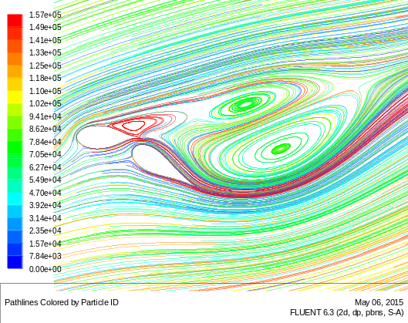
- 5.5cm long diversion airfoil chord
Figure 7: The streamlines with different diversion airfoil chord
Recent Publications
- Yihuai Hu, Juanjuan Tang, Shuye Xue, Sheweng Liu (2015) Stability Criterion and its Calculation for Sail-assisted Ship. International Journal of Naval Architecture and Ocean Engineering 1:1-18.
- YiHuai Hu, Jianhai He, Juanjuan Tang, Shuye Xue (2015) Sail Structure Design and Stability Calculation for Sail-assisted Ships. Marine Engineering Frontiers 3:1-12.
- YiHuai Hu, XiangMin Zeng (2011) Research on the aerodynamic characteristics of ellipse wing sail. Renewable and Sustainable Energy 347:2249-2254.
- YiHuai Hu, Shuye Xue, Jianhai He(2014) Considerations on the Application of Ship Sail-assisted Technology. Ship engineering 3: 1-4.
- YiHuai Hu, Taiyou Wang, Yongli Luan(2017) Numerical Simulation and Kinetic Analysis of Turbine Sail. Journal of Energy and Power Engineering 2: 127-134.
- YiHuai Hu, Taiyou Wang, Hao Jin (2017) Experimental study on aerodynamic characteristics of vertical-axis wind turbine. International Journal of Smart Grid and Clean Energy 2: 104-113.

Biography
Yihuai Hu got his Ph.D. of Marine Engineering from Wuhan University of Technology in 1993, and then worked in the Huazhong University of Science and Technology as a post-doctorial researcher until 1995. He immediately joined Shanghai Maritime University and has been working there since then. In 2006 he worked in the University of New South Wales in Australia as a visiting professor and he is now a professor in Shanghai Maritime University. He is also the member of Shanghai Society of Internal Combustion Engine, member of China Ship Building Society and member of Shanghai System Simulation Society, member of China New Energy Society. Over the past two decades, he has published 110 academic papers and 6 books, guided 6 research projects and participated in 24 projects. He has obtained 11 awards and honors for teaching, research and technical development by Shanghai Education Committee and Communications Ministry of China.
Email: yhhu@shmtu.edu.cn

Notes/Comments:

