Solar module modeling, simulation and validation under matlab/Simulink
Seidou Kane PhD Student, UCAD, Dakar/Senegal Soussou Sambou, Senior lecturer, UCAD Dakar/Senegal

Abstract

The use of renewable energies, particularly photovoltaic systems is growing more and more. These renewable energy sources are essential for the electrification of isolated areas that are not connected to distribution system. The photovoltaic system is the most used in the field of renewable energy [1]. It generates electricity in direct current, without major impact on the environment. However, to understand the operation of the photovoltaic system and estimate its production based on climatic conditions, it is necessary to represent it by a mathematical model based on a PV cell. Solar modules are systems which convert sunlight into electricity using the physics of semiconductors. Mathematical modeling of these systems uses weather data such as irradiance and temperature as inputs. It provides current, voltage or power as outputs, which allows to plot the characteristic curve as a function of voltage V and intensity I for photovoltaic cells. In this work, we have developed a one diode numerical model for a Photovoltaic module under the Matlab / Simulink environment. From this model, we have plotted the characteristic curves I-V and P-V of a solar cell for different values of temperature and sunlight. The validation has been done by comparing the experimental curve of the power obtained from a solar panel (HORONYA 20W type) with the curve power obtained by our model. During the high sunlight, the model underestimates the power. This comes from the high values of ISH and Voc used in the calculated power. Further research can be made by taking into account the RSH.
Image

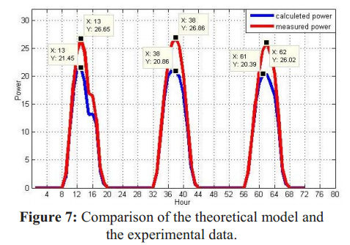

Email: seidou.kane@ucad.edu.sn

