A supercritical power cycle using carbon dioxide for low temperature geothermal sources
Fanxiao Meng, Enhua Wang, Beijing Institute of Technology, Beijing

Abstract (300 word limit)
The wide utilization of renewable energy can relieve current energy crisis effectively. Supercritical Rankine cycle using carbon dioxide as working fluid can be adopted to recover low-temperature geothermal energy. In the study, a thermodynamic model is set up firstly to study the performance of a supercritical Rankine cycle using carbon dioxide as working fluid for low-temperature geothermal source. Then, the effects of the evaporating pressure and temperature on the systematic efficiency are analyzed. The results show that the thermal efficiency increases first and then decreases as the evaporation pressure ascends and there exists an optimal evaporation pressure whose efficiency is maximized. In addition, the system efficiency rises as the evaporating temperature rises. The highest thermal efficiency achieves at 9.53% when the evaporating pressure and temperature are 2.8MPa and 380K, respectively. This study can provide some theoretical guidance for the application of supercritical Rankine cycle system with CO₂ in the future.

Image
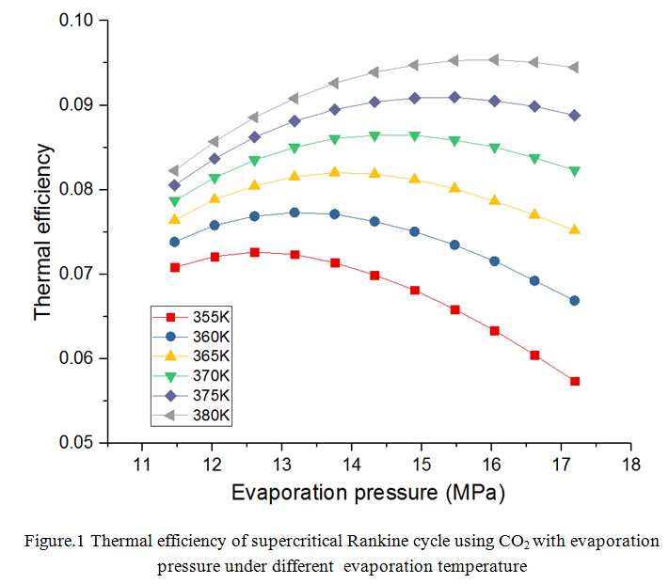
Recent Publications (minimum 5)
- Kim Y M, Kim C G, (2012) Transcritical or supercritical CO₂cycles using both low-and high-temperature heat sources[J]. Energy, 43(1):402-415.
- Le V L, Feidt M, (2014) Performance optimization of low-temperature power generation by supercritical ORCs (organic Rankine cycles) using low GWP (global warming potential) working fluids[J]. Energy,67(4):513-526.
- Yamaguchi H, Zhang X R, (2006) Solar energy powered Rankine cycle using supercritical CO₂[J]. Applied Thermal Engineering, 26(17):2345-2354.
- Chen H, Goswami D Y, (2011) A supercritical Rankine cycle using zeotropic mixture working fluids for the conversion of low-grade heat into power[J]. Energy,36(1):549-555.
- Vidhi R, Goswami D Y, (2014) Supercritical Rankine Cycle Coupled with Ground Cooling for Low Temperature Power Generation [J]. Energy Procedia, 57:524-532.

Biography (150 word limit)
Fanxiao Meng is currently studying at the Beijing Institute of Technology as a PhD student under the instruction of Associate Professor Enhua Wang. His major research is focused on the utilization of renewable energy and recovery of waste heat energy using organic Rankine cycle technology.

Email: 526179895@qq.com

Notes/Comments:

