HOXB4 gene expression is upregulated by ghrelin through PI3-kinase signaling pathway in rat’s bone marrow stromal cells

Hadi Feizi, PhD, Zanjan University of Medical Sciences, Zanjan, Iran
Fatemeh Moradi, PhD, Zanjan University of Medical Sciences, Zanjan, Iran
Mohsen Alipour, PhD, Zanjan University of Medical Sciences, Zanjan, Iran

Abstract

Introduction: Ghrelin, a 28 amino acid peptide, has diverse physiological roles. Phosphatidylinositol-bisphosphate 3-kinase, PI3K and mitogen-activated protein kinase, MAPK are intracellular signal transducers involved in cellular functions such as cell growth and differentiation. Some of the recognized actions of ghrelin are mediated by these enzymes. HOXb4 is a transcription factors and mostly is expressed in hematopoietic stem cells. It has been shown that ghrelin upregulates HOXB4 gene expression in rat’s bone marrow stromal cells (BMSCs) but the real mechanism of this effect is not clear.

Materials and Methods: Rat BMSCs were cultured in DMEM. Passage 3 BMSCs were treated with ghrelin 100 μM for 48 h. Real-time PCR for HOXB4 was performed from Control (untreated BMSCs), BG (BMSCs treated with 100 µM ghrelin), PD (BMSCs treated with 10 µM PD98059 and 100 µM ghrelin) and LY (BMSCs treated with 10 µM LY294002 and 100 µM ghrelin) groups. Relative gene expression changes were determined using Relative expression software tool 9 (REST 9). Values of P<0.05 were considered statistically significant. For immunofluorescence, cells were incubated Anti-Hoxb4 monoclonal antibodies. Primary antibodies were visualized using the FITC method.All data are presented as means ± SEM. Values of P<0.05 were considered statistically significant.

Results: Hoxb4 gene has been overexpressed in ghrelin treated BMSCs (P < 0.05). PI3K inhibition by LY294002 significantly downregulated the ghrelin induced overexpression of Hoxb4 (P < 0.05). The mean of ghrelin treated positive immunoreactive BMSCs were 2.08±0.54, 26.22±1.16, 10.06±2.42 and 18.99±1.08 for B, BG, BH and BGH groups respectively.

Conclusion: Ghrelin upregulates HOXB4 gene expression in rat’s BMSCs through PI3-kinase signaling pathway.
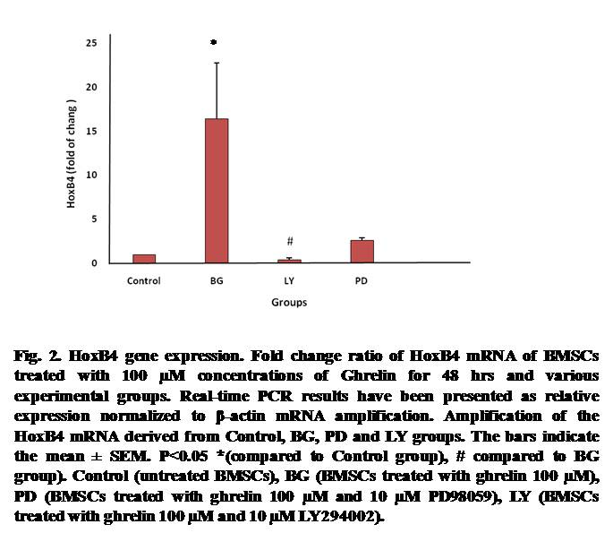
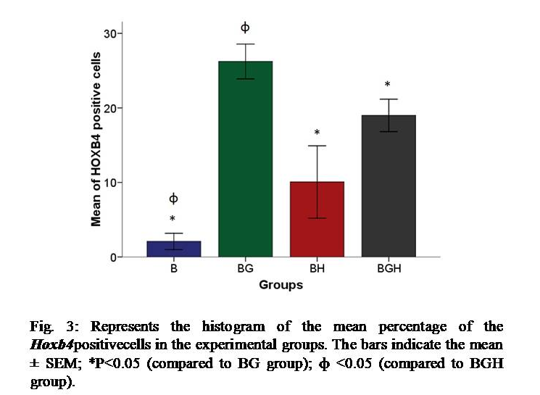
Recent Publications
- Alipour MR, Aliparasti MR, Keyhanmanesh R et al. (2011) Effect of Ghrelin on PKC-ε and PKC-δ gene expression in the pulmonary arterial smooth muscles of chronic hypoxic rats. J Endocrinol Invest 34(10):e369-73.
- Feizi H, Rajaee K, Rana Keyhanmanesh R et al. (2014) Effect of Ghrelin on Renal Erythropoietin Production in chronic Hypoxic Rats. Endocr Regul 48(1): 3–8.
- Varedi M, Moatari A, Amirghofran Z, Karamizadeh Z, Feizi H (2014) Effects of Hypo- and Hyper-thyroid States on Herpes Simplex Virus (HSV) Infectivity in The Rat. Endocr Res 39(1):50-5.
- Abdanipour A, Shahsavandi B, Alipour M, Feizi H (2018) Ghrelin upregulates Hoxb4 gene expression in rat bone marrow stromal cells. Cell J 20(2): 183-187.

 Biography
I am Hadi Feizi who his expertise is in Medical physiology. I am very interested in cellular and molecular mechanisms of physiological actions of endogenous peptides such as ghrelin. Currently, I am a faculty member in Zanjan University of Medical Sciences, Zanjan, Iran.
Email: hfeizik@zums.ac.ir

