POST PARTUM HAEMORRHAGE

ABSTRACT:

Postpartum Haemorrhage is one of the top direct leading causes of maternal mortality and morbidity all over the world particularly in developing countries. Majority of deaths occur within four hours of delivery indicating a major consequence of third stage of labour. 5 We report a similar case of 30 yr old female who presented with post partum haemorrhage, who went into cardiac arrest and successfully resuscitated.

CASE DISCUSSION:

A 30-year-old woman P2L2A1 / status post Emergency Lower segment cesarean section (LSCS) for placenta Previa/ POD-0 was brought to Emergency Department with complaints of Bleeding per vagina after LSCS.
On receiving; HR: 133 / min; BP: not recordable; CBG: 402 mg/dl; Temp: Afebrile; GCS: E3M5V4 12/15; B/L 2mm pupil equally reacting to light. Peripheries were cold. Vaginal packing in situ and Inj.Oxytocin drip was on flow.
Blood grouping and cross matching was sent and Massive Blood transfusion was started at the ratio of 1:1:1.
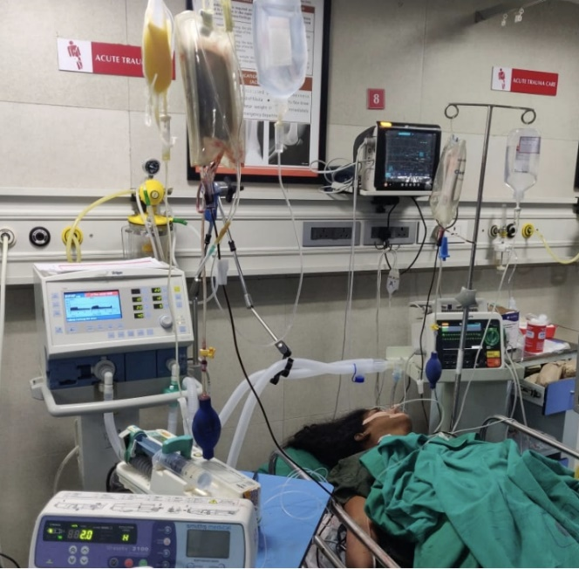
In view of Hypovolemic shock, the patient was intubated and Right IJV was secured.
Arterial blood gas was done which showed Hyperkalaemia and severe Metabolic acidosis. Inj.Calcium gluconate and Inj.Sodium Bicarbonate was administered. Patient was started on inotropes – Inj.Noradrenaline, Inj.Dopamine and Inj. Vasopressin. Inj.Tranexemic acid was administered. Emergent obstetric and Gynaecology opinion was obtained.

Patient cardiac monitor show bradycardia and carotid pulse not felt. Cardio pulmonary resuscitation was initiated as per ACLS protocol. ROSC obtained after 3 cycles of CPR.

Diagnosis Postpartum hemorrhage / Placenta Accreta, Hypovolemic shock, s/p cardiac arrest

Patient was immediately shifted to Operation theatre.
Hysterectomy was performed under General Anaesthesia. Patient was admitted under Intensive care unit. After 3 days of ICU care, patient was extubated and observed in Ward for 5 days. Patient condition improved well and discharged in good condition.

DISCUSSION:

PPH is defined as volume of blood loss ≥ 500ml after vaginal delivery in the first 24 hours after delivery (primary postpartum haemorrhage) or up to six weeks postpartum (secondary postpartum haemorrhage) or greater than or equal to 1000ml after caesarean delivery. 1
According to American College of Obstetrics and Gynaecology in 2017, the PPH is defined as cumulative blood loss greater than 1000 mL with signs and symptoms of hypovolemia within 24 hours of the birth process, regardless of the route of delivery. 2

ETIOLOGY:

There are numerous causes predisposing PPH, but they are briefly categorised into 4 T

- Tone (uterine atony);
Uterine atony is caused by dysfunctional hypo-contractility of the myometrium during the immediate puerperium. Uterine atony causes: leiomyomata, multifetal gestations, polyhydramnios, foetus who are large for gestational age (fetal macrosomia), drugs like magnesium sulfate (preeclampsia, eclampsia) and nifedipine (hypertension in pregnancy). Chorioamnionitis, placental abruption, and placenta that implants into lower uterine segment which leads to subsequent postpartum hemorrhage.

- Tissues (placenta-related problems: Accreta, Incerta, Perceta);
These factors include retained placental fragments as well as the spectrums of placenta previa and placenta accreta.
In placenta previa, the placenta is attached to the uterine wall either partially or completely covering the internal cervical os.
In placenta accreta, the placenta abnormally invades the uterine wall; which is divided into three categories: accreta, increta, and percreta, depending on the depth of invasion into the myometrium.
Placenta percreta, the most invasive type, is characterized by the placenta growing through the uterine wall and potentially invading nearby organs.
- Trauma (uterine rupture, lacerations, uterine inversion);
Uterine inversion occurs when the fundus of the uterus is pulled into the uterine cavity causing the uterus to be turned inside-out.
Trauma from instrumentation which is used to assist during delivery can also cause postpartum hemorrhage. Patients who experience prolonged labor, particularly when uterine stimulants such as IV oxytocin and vaginal prostaglandins are used, can develop postpartum hemorrhage.
Uterine rupture can occur in patients undergoing a trial of labor after cesarean delivery and the risk is significantly increased if the patient has had a low-vertical or high-vertical uterine incision with previous cesarean deliveries.

- Thrombin (in relation to clotting disorders)
May be Inherited or Acquired. Von Willebrand disease is one of the mmost common inherited coagulopathies that can cause postpartum hemorrhage. Acquired coagulopathies include HELLP syndrome (hemolysis, elevated liver enzymes, and low platelets) and disseminated intravascular coagulopathy (DIC). Placental abruption, amniotic fluid embolism, sepsis, fetal demise, and HELLP syndrome can cause DIC.

RISK FACTORS:

- Increase in Maternal age
- Antepartum haemorrhage
- Previous history of PPH
- Haematocrit less than 30%
- Retained placenta
- Augmented labor
- Chorioamnionitis
- Foetal macrosomia
- Maternal anemia
- Maternal obesity
- Multifetal gestation
- Preeclampsia
- Primiparity
- Prolonged labor

CLINICAL PRESENTATION:

- Abdominal examination shows boggy uterus
- Examination of placenta for any placenta missing pieces and retained products of conception.
- Examination of vagina for laceration caused during delivery and uterus displacement into vagina.
- Look for any signs of Disseminated intravascular coagulation.
- Heart rate and BP are the two most commonly used vital signs to predict haemorrhage.
Signs of a haemorrhage include heart rate greater than 110 beats/minute, BP of 85/45 mm Hg or less, SpO2 less than 95%, delayed capillary refill, decreased urine output, and pallor.

INVESTIGATIONS:
Complete blood cell count, coagulation profile, Haemoglobin and Haematocrit, a metabolic panel to assess for electrolyte abnormalities and renal compromise; also order D-dimer, fibrinogen, liver enzymes, and serum lactate levels.

MANAGEMENT:

- Primary survey (ABCs)
Perform the Airway assessment evaluating for patency.
Assess Breathing adequacy and provide supplementation with 100% oxygen if needed.
Assess the Circulatory status (including peripheral pulses, heart rate, blood pressure, and a perineal examination). Support circulation to vital organs by keeping the patient in Trendelenburg position, placing at least 2 large-bore IVs, starting a rapid crystalloid infusion through both IVs, and continuous vital sign monitoring.

- SECONDARY SURVEY
Perform a focused physical examination and a bedside ultrasonography (EFAST examination to look for intra-abdominal fluid and/or a pelvic ultrasound).
Two essential initial interventions for postpartum haemorrhage are oxytocin, fundal massage and uterine massage (Bimanual compression of the uterus). Avoid downward massage it can cause uterine inversion and injury to blood vessels.

Table-1 Medical Management 3
TRANEXAMIC ACID | 1 gm over 10min  2nd dose after 30 min or within 24 hrs if Bleeding persists
OXYTOCIN | 20 to 40 U IV in 1l of crystalloid  Inf. 200-500ml/hr or 10 U IM
METHYLERGONOVINE MALEATE | 0.2mg IM  C.I  Hypertensive and Cardiovascular disorders
CARBOPROST TROMETHAMINE | 0.25mg IM repeat q15min until haemorrhage control  Max dose 1 mg  C.I  Asthma patients
MISOPROSTOL | 800 – 1000 mcg PR

- Direct uterine tamponade:

  - Uterine packaging: uterus is packed with gauze dressings.
  - Balloon tamponade: device is placed into the uterus and balloon is filled with saline or water.

- Targeted transfusion therapy:

Packed red blood cells to maintain haematocrit between 21% and 27% and haemoglobin between 7 and 9 g/l. Rapid transfusion of 2 to 4 units of packed red blood cells is recommended.
Type-specific is preferred, but type O Rh-negative blood may be used.
Monitor for coagulopathy; 4 units of fresh frozen plasma are initially used to help correct a coagulation defect. If the patient's fibrinogen levels are significantly decreased, administer cryoprecipitate.
If significant thrombocytopenia persists, administer platelet concentrates.
The usual ratio of packed red blood cells to fresh frozen plasma to platelets is 1:1:1 as per Massive transfusion protocol. 4

- Definitive surgical management with hysterectomy may be necessary.

CONCLUSION:

Clinicians must manage the patient's hypovolemia and shock by Identifying the cause of the hemorrhage. If the patient has a massive hemorrhage, use life supportive measures. Early diagnosis and intervention in the ‘golden hour’ are essential in reducing mortality from postpartum hemorrhage. A coordinated team effort and decision making will save a life.

ACKNOWLEDGEMENT:

Thanks to Department of Obstetrics and Gynaecology, Department of Anesthesia and Department of Critical Care Medicine.
Reference

- Anger H, Durocher J, Dabash R, Winikoff B. Postpartum blood loss and common definitions of postpartum hemorrhage correlate with postpartum anemia and fall in hemoglobin 2019; 14:e0221216.

- WHO. The Prevention and Management of Postpartum Haemorrhage. Report of a Technical Working Group. Geneva 3–6 July 1989. World Health Organization/Maternal and Child Health 90.7. Geneva: WHO, 1990

- Roberts WE Emergent obstetric management of postpartum hemorrhage. Obstet Gynecol Clin North Am 1995; 22: 283–302

- Knight M, Callaghan WM, Berg C, et al. Trends in postpartum hemorrhage. BMC Pregnancy Childbirth. 2009;9:55.

- Hoveyda F, MacKenzie I: Postpartum haemorrhage: incidence, morbidity and current management. Br J Obstet Gynaecol. 2001, 108 (9): 927-930

Authors:

Dr.Nancy Saral Mary
MEM II yr Resident, Department of Emergency Medicine
Dr.Hema Sindhu
Register, Department of Emergency Medicine
Dr.Narendra Nath Jena
Head of Department of Emergency Medicine

