

Abstract Template

Title: Comparison of the Hemostatic Effect of Topical “Tranexamic Acid” versus “Tranexamic Acid and Chitosan Linear Polymer”, in a Rat Model with Severe Femoral Artery Bleeding

Gürkan ERSOY1, Sibel BÜYÜKÇOBAN2, Meryem ÇALIŞIR³, Hale ERDOST², Elvan ÖÇMEN²
1University of Dokuz Eylül, School of Medicine, Department of Emergency Medicine, Izmir-Turkey
2University of Dokuz Eylul, School of Medicine, Department of Anesthesiology and Intensive Care, Izmir-Turkey
³Department of Laboratory Animal Science, Dokuz Eylül University, Izmir, Turkey

Keywords: Tranexamic acid, chitosan linear polymer, rat, uncontrolled hemorrhage, hemorrhage control

Abstract Body
Hemorrhage is the leading cause of death worldwide. A local hemostatic could reduce mortality due to hemorrhage. Our aim was to determine the hemostatic effect of local tranexamic acid alone or tranexamic acid and chitosan linear polymer together in a rat model with femoral artery bleeding. Femoral artery of rats was pierced to initiate bleeding and assigned to; tranexamic acid and tranexamic acid and chitosan linear polymer groups. For the first group, tranexamic acid and later Chitosan linear polymer was poured over the bleeding site. A weight was placed over the bleeding site. At 30 second intervals, the weight was removed and hemostasis was assessed. After 30 sec, if the bleeding had ceased, the test was scored as passed at 30 sec. If the bleeding did not stop, the same procedures was repeated for 3 times. If hemostasis could not be achieved even after the third application, the test was scored as failed. The same procedures was repeated for the tranexamic acid group without Chitosan linear polymer. Application of tranexamic acid and Chitosan linear polymer resulted in complete control of bleeding in 1, 4, and 2 rats at 30, 60, and 90 sec, respectively. In the tranexamic acid group, hemostasis could be achieved in 1 rat at 60 and 1 at 90 sec. Hemostasis could not be achieved even after 90. sec. in 5 rats. The difference between the groups was significant (p<0.04). Tranexamic acid and chitosan linear polymer together significantly decreased the time to hemostasis compared to other group.

Image:
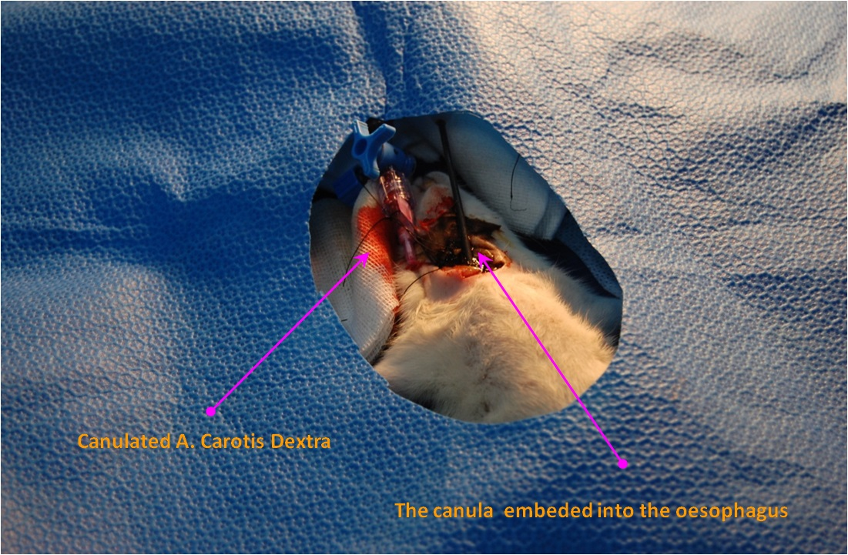
- Reference:

Gürkan Ersoy, Ülkümen Rodoplu, Osman Yılmaz, Necati et all. Hemostatic Efficacy of Local “Chitosan Linear Polymer” Granule in an Experimental Sheep Model with Severe Bleeding of Arteria and Vena Femoralis. Ulus Travma Acil Cerrahi Derg 2016; 22(3): 215-223.
http://www.bleedingcontrol.org/resources/save-a-life-flowchart. Web site, accesed at 10 July, 2018.
Getaw Worku Hassen, Paula Clemons, Michelle Kaplun. Is topical tranexamic acid a better alternative for selected cases of anterior epistaxis management in the Emergency Department? Am J Emerg Med.

Biography:
XXXX has completed his PhD at the age of 25 years from XXXX University and Postdoctoral Studies from School of Medicine, XXXX University, Singapore. He is the Director of XXXX, a premier Bio-Soft service organization. He has published more than 25 papers in reputed journals and has been serving as an editorial board member of repute. (Up to 100 words)

Presenting author details


Full Name: GÜRKAN ERSOY
Contact number: +90 505 525 14 14
Twitter account: @ersoygurkan
Linked In account:
Session name/ number:
Category: (Oral presentation/ Poster presentation) Passport Number:

Copyright © 2016-2018 Meetings Int PTE Ltd, All Rights Reserved.
Meetings Int.Pte Ltd

Company Registration No: 201524282R,28 MAXWELL ROAD, #03-05 RED DOT TRAFFIC, SINGAPORE (069120)
Tel: +6531080483| Toll Free no. +800-852-6126
Web: https://www.meetingsint.com/conferences/emergencymedicine | E-mail: emergencymedicine@annualmeetings.net

