

Pediatric C-spine injuries : Current evidence
Ahmad M. Althekair ¹

¹ Emergency Department, Prince Sultan Military Medical City (Riyadh, Saudi Arabia)

Keywords: cervical, imaging, pediatric, trauma

- Abstract Body (up to 250 words)
Pediatric cervical spine injuries (CSIs) are rare and differ from adult CSIs. It has been a major dilemma in the Emergency Department due to the nature of the patient, age variation and lack of strong evidence. Many research networks in Europe, Australia and north America worked to establish guiding protocols that determine which patients require imaging (CT vs. X-ray) or clinical clearance.
Emergency radiologic evaluation of the pediatric cervical spine can be challenging because of the confusing appearance of synchondroses, normal anatomic variants, and injuries that are unique to children. Cervical spine injuries in children are usually seen in the upper cervical region owing to the unique biomechanics and anatomy of the pediatric cervical spine. Familiarity with anatomic variants is also important for correct image interpretation. These variants include pseudosubluxation, absence of cervical lordosis, wedging of the C3 vertebra, widening of the predental space, prevertebral soft-tissue widening, intervertebral widening, and “pseudo–Jefferson fracture.” In addition, familiarity with mechanisms of injury and appropriate imaging modalities will aid in the correct interpretation of radiologic images of the pediatric cervical spine.

Image:
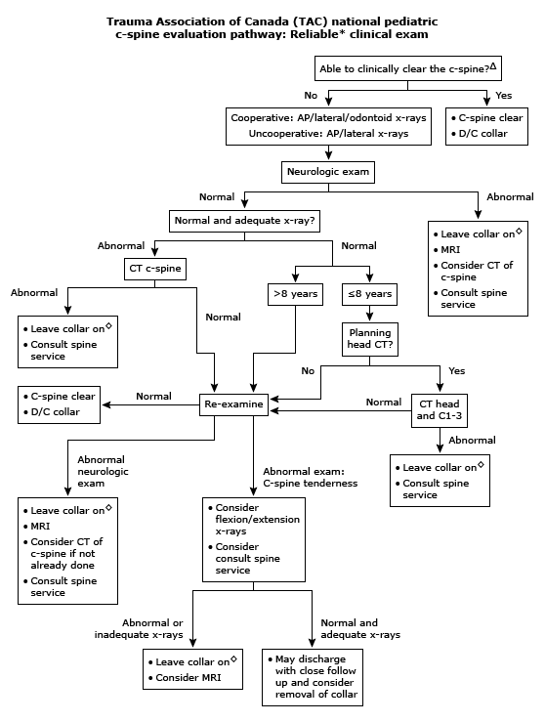
- Reference:

- Leonard et al, Pediatrics Volume 133, Number 5, 2014
- Baker et a, Am J Emerg Med. 1999;17(3):230.
- Hoffman ET al, N. Engl. J. Med. 2000;343:94-9
- Garton et al, Neurosurgery 2008;62:700-8
- Leonard et al, Ann Emerg Med 2011 Aug;58(2):145-55
- Chung et al, Trauma Association of Canada Pediatric Subcommittee National Pediatric Cervical Spine Evaluation Pathway: Consensus Guidelines. J Trauma 2011
- Viccellio et al, Pediatrics. 2001;108(2):E20.
- Pieretti-Vanmarcke et al, J Trauma. 2009;67(3):543.
- Anderson et al, J Neurosurg Pediatr. 2010;5(3):292.

Biography:
Ahmad completed his Boards in Pediatric in Saudi Arabia then joined Hospital for Sick Children (SickKids) in Toronto, Canada where he achieved Pediatric Emergency Medicine fellowship, Pediatric Trauma Fellowship and an advanced training in Pediatric Point of Care Ultrasound (POCUS).
Currently, he is a Consultant Pediatric Emergency and Trauma in Riyadh. He is the Director of Pediatric POCUS training in Kingdom of Saudi Arabia. He is an international speaker in the field of Pediatric Emergency and Trauma with a major research interest in the field of Pediatric POCUS.

Presenting author details

Ahmad Althekair
00966 555587779 @aalthekair
Oral presentation

Copyright © 2016-2018 Meetings Int PTE Ltd, All Rights Reserved.
Meetings Int.Pte Ltd

Company Registration No: 201524282R,28 MAXWELL ROAD, #03-05 RED DOT TRAFFIC, SINGAPORE (069120)
Tel: +1-302-231-6756 ; +6531080483| Toll Free no. +800-852-6126
Web: https://www.meetingsint.com/conferences/emergencymedicine | E-mail emergencymedicine@meetingseries.org

