

Abstract Template

The Impact of Introduction of Code-STEMI Program on the Reduction of Door to Balloon Time in Acute ST-Elevation Myocardial Infarction (STEMI) Patients Undergoing Primary PCI: Single Center Study in Saudi Arabia
Abdulmalik Abdullah Alyahya, Mohammed Abdullah Alghammass, Fahad Saleh Aldhahri, Abdullah Abdulaziz Alsebti, Abdullah Yousef Alfulaij, Saleh Hamad Alrashed, Husam Al Faleh, Mostafa Alshameri, Khalid Alhabib, Mohammed Arafah, Abduellah Moberik, Abdulaziz Almulaik, Zuhair Al-Aseri, Tarek Seifaw Kashour

Keywords: STEMI (ST-elevation myocardial infarction), D2B (door-to-balloon), Primary PCI

Abstract Body (up to 250 words)
Abstract Objectives
This study was conducted to evaluate the effect of direct emergency department (ED) activation of the catheterization lab on door to balloon time (D2BT) and outcomes of acute ST-elevation myocardial infarction (STEMI) patients at a major tertiary care hospital, Riyadh, Saudi Arabia. Methods: This was a retrospective cohort study that enrolled 100 consecutive patients with acute STEMI who underwent primary percutaneous coronary intervention (PPCI), between June 2010 and January 2015. The subjects were divided into two groups of 50 patients each. The first group was treated before establishing the Code-STEMI program. The other was treated according to the protocol, which was implemented in June 2013. The Code-STEMI protocol is a comprehensive program implementing direct activation of the catheterization lab team using a single call system, data monitoring and feedback, and standardized order forms. Results: The mean age for both groups was 54 ±12 years. Males represented 86% (43) and 94% (47) of the patients in the two groups, respectively. 90% (90) of patients in both groups had one or more comorbidities. The Code-STEMI group had a significantly lower D2BT, with 70% of patients treated within the recommended 90 minutes (median= 76.5 minutes, IQR: 63-90 minutes). In contrast, only 26% of pre-Code-STEMI patients were treated within this timeframe (median= 107 minutes, IQR: 74-149 minutes). In-hospital complications were lower in the Code-STEMI group; however, the only statistically significant reduction was in non-fatal re-infarction (8% vs. 0%, p=0.043). Conclusion: Implementation of direct ED catheterization lab activation protocol was associated with a significant reduction in D2BT.

Image:
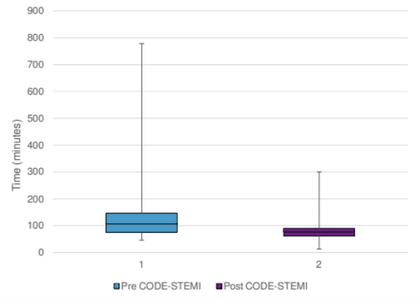
Figure 1: Summary of door to balloon time (D2BT). Median and IQR in the two groups.
Figure 2: Proportions of patients who had a D2BT less/more than 90 minutes in both groups.
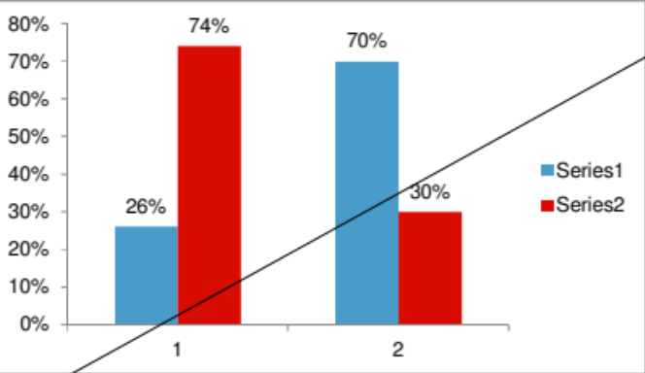
Reference: [1] Members AF, Steg PG, James SK, Atar D, Badano LP, Lundqvist CB, et al. ESC Guidelines for the management of acute myocardial infarction in patients presenting with ST- segment elevation. Eur Heart J 2012 Oct 1;33(20):2569–619. http://eurheartj.oxfordjournals.org/content/33/20/2569.
[2] Keeley EC, Boura JA, Grines CL. Primary angioplasty versus intravenous thrombolytic therapy for acute myocardial infarction: a quantitative review of 23 randomized trials. The Lancet 2003 Jan 4;361(9351):13–20. http://www.sciencedirect.com/science/article/pii/S0140673603121137.
[3] Guptill JT, Mehta RH, Armstrong PW, Horton J, Laskowitz D, James S, et al. Stroke After Primary Percutaneous Coronary Intervention in Patients With ST-Segment Elevation Myocardial Infarction Timing, Characteristics, and Clinical Outcomes. Circ Cardiovasc Interv 2013 Apr 1;6(2):176–83. http://circinterventions.ahajournals.org/content/6/2/176.
[4] O’Gara PT, Kushner FG, Ascheim DD, Casey DE, Chung MK, de Lemos JA, et al. 2013 ACCF/AHA Guideline for the Management of ST-Elevation Myocardial InfarctionA Report of the American College of Cardiology Foundation/American Heart Association Task Force on Practice Guidelines. J Am Coll Cardiol. 2013 Jan 29;61(4):e78–140. http://dx.doi.org/10.1016/j.jacc.2012.11.019.
[5] Rathore SS, Curtis JP, Chen J, Wang Y, Nallamothu BK, Epstein AJ, et al. Association of door-to-balloon time and mortality in patients admitted to hospital with ST elevation myocardial infarction: national cohort study. BMJ 2009 May 19;338(may19 1):b1807–b1807. http://www.bmj.com/content/338/bmj.b1807.long.
[6] Cannon CP, Gibson CM, Lambrew CT, Shoultz DA, Levy D, French WJ, et al. Relationship of symptom-onset-to-balloon time and door-to-balloon time with mortality in patients undergoing angioplasty for acute myocardial infarction. JAMA. 2000 Jun 14;283(22):2941–7.

[7] Chakrabarti AK, Gibson CM, Pinto DS. Optimal selection of STEMI treatment strategies in the current era: benefit of transferring STEMI patients for PCI compared with administration of onsite fibrinolytic therapy. Curr Opin Cardiol. 2012 Nov;27(6):651–4.
[8] Cardiac Care Network. Primary Percutaneous Coronary Intervention Optimizing Access to Primary PCI for ST Elevation Myocardial Infarction. 2010;(September):1–71.
[9] Al-Zakwani I, Zubaid M, Al-Riyami A, Alanbaei M, Sulaiman K, Almahmeed W, et al. Primary coronary intervention versus thrombolytic therapy in myocardial infarction patients in the Middle East. Int J Clin Pharm 2012 Jun;34(3):445–51.
[10] Alhabib KF, Sulaiman K, Suwaidi J Al, Almahmeed W, Alsheikh-ali AA, Amin H, et al. Patient and System-Related Delays of Emergency Medical Services Use in Acute ST- Elevation Myocardial Infarction : Results from the Third Gulf Registry of Acute Coronary Events ( Gulf RACE-3Ps ). 2016;7:1–14.
[11] Kristensen SD, Laut KG, Fajadet J, Kaifoszova Z, Kala P, Di Mario C, et al. Reperfusion therapy for ST elevation acute myocardial infarction 2010/2011: Current status in 37 ESC countries. Eur Heart J. 2014;35(29):1957–70.
[12] AlHabib KF, Hersi A, AlFaleh H, AlNemer K, AlSaif S, Taraben A, et al. Baseline characteristics, management practices, and in-hospital outcomes of patients with acute coronary syndromes: Results of the Saudi project for assessment of coronary events (SPACE) registry. J Saudi Heart Assoc 2011 Oct;23(4):233–9. http://www.journalofthesaudiheart.com/article/S1016731511001783/abstract.
[13] Bradley EH, Herrin J, Wang Y, Barton BA, Webster TR, Mattera JA, et al. Strategies for Reducing the Door-to-Balloon Time in Acute Myocardial Infarction. N Engl J Med 2006 Nov 30;355(22):2308–20. http://www.nejm.org/doi/full/10.1056/NEJMsa063117.

[14] Khot UN, Johnson ML, Ramsey C, Khot MB, Todd R, Shaikh SR, et al. Emergency Department Physician Activation of the Catheterization Laboratory and Immediate Transfer to an Door-to-Balloon Time in ST-Elevation Myocardial Infarction. 2007 Circulation; 116(1):67-76. PMID: 17562960 DOI: 10.1161/CIRCULATIONAHA.106.677401.

[15] the emergency physician without prior consultation decreases door-to-balloon time. J Invasive Cardiol [Internet]. 2005 Mar [cited 2017 May 1];17(3):154–5. http://www.ncbi.nlm.nih.gov/pubmed/15867444.
[16] McManus DD, Gore J, Yarzebski J, Spencer F, Lessard D, Goldberg RJ. Recent trends in the incidence, treatment, and outcomes of patients with STEMI and NSTEMI. Am J Med 2011 Jan;124(1):40–7.
[17] Shiomi H, Nakagawa Y, Morimoto T, Furukawa Y, Nakano A, Shirai S, et al. Association of onset to balloon and door to balloon time with long term clinical outcome in patients with ST elevation acute myocardial infarction having primary percutaneous coronary intervention: observational study. BMJ 2012;344:e3257.
Jacoby J, Axelband J, Patterson J, Belletti D, Heller M. Cardiac cath lab activation by

[18] ElGuindy AM. STREAM and FAST-MI - Pharmacoinvasive therapy: A continued role for fibrinolysis in the primary PCI era. Glob Cardiol Sci Pract [Internet]. QScience; 2014 [cited 2017 May 1];2014(2):56–60. http://www.ncbi.nlm.nih.gov/pubmed/25405180.

[19] Singer AJ, Shembekar A, Visram F, Schiller J, Russo V, Lawson W, et al. Emergency Department Activation of an Interventional Cardiology Team Reduces Door-to-Balloon Times in ST-Segment-Elevation Myocardial Infarction. Ann Emerg Med [Internet]. 2007 Nov [cited 2017 May 2];50(5):538–44. http://www.ncbi.nlm.nih.gov/pubmed/17963981.
[20] Kraft PL, Newman S, Hanson D, Anderson W, Bastani A. Emergency Physician Discretion to Activate the Cardiac Catheterization Team Decreases Door-to-Balloon Time for Acute ST-Elevation Myocardial Infarction. Ann Emerg Med [Internet]. 2007 Nov [cited 2017 May 2];50(5):520–6. http://www.ncbi.nlm.nih.gov/pubmed/17583375.
[21] Martin L, Murphy M, Scanlon A, Clark D, Farouque O. The impact on long term health outcomes for STEMI patients during a period of process change to reduce door to balloon time. European Journal of Cardiovascular Nursing 2016; 15: e37-44. doi: 10.1177/1474515115577294. Epub 2015 Mar 17.
[22] Krumholz HM, Herrin J, Miller LE, et al. Improvements in door-to-balloon time in the United States 2005 to 2010: Clinical perspective. Circulation. 2011; 124: 1038-45. doi: 10.1161/CIRCULATIONAHA.111.044107. Epub 2011 Aug 22. PMID: 21859971.

Biography:

Zohair Al Aseri
Associate professor & Consultant at Departments of Critical Care and Emergency Medicine king saud university medical city
M.B.B.S King Abdul-Aziz University / College of medicine, Jeddah , KSA 1997
  - Royal college of physician and surgeon / Canada Emergency Medicine 1999-2003
  - Royal college of physician and surgeon / Canada 2003-2005, ICU Intensivist 2003-2005
  - Fellowship College of Emergency Medicine, FCEM UK 2012
  - Chairman and founder of the Disaster and safety Committee, King Khalid and King Abdulaziz University Hospitals since December 2006 to 2016.
  - Director and cofounder of Public Health Master in 5 health KSU colleges since April 7th 2015
  - Chairman National Critical Medicine Development Committee 2013 till now
  - Published more than 35 papers related to EM and CCM.
  - International speakers in ICU and EM conferences.

Presenting author details

Full Name: Zohair Al Aseri
zalaseri@ksu.edu.sa
Contact number: +966500900750
(Oral presentation/ Poster presentation)
Passport Number: R051508

Copyright © 2016-2018 Meetings Int PTE Ltd, All Rights Reserved.
Meetings Int.Pte Ltd

Company Registration No: 201524282R,28 MAXWELL ROAD, #03-05 RED DOT TRAFFIC, SINGAPORE (069120)
Tel: +1-302-231-6756 ; +6531080483| Toll Free no. +800-852-6126
Web: https://www.meetingsint.com/conferences/emergencymedicine | E-mail emergencymedicine@meetingseries.org

