

Abstract Template

Title: An Anthropological Interpretation on Methods of Educational Research

¹Ajeet Jaiswal
1Dr. Ajeet Jaiswal, Department of Anthropology, Pondicherry University, Puducherry, India

Keywords: Educational Research, Anthropological Interpretation, Data Collection, Data Analysis

- Abstract Body (up to 250 words)
Human beings have always sought answers to their questions through various methods: experience, customs and tradition, deductive and inductive reasoning, and scientific approach. We have been an active participant in the process of education, initially as a student, and now as a teacher or counsellor or as an educational administrator. While carrying out educational activities, we have to take decisions about how to plan learning experiences, how to organize an institutional activity like examinations or admissions, how to develop a distance education programme or how to deliver a course through distance education. While taking those decisions, we must have used your own experience and knowledge. The following questions, however, always come to mind in such situations: Is personal knowledge and experience an adequate source in planning an educational activity? Are there other sources of knowledge? Are there sources of knowledge that bring in a synthetic manner experiences of a large number of educational practitioners like we? In this paper, Research will briefly discuss about possible sources of knowledge for the practitioners of education to arrive at more dependable and tested answers. That is precisely what educational research purports to do. Also discuss the fundamentals of educational research, namely, its purpose, nature and scope especially through anthropological means. This paper covers the whole range of methods currently employed by educational research at all stages. It has five main parts: the context of educational research, planning educational research, styles of educational research, strategies for data collection and researching and data analysis

Image:
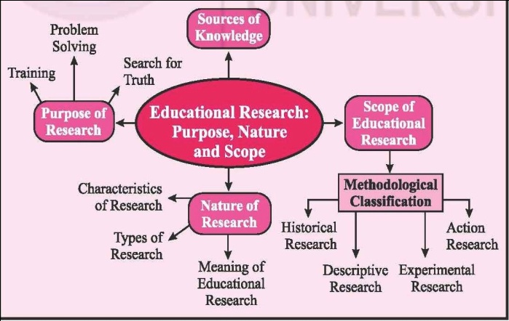
- Reference:

- Walford, G. (2001) Doing Qualitative Educational Research: A Personal Guide to the Research Process. London: Continuum
- Yorke, D. M (1978) Repertory grids in educational research: some methodological considerations. British Educational Research Journal, 4 (2), 63–74.
- Glass, G. V. (1976) Primary, secondary and metaanalysis. Educational Research, 5, 3–8.

Biography:
Dr. AJEET JAISWAL (Ph.D., Delhi University, India, 2009) is an Assistant professor of Anthropology at Department of Anthropology, Pondicherry University, Puducherry, India, an author of Eight (8) books, Written more than 65 papers and more than 40 Unit or Modules for IGNOU and PG e- Pathshala, Recorded more than 45 Lectures for paper Anthropology, under e-PG Pathshala Project, editorial board member and reviewer member of more than 30 International and National journals, attended more than 100 International and National educational Programmes, Delivered several Endowment Lecture, Keynote Address, Invited Speaker and Special Lecture, Three times received Best Paper Award, Lifetime Membership of many Educational Bodies. Recently Received Young Progressing Career Achievement Award and Fellow Of Social Science Research Council (FSSRC) from Open Association of Research Society (USA).

Presenting author details

Full Name: Dr AJEET Jaiswal
Contact number: +919791201427; +918122594335 (Whatsapp)
Linked In account:
Session name/ number:
Category: (Oral presentation/ Poster presentation) Passport Number:



